**St. Andrew’s Canteen Management System**

**A Project Report**

Submitted in partial fulfilment of the

Requirements for the award of the Degree of

**BACHELOR OF SCIENCE (INFORMATION TECHNOLOGY)**

**By**

**Samantha Simran Subramanian**

**5237**

**Under the esteemed guidance of**

**Mrs. A.N.S Sarvani**

(Coordinator, BSc-IT)



**DEPARTMENT OF INFORMATION TECHNOLOGY**

**ST. ANDREW’S COLLEGE OF ARTS, SCIENCE AND COMMERCE**

***Affiliated to University of Mumbai***

**MUMBAI, 400 050**

**MAHARASHTRA**

**2019-2020**

**Certificate**

**St. Andrew’s College of Art, Science And Commerce**

**St. Dominic Road, Bandra(W)**

**Mumbai-400 050**



**This is to certify that the Project Report**

**On**

**ST. ANDREW’S CANTEEN MANAGEMENT SYSTEM**

**Prepared by the following student(s) of**

**Bachelor of Science (Information Technology)**

**Samantha Simran Subramanian**

**5237**

**Submitted as partial fulfilment for the award of the**

**B.Sc.-I.T. degree from the University of Mumbai**

**During the Academic year 2019-2020**

**______________________ ______________________**

**Internal Examiner External Examiner**

**______________________ ______________________**

**Co-ordinator, B.Sc. (I.T.) Principal**

# **ABSTRACT**

St. Andrew’s Canteen Management System is created to make the process of ordering food in the canteen simpler and handle the details of the employees. The aim of this project is to lead to the smooth functioning of the canteen.

Currently, the break time is not sufficient for students to order and eat food from the canteen and this discourages them from going there. The staff is also overburdened with extra work during rush hours.

The proposed system will allow students to order their meals beforehand and pay online or by cash. This will give the canteen staff time to prepare their meals. Students only need to come and collect their meals during their break time. This will save a lot of time and improve the time management.

This system will have details of the inventory. It will also create reports to analyze the total transactions and other details.

**ACKNOWLEDGEMENT**

I take this opportunity to thank following people for their kind support and guidance without which successful completion of this project would have been difficult.

I would like to express my greatest gratitude to our Department coordinator Professor A.N.S. Sarvani for her esteemed guidance, constant encouragement, useful critiques, suggestions throughout the project and providing assistance in keeping my progress on schedule.

I would like to thank the college for providing space and resources in order to build my project. Finally, I wish to thank my parents for their support and encouragement throughout my project.

**DECLARATION**

I hereby declare that the project entitled, “**St. Andrew’s Canteen Management System**” done at our college has not been in any case duplicated to submit to any other university for the award of any degree. To the best of my knowledge other than me, no one has submitted to any other university.

The project is done in partial fulfillment of the requirements for the award of degree of BACHELOR OF SCIENCE (INFORMATION TECHNOLOGY) to be submitted as final semester project as part of our curriculum.

**SAMANTHA SIMRAN SUBRAMANIAN**

**5237**

**TABLE OF CONTENTS**

|  |  |
| --- | --- |
| **1. INTRODUCTION**  **1.1 Background**  **1.2 Objectives**  **1.3 Purpose and Scope** | **12**  **12**  **13**  **14** |
| **2. SYSTEM ANALYSIS**  **2.1 Existing System**  **2.2 Proposed System**  **2.3 Requirement Analysis**  **2.4 Hardware Requirements**  **2.5 Software Requirements**  **2.6 Justification of Selection of Technology** | **16**  **16**  **20**  **22**  **27**  **27**  **28** |
| **3. SYSTEM DESIGN**  **3.1 Gantt Chart**  **3.2 Module Division**  **3.3 Data Dictionary**  **3.4 E-R Diagram**  **3.5 Data Flow Diagram**  **3.6 UML Diagram**  **3.6.1 Use Case Diagram**  **3.6.2 Sequence Diagram**  **3.6.3 Activity Diagram**  **3.6.4 Statechart Diagram**  **3.7 SDLC Model – Iterative Model**  **3.8 Basic Modules**  **Module 1**  **Module 2**  **3.9 Data Design**  **3.9.1 Integrity Constraints**  **3.9.2 Algorithm**  **3.10 Business Rules**  **3.11 Test Cases**  **3.12 Security Issues**  **3.13 Software Quality** | **30**  **30**  **31**  **32**  **37**  **42**  **47**  **48**  **52**  **55**  **59**  **62**  **65**  **65**  **66**  **67**  **67**  **67**  **68**  **69**  **71**  **72** |
| **4. IMPLEMENTATION AND TESTING**  **4.1 Implementation Approach-Spiral Model**  **4.2 Code and Efficiency**    **4.3 Testing Approach**  **4.3.1 Early Testing**  **4.3.2 Unit Testing**  **4.3.3 Integration Testing**  **4.3.4 System Testing**  **4.3.5 Acceptance Testing**  **4.4 User Interface** | **73**  **73**  **75**  **83**  **83**  **84**  **84**  **84**  **87** |
| **5.RESULTS AND DISCUSSIONS**  **5.1 Test Reports**  **5.2 User Manual** | **128**  **128**  **129** |
| **6. CONCLUSION**  **6.1 Significance of System**  **6.2 Limitations of the Project**  **6.3 Future Scope of Project** | **130**  **131**  **131**  **131** |
| **7. References** | **132** |

**LIST OF TABLES**

Table 1: Requirement analysis 22

Table 2:Priority table 26

Table 3:Hardware requirements 27

Table 4:Software requirements 27

Table 5:Admin login 32

Table 6:Student login 33

Table 7:Staff login 33

Table 8:Product details 34

Table 9:Order details 35

Table 10:Coupon details 35

Table 11:Feedback details 36

Table 12:Advantages/disadvantages of SDLC model 64

Table 13:Test case 1 69

Table 14:Test case 2 69

Table 15:Test case 3 70

Table 16:Test case 4 70

Table 17:Test case 5 70

Table 18:Test case 6 71

Table 19:Advantages/disadvantages of White Box Testing 85

Table 20:Advantages/disadvantages of Black Box Testing 86

Table 21:Test reports 129

**LIST OF FIGURES**

Figure 1:Existing system (canteentaco.com): 16

Figure 2:Existing system(canteentaco.com) 16

Figure 3:Existing system (canteentaco.com) 17

Figure 4: Existing system 2(mykidslunchbox.com.au) 17

Figure 5:Existing system 2(mykidslunchbox.com.au) 18

Figure 6:Existing system 2(mykidslunchbox.com.au) 18

Figure 7:Existing system 2(mykidslunchbox.com.au) 19

Figure 8:Proposed system 1 20

Figure 9:Proposed system 2 21

Figure 10:Proposed system 3 21

Figure 11:Requirement analysis pie chart (1) 23

Figure 12:Requirement analysis pie chart(2) 23

Figure 13:Requirement analysis bar graph (1) 24

Figure 14:Requirement analysis pie chart(3) 24

Figure 15:Requirement analysis bar graph (2) 25

Figure 16:Requirement analysis pie chart(4) 25

Figure 17:Requirement analysis pie chart(5) 26

Figure 18:Gantt chart 30

Figure 19:E-R diagram 41

Figure 20:DFD Components 42

Figure 21: Context level Data Flow Diagram 43

Figure 22: Level 1 Data Flow Diagram (admin) 44

Figure 23:Level 1 Data Flow Diagram (user) 44

Figure 24:Level 2 Data Flow Diagram (admin) 45

Figure 25:Level 2 Data Flow Diagram (user) 46

Figure 26:Use case diagram 51

Figure 27:Sequence diagram 54

Figure 28:Activity diagram (admin) 57

Figure 29:Activity diagram (user) 58

Figure 30:Statechart diagram 61

Figure 31:SDLC Model 64

Figure 32:Spiral model 73

Figure 33:Student registration 75

Figure 34:Encryption of password 76

Figure 35:Student login 76

Figure 36:Password decryption 76

Figure 37:Add to cart(1) 77

Figure 38:Add to cart(2) 77

Figure 39:Add to cart(3) 78

Figure 40:Add to cart(4) 78

Figure 41:Application of coupon(1) 78

Figure 42:Application of coupon(2) 79

Figure 43:Get order id 79

Figure 44:Create pdf of receipt 79

Figure 45:Send forgotten password to user's mobile number(1) 80

Figure 46:Send forgotten password to user's mobile number(2) 80

Figure 47:Get transaction details of a particular month 81

Figure 48:Convert transaction details to an excel file 81

Figure 49:Update and delete stock details 82

Figure 50:Welcome page 87

Figure 51:Student Login 87

Figure 52:Invalid login details 88

Figure 53:Student registration 88

Figure 54:Student registration(Validation controls) 89

Figure 55:Student registration(Incorrect captcha) 89

Figure 56:Student registration(correct captcha) 90

Figure 57:Registration successful 90

Figure 58:Student login 91

Figure 59:Forgot password 91

Figure 60:Send password to registered mobile number 92

Figure 61:Message sent to registered mobile number 92

Figure 62:Send password to registered email address 93

Figure 63:Email sent to registered email address 93

Figure 64:Student login 94

Figure 65:Student Home page 94

Figure 66:Menu(1) 95

Figure 67:Menu(2) 95

Figure 68:Menu(3) 96

Figure 69:Start my order(1) 96

Figure 70:Start my order(2) 97

Figure 71:Start my order(3) 97

Figure 72:Start my order(4) 98

Figure 73:Sort products (High to low price) 98

Figure 74:Sort products (Low to high price) 99

Figure 75:Using the search bar 99

Figure 76:Results from the search bar 100

Figure 77:Cart 100

Figure 78:Coupon code added 101

Figure 79:Order confirmation 101

Figure 80:Order pick up time 102

Figure 81:Order placed successfully 102

Figure 82:Download order receipt 103

Figure 83:Order receipt 103

Figure 84:Feedback form 104

Figure 85:Feedback 104

Figure 86:Feedback submitted successfully 105

Figure 87:Homepage dropdown list 105

Figure 88:Check feedback status 106

Figure 89:Feedback is being processed 106

Figure 90:Homepage dropdown list 107

Figure 91:Log out 107

Figure 92:Welcome page 108

Figure 93:Admin login 108

Figure 94:Admin registration(Validation controls) 109

Figure 95:Admin registration with captcha 109

Figure 96:Registration successful 110

Figure 97:Admin login 110

Figure 98:Admin homepage 111

Figure 99:View orders 111

Figure 100:View a particular order 112

Figure 101:Hide order details 112

Figure 102:View all orders 113

Figure 103:Delete order after completion 113

Figure 104:Product details(1) 114

Figure 105:Product details(2) 114

Figure 106:Product details(3) 115

Figure 107:Product details(4) 115

Figure 108:Product details(5) 116

Figure 109:Edit product details 116

Figure 110:Edit product details 117

Figure 111:Update product details 117

Figure 112:Insert a new product in product details 118

Figure 113:New product inserted 118

Figure 114:Create coupon 119

Figure 115:Coupon details 119

Figure 116:Coupon created successfully 120

Figure 117:Reports 120

Figure 118:Find transactions of a particular month 121

Figure 119:Transaction details of a particular month 121

Figure 120:Download transaction excel file 122

Figure 121:Transaction details excel file 122

Figure 122:View and download all Student details 123

Figure 123:Student details excel file 123

Figure 124:View and download all staff details 124

Figure 125:Staff details excel file 124

Figure 126:View and download order details 125

Figure 127:Order details excel file 125

Figure 128:View all feedbacks 126

Figure 129:Reply a particular feedback 126

Figure 130:Reply inserted successfully 127

Figure 131:User views admin's reply 127

1. **Introduction**

**1.1 Background:**

St. Andrew’s Canteen Management system is made to make management of the canteen simpler. The college canteen consists of few workers at the station and a few in the kitchen. Students rush to the canteens during break and order their respective items. The break lasts for 20 minutes. This is very less time for students to order, receive and finish their meals which discourages students from ordering from the canteen. To remedy this, St. Andrew’s canteen management is created. It is a website where students can create their own accounts and order meals beforehand. They can order their meals and also pay for them online. The admin in the canteen will receive these orders and prepare food before the break. The student then has to only come and collect their food. This will improve the time management of the canteen system. Staff members can also have their accounts from which they can get food delivered to the staff rooms.

Generally, food ordering and delivery systems are used by various food corporations in India. They include individual corporations (pizza hut, kfc, restaurants) as well as corporations which act as a search engine for individual corporations (zomato, swiggy).

**1.2 Objective of the project:**

* This project will make ordering of food more efficient for the students and the canteen workers.It will lead to the smooth functioning of the canteen.
* Students can order food beforehand. The canteen can prepare food before the students arrive and the students can simply collect their orders.
* This will save time of the students and the canteen staff will not be overburdened during rush hours.
* Admin from the canteen can view monthly transactions as well as total transactions.
* Admin can also easily make changes to the product details like its price and it will be reflected at the user’s side.
* It will also contain a feedback system which will help canteen improve more.
* This will lead to the canteen working more smoothly.

**1.3 Purpose and Scope**

**1.3.1 Purpose:**

Normally, ordering food can be a hassle during rush hours. Students get 20 minutes of break which is not enough to order the food and finish it. This often leads to overcrowding during break time.

Students receive their food late due to the surplus of orders and therefore get very less time to consume it.

The canteen workers get surplus orders during break time and little to no orders during regular time which can overburden them.

The main aim of this project is to provide smooth functioning to the canteen management system.

This system will take orders behorehand and prepare them. This saves the students time as they can order their food beforehand and later go and collect them.

It provides a smooth flow to the entire system.

The canteen workers can prepare the food as they receive the orders so this will not lead to overburdening them during rush hours. This leads to better time management

This app will introduce an online payment system. This will further simplify the process of getting the food faster.

**1.3.2 Scope:**

St. Andrews Canteen Management system will make canteen management simpler and more effective.

It will take orders beforehand which will allow the workers to prepare food before rush hour. It will also contain reports which will help the admin to see the total sales that have taken place.

This will help the admins to analyze the products and further keep the inventory stocked accordingly.

This system will also maintain the order details and also the details of the product. It will contain a coupon system which will give discounts on the food items special which will encourage the users further to use the website.

It will have a feedback system where user’s can give their feedback to the canteen and the admin can send appropriate reply back to the user. This can bring to notice certain issues of the canteen to the admin.

1. **System Analysis**
   1. **Existing system**

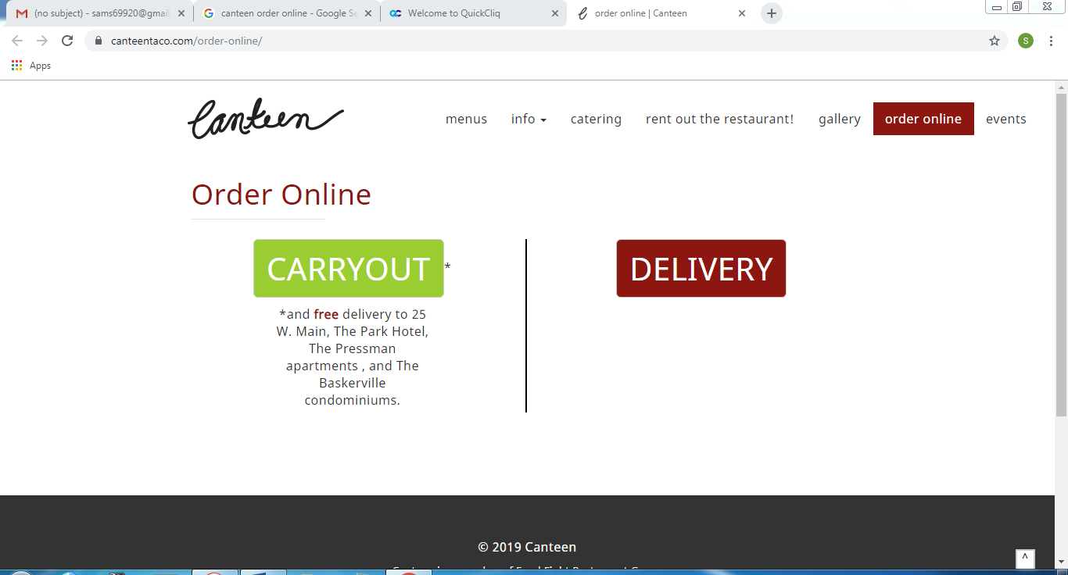

Figure :Existing system (canteentaco.com):

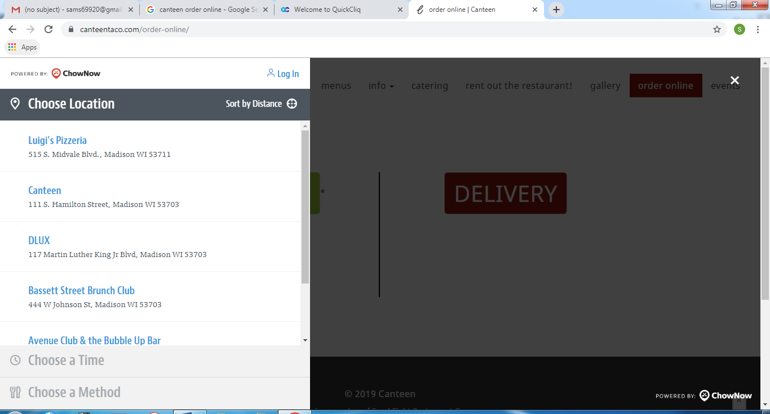

Figure :Existing system(canteentaco.com)

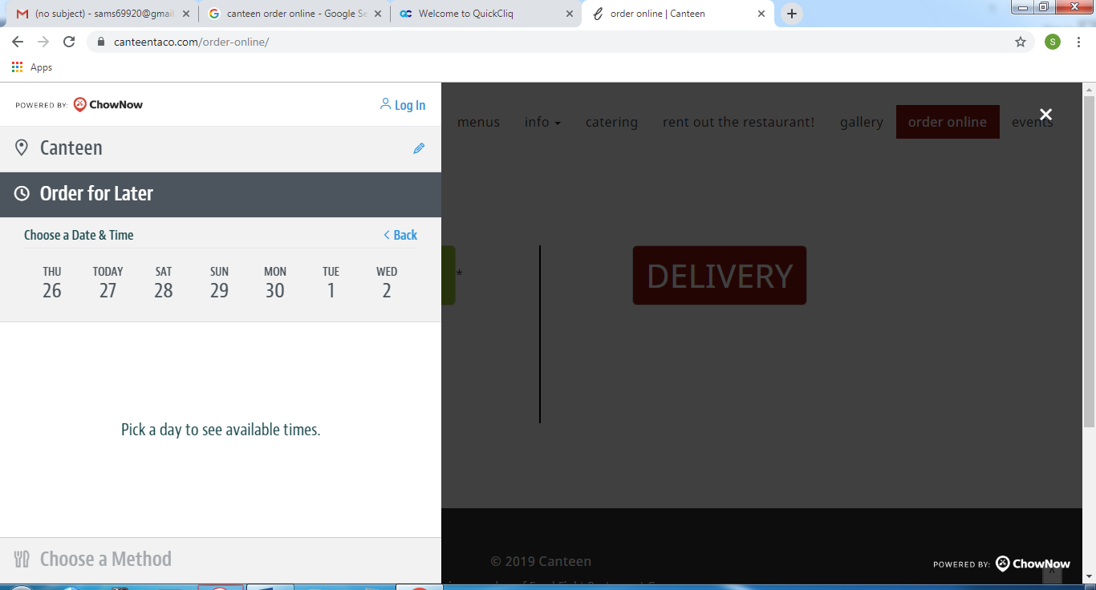

Figure :Existing system (canteentaco.com)

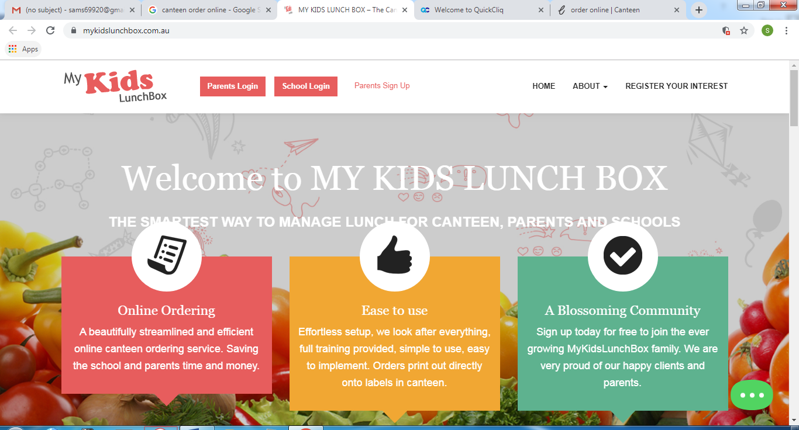

Figure : Existing system 2(mykidslunchbox.com.au)

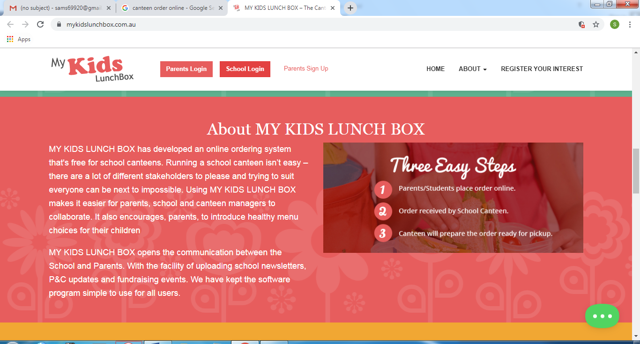

Figure :Existing system 2(mykidslunchbox.com.au)

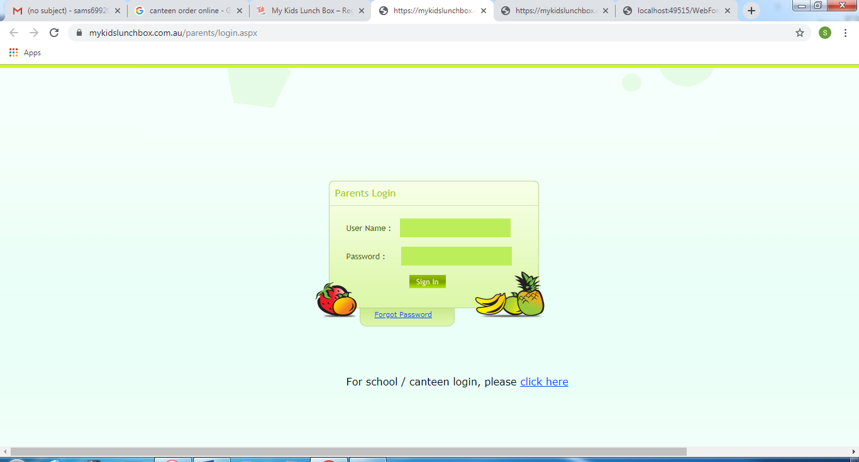

Figure :Existing system 2(mykidslunchbox.com.au)

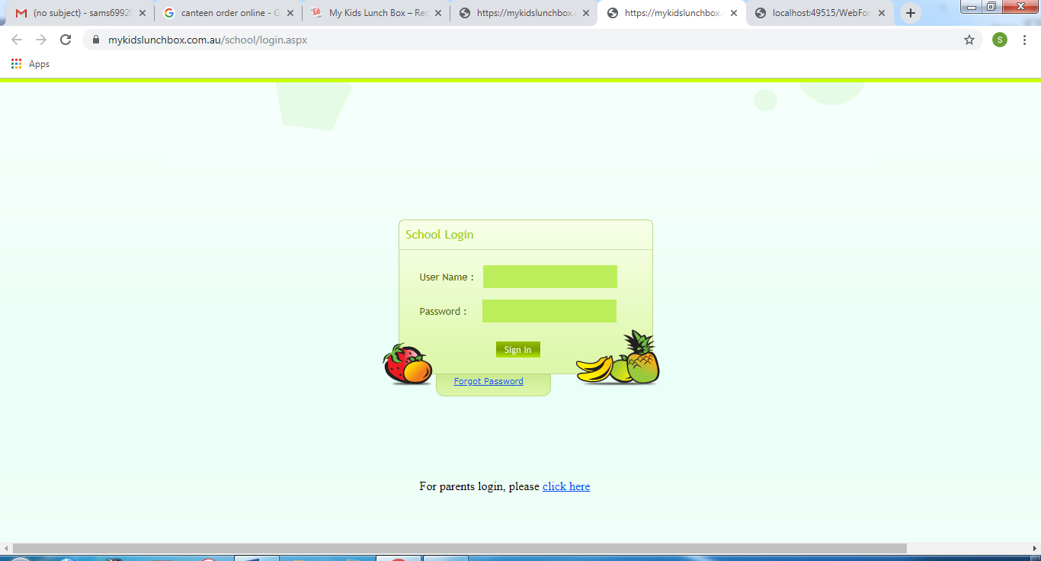

Figure :Existing system 2(mykidslunchbox.com.au)

In the existing systems, food needs to be ordered days prior. A monthly plan or weekly plan is to be made in advance.

This is not very convenient for college students and it may discourage them from using the website.

The students have to get pre-planned meals rather than meals that they decide for the day.These sites extends to the countries of Australia and United States respectively. So, they cover large geographical territories which lead to late deliveries and mix ups in orders.

Slow processing speed

Admins do not get charts to analyze the food items being sold.

**2.2 Proposed system**

In the proposed system, the user can order meals an hour prior to collecting it.

This gives them more advantage to choose meals they wish to have that day.

It does not contain weekly or monthly plans. So, students need not to tied to eating from the canteen everyday…It covers only the canteen of St. Andrew’s College. This leads to less confusion in the orders and deliveries on time.

Faster processing speed.

Admins are provided with reports to analyze the food items that are sold.

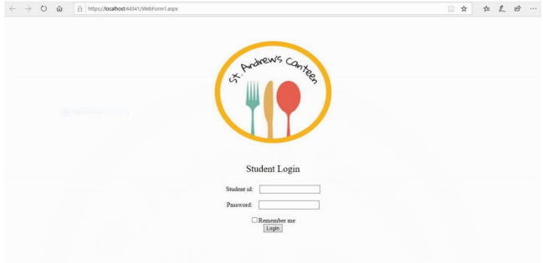

Figure :Proposed system 1

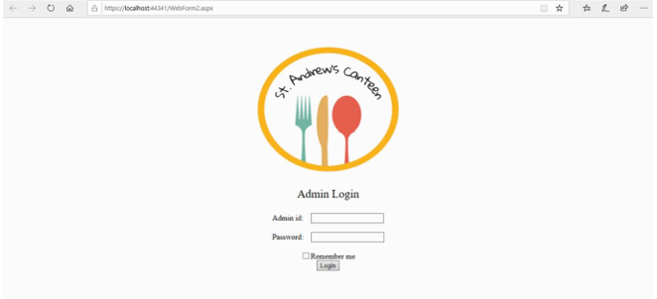

Figure :Proposed system 2

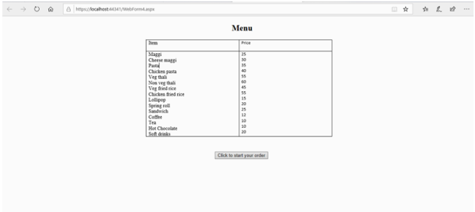

Figure :Proposed system 3

**2.3 Requirement analysis**

|  |  |  |
| --- | --- | --- |
| Sr. No. | Questions | User answers |
| 1. | Is the break time enough for you to order and eat? | No |
| 2. | How long do you have to wait for your ordered food? | Majority answered more than 5 minutes but less than 10 minutes. |
| 3. | Which food item which you have ordered has taken the most time to arrive? | Maggi, fried rice |
| 3. | How long are you in the canteen for per day? | Various responses ranging from 10 minutes to 2-3 hours |
| 4. | Would you prefer to have an app to order your meals beforehand? | Yes |
| 5. | What features would you want this online system to include? | Pre-order, updating the menu so that only available food is shown, online payment, tracking order. |
| 6. | Would you prefer to pay in cash or through an online medium? | Cash |
| 7. | What time slot would you prefer to send the orders in? | Answers range from 15 minutes to an hour before the pickup |

Table : Requirement analysis

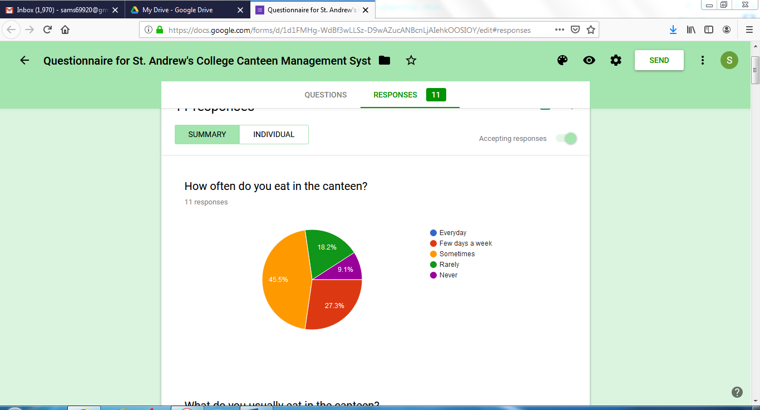

Figure :Requirement analysis pie chart (1)

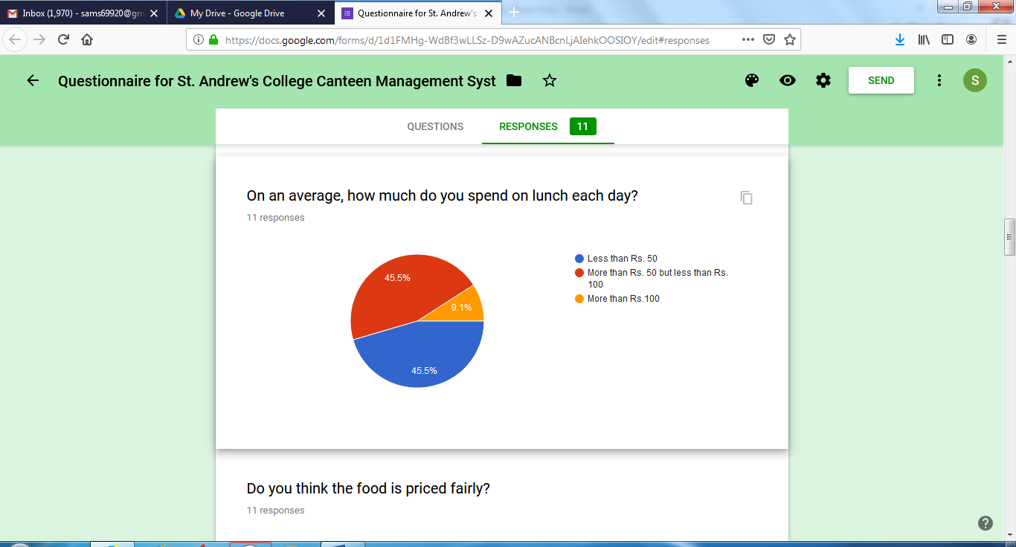

Figure :Requirement analysis pie chart(2)

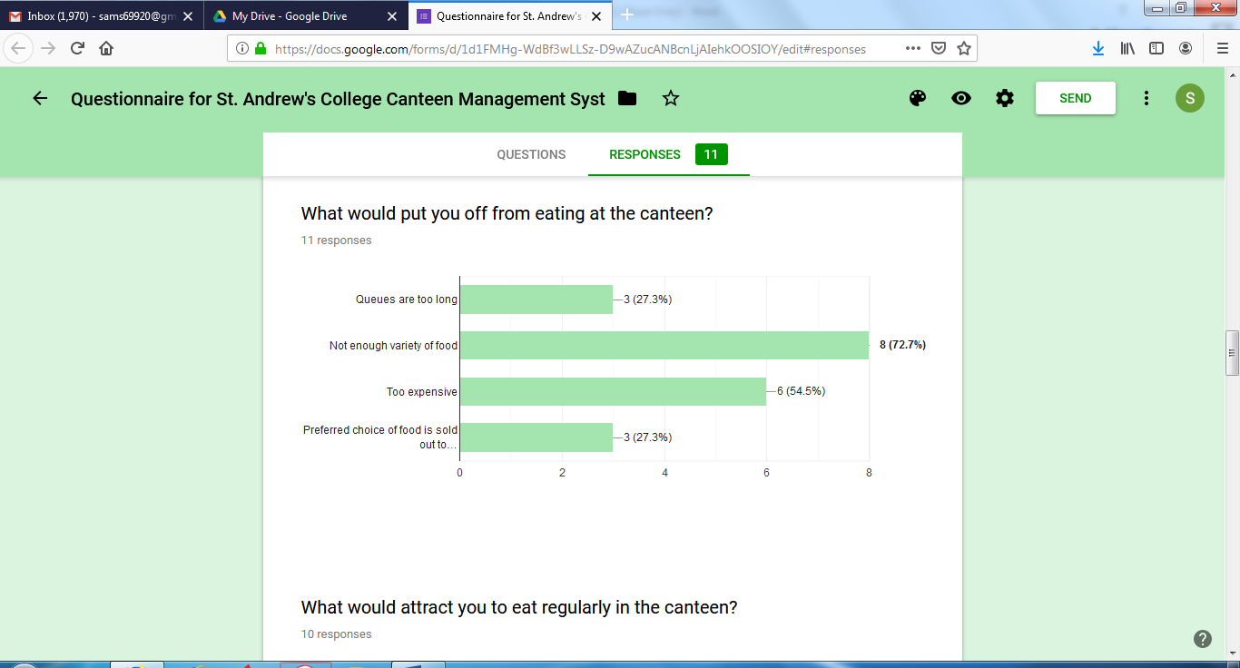

Figure :Requirement analysis bar graph (1)

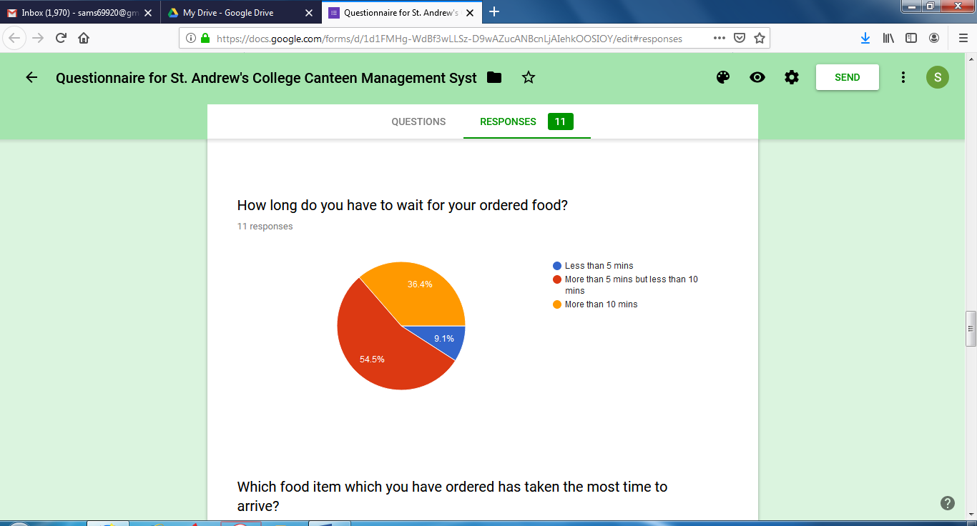

Figure :Requirement analysis pie chart(3)

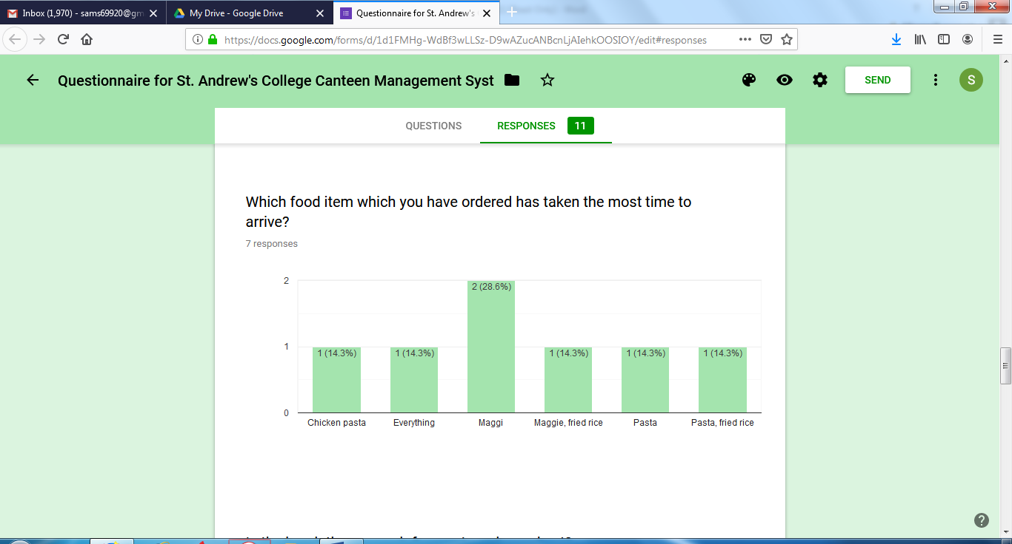

Figure :Requirement analysis bar graph (2)

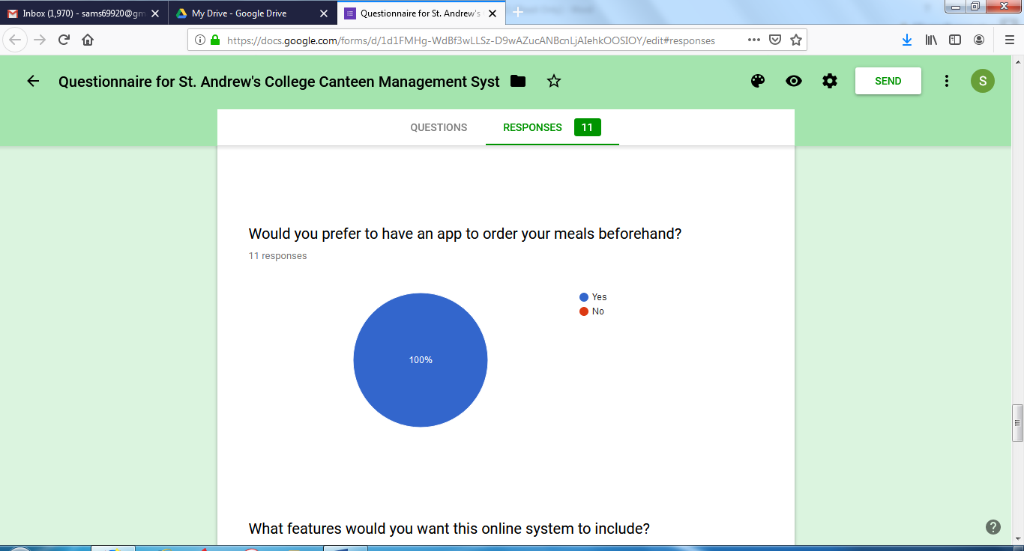

Figure :Requirement analysis pie chart(4)

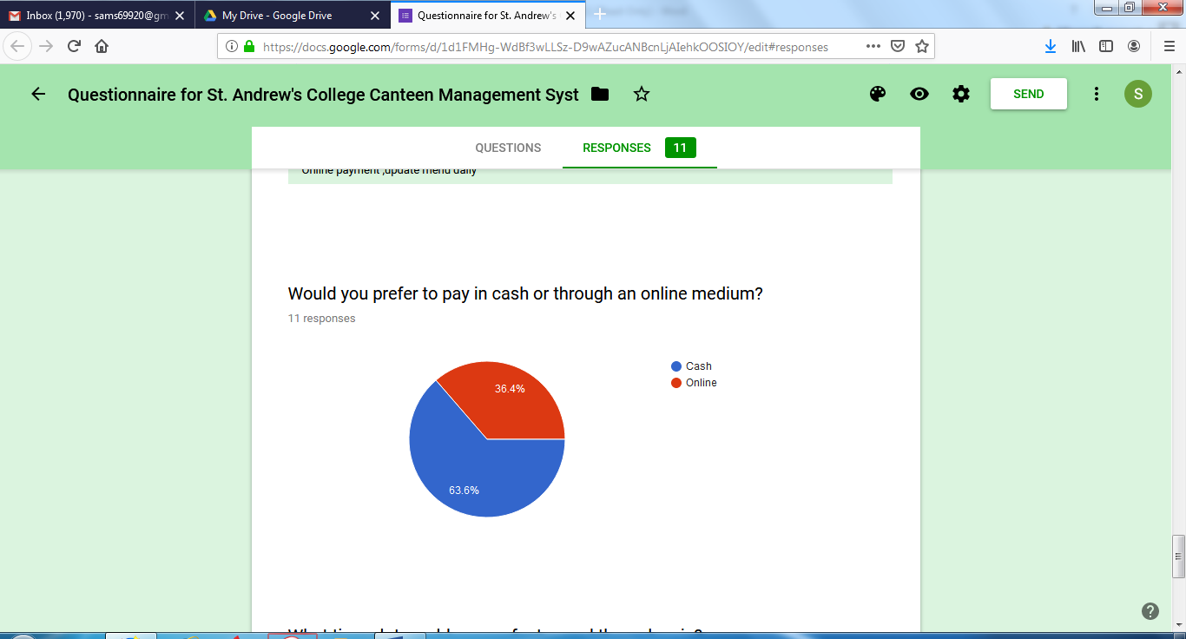

Figure :Requirement analysis pie chart(5)

|  |  |  |  |
| --- | --- | --- | --- |
| **High** | **Medium** | **Low** | **Avoid** |
| Updating the menu regularly so that only available food is shown. | Tracking food. | Order time limit: about an hour | Keeping only online payment as an option. |
|  | Increasing the variety of food. | Certain benefits for regular users |  |

Table :Priority table

**Summary:**

This survey was carried out among the students of St. Andrew’s College. There are certain drawbacks of the canteen. According to the students, fewer variety of food seems to be the biggest drawback followed by cost, long queues and unavailability of certain food items. Most students spend about 50-100 rupees in canteen everyday. Students unanimously agreed that they would prefer to order their meals beforehand using an online medium. Some features that students suggested for the online medium to have were updating the menu so that only available food is shown, online payment and tracking order. Most of the students prefer to pay by cash.

**2.4 Hardware Requirements:**

|  |  |
| --- | --- |
| **Users**: | **Developers**: |
| * Any android phone with: * Minimum 1GB RAM * 80-100 MB ROM * Minimum quad core processor | * 3 GB RAM minimum, 8 GB RAM recommended * 1280 x 800 minimum screen resolution * 4 GB disk space * Minimum quad core processor |

Table :Hardware requirements

**2.5 Software Requirements:**

|  |  |
| --- | --- |
| **Users:** | **Developer:** |
| * Smart phone (Android or iOS) | * Windows operating system * Microsoft windows 7 or higher * Visual Studio 2019 * SQL 2016 |

Table :Software requirements

**2.6 Justification of Selection of Technology**

**Front end:**

**ASP.NET**

* ASP.NET is a web application framework developed and marketed by Microsoft to allow programmers to build dynamic web sites. It allows you to use a full featured programming language such as C# or VB.NET to build web applications easily.
* The ASP.NET platform has always been preferred by developers as it’s simple to use and yet very effective in delivering the appropriate solutions.
* ASP.NET is useful for creating dynamic, robust and scalable web applications ASP.NET languages can be built to be language-independent. It allows users to choose the language of their choice or divide the application as per different languages.
* As all the configuration information is built-in, there is no process of registration of components. This allows for easy deployment of applications.

**Back end:**

**MySQL**

* MySQL is a free, open-source database management system .A DBMS is a system that manages databases and connects them to software. For example, a MySQL database can be used to run a website, to run the database of an ERP or any other software.
* MySQL provides a implementation of a SQL database very well suited for small to medium web pages. The database has a commercial license available.
* It is a powerful, free database management system that has been around for years. It is very stable and has a big community that helps maintain, debug and upgrade it.
* MySQL works rapidly and functions admirably even with huge informational collections.

**C#**

* C# is an object-oriented programming language from Microsoft that aims to combine the computing power of C++ with the programming ease of Visual Basic. C# is based on C++ and contains features similar to those of Java.
* It integrates well with Windows. You don't need any special configurations to get a C# program to run in your Windows environment. Whether it's a web application, a Windows service, or a desktop app, C# programs are easily deployed on the network.
* C# being a .NET language, supports language interoperability, i.e. C# can access code written in any .NET compliant language and can also inherit the classes written in these languages.
* C# is a compiled language, which means that the code stored on a public-facing server is in binary form.

**3.** **System Division**

**3.1 Gantt chart**

Figure :Gantt chart

**3.2 Module Division**

**Admin module**

* Admin registration: admin can register themselves in the database. The password entered will be encrypted before saving it to database
* Admin login: admin can log in to their account. The password will be decrypted here.
* Orders received: admin can check the orders received and pass them to the kitchen. Once the order is completed they can delete the order.
* Reports: admin can view monthly reports or reports until the current date. They can also view the details of students and staff who have registered.
* Stock details: admin can check the product details and also change the details of the products like its price. They can also delete some items from the menu and insert new items.
* Feedback: Admin can view the feedback given by the students and reply to them.
* Coupon: Admin can create coupons.

**User module:**

* User registration: users can register themselves in the database. The password entered will be encrypted before saving it to database
* User login: users can login to their account. It will contain a forgot password method which will send the password to the phone number or email. The password will be decrypted here.
* Menu: users check the menu and decide the food they want to order.
* Order: users can select the food they want to buy and add them to cart. They can type the type of food they want to eat and related results will be shown.
* Cart: it contains items that the users have selected.
* Place order: user will confirm their order and enter the time they will collect their food and use coupons if they have any
* Feedback: users can give their feedback regarding the food or canteen and can also check the reply they get from the admin.

**3.3 Data dictionary**

* A data dictionary is a file or set of files that contains a database’s metadata. The data dictionary contains records about other objects in the database such as data ownership, data relationships to other objects and other data.
* The data dictionary is a crucial component of any relational database. Ironically, because of its importance, it is invisible to most database users. Typically, only database administrators interact with the data dictionary.
* In a relational database, the metadata in the data dictionary includes the following:
* Names of all tables in the database and their owners.
* Names of all indexes and the columns to which the tables in those indexes relate.
* Constraints defined on tables, including primary keys, foreign-key relationships to other tables and not-null constraints.

Admin login:

|  |  |  |  |  |
| --- | --- | --- | --- | --- |
| Sr. No. | Field Name | Datatype | Constraints | Description |
| 1. | Adminname | Varchar(50) | Primary Key | Username of the employee |
| 2. | Password | Varchar(50) | Not Null | Password of the employee |
| 3. | Email | Varchar(50) | Not Null | Email of the employee |
| 4. | Phone | Varchar(50) | Not Null | Phone Number of the employee |

Table :Admin login

Customer login:

|  |  |  |  |  |
| --- | --- | --- | --- | --- |
| Sr. No. | Field Name | Datatype | Constraints | Description |
| 1. | ID | Integer | Primary Key | Student ID |
| 2. | Stpassword | nchar(50) | Not Null | Password of the student |
| 3. | Firstname | nchar(50) | Not Null | First name of the student |
| 4. | Lastname | nchar(50) | Not Null | Last name of the student |
| 5. | Course | nchar(50) | Not Null | Course of the student |
| 6. | Phone | nchar(50) | Not Null | Phone number of the student |
| 7. | Email | nchar(50) | Not Null | Email address of the student |

Table :Student login

Staff login:

|  |  |  |  |  |
| --- | --- | --- | --- | --- |
| Sr. No. | Field Name | Datatype | Constraints | Description |
| 1. | Fullname | Varchar(50) | Primary Key | Username of the staff |
| 2. | Password | Varchar(50) | Not Null | Password of the staff |
| 3. | Email | Varchar(50) | Not Null | Email of the staff |
| 4. | Phone | Varchar(50) | Not Null | Phone Number of the staff |

Table :Staff login

Product details:

|  |  |  |  |  |
| --- | --- | --- | --- | --- |
| Sr. No. | Field Name | Datatype | Constraints | Description |
| 1. | productId | Integer | Primary Key | ID number of the product |
| 2. | productname | nchar(50) | Not Null | Product name |
| 3. | price | Integer | Not Null | Price of the product |
| 4. | image | Varchar(MAX) | Not Null | Image of the product |
| 5. | Category | Varchar(50) | Not Null | Category of the product |
| 6. | KeywordSearch | Varchar(50) | Not Null | Keyword searches allowed of the product |
| 7. | discount | Integer | Not Null | Discount on the product |

Table :Product details

Order details:

|  |  |  |  |  |
| --- | --- | --- | --- | --- |
| Sr. No. | Field Name | Datatype | Constraints | Description |
| 1. | orderid | Varchar(50) | Primary Key | Order Id |
| 2. | sno | Integer | Not Null | Serial number of the order |
| 3. | productid | Integer | Not Null | Product ID |
| 4. | productname | Varchar(50) | Not Null | Name of the product |
| 5. | price | Integer | Not Null | Price of the product |
| 6. | quantity | Integer | Not Null | Quantity of the product ordered |
| 7. | dateoforder | Varchar(50) | Not Null | Date of order |
| 8. | totprice | Varchar(50) | Not Null | Total price of the order |
| 9. | disprice | Varchar(50) | Not Null | Discount on the order |
| 10. | time | Varchar(50) | Not Null | Time of order |

Table :Order details

Coupon details:

|  |  |  |  |  |
| --- | --- | --- | --- | --- |
| Sr. No. | Field Name | Datatype | Constraints | Description |
| 1. | couponid | Integer | Primary Key | Coupon Id |
| 2. | couponcode | Varchar(50) | Not Null | Coupon Code |
| 3. | discount | Integer | Not Null | Discount on the coupon |
| 4. | maxdiscount | Integer | Not Null | Maximum discount on the coupon |
| 5. | tilldate | Datetime | Not Null | Validity of the coupon |

Table :Coupon details

Feedback

|  |  |  |  |  |
| --- | --- | --- | --- | --- |
| Sr. no. | Field name | Data Type | Constraints | Description |
| 1. | Id | Integer | Primary key | Feedback id |
| 2. | Name | Varchar(50) | Not null | Name of the sender |
| 3. | Email Id | Varchar(50) | Not null | Email ID of the sender |
| 4. | Feedback | Varchar(MAX) | Not null | Feedback |
| 5. | Date | Datetime | Not null | Date of the feedback |
| 6. | Status | Varchar(50) | Not null | Current status of feedback. |
| 7. | Reply | Varchar(MAX) | Not null | Reply given by the admin |

Table :Feedback details

**3.4 ER diagram**

An entity-relationship diagram (ERD) is a graphical representation of an information system that shows the relationship between people, objects, places, concepts or events within that system. An ERD is a data modeling technique that can help define business processes and can be used as the foundation for a relational database.

**Components of a ER Diagram**

This model is based on three basic concepts:

* Entities
* Attributes
* Relationships

#### **Entity**

An entity can be a person, place, event, or object that is relevant to a given system. For example, a school system may include students, teachers, major courses, subjects, fees, and other items. Entities are represented in ER diagrams by a rectangle and named using singular nouns.

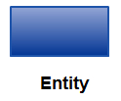

#### **Weak Entity**

A weak entity is an entity that depends on the existence of another entity. In more technical terms it can be defined as an entity that cannot be identified by its own attributes. It uses a foreign key combined with its attributed to form the primary key. An entity like order item is a good example for this. The order item will be meaningless without an order so it depends on the existence of the order.

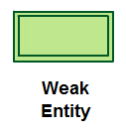

#### **Attribute**

An attribute is a property, trait, or characteristic of an entity, relationship, or another attribute. For example, the attribute Inventory Item Name is an attribute of the entity Inventory Item. An entity can have as many attributes as necessary. Meanwhile, attributes can also have their own specific attributes. For example, the attribute “customer address” can have the attributes number, street, city, and state. These are called composite attributes. Note that some top level ER diagrams do not show attributes for the sake of simplicity. In those that do, however, attributes are represented by oval shapes.

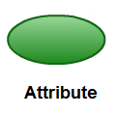

#### **Multivalued Attribute**

If an attribute can have more than one value it is called a multi-valued attribute. It is important to note that this is different from an attribute having its own attributes. For example, a teacher entity can have multiple subject values.

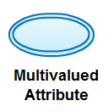

**Relationship**

A relationship describes how entities interact. For example, the entity “Carpenter” may be related to the entity “table” by the relationship “builds” or “makes”. Relationships are represented by diamond shapes and are labeled using verbs.

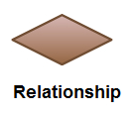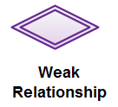

**Binary relationship and Cardinality**

A relationship where two entities are participating is called a binary relationship. Cardinality is the number of instance of an entity from a relation that can be associated with the relations.

**One-to-one** – When only one instance of the entity is associated with the relationship, it is marked as ‘1:1’. The following image reflects that only one instance of each entity should be associated with the relationship. It depicts one-to-one relationship.



**One-to-many**- When more than one instance of an entity is associated with a relationship. It is marked as ‘1:N’. The following image reflects that only one instance of entity on the left and more than one instance of an entity on the right can be associated with the relationship. It depicts one-to-many relationship.



**Many-to-one**- When more than one instance of an entity is associated with the relationship, it is marked as ‘N:1’The following image reflects that more than one instance of an entity on the left and only one instance of the entity on the right can be associated with the relationship.



**Many-to-Many** – The following image reflects that more than one instance of an entity on the left and more than one instance of an entity to the right can be associated with the relationship. It depicts many-to-many relationship.



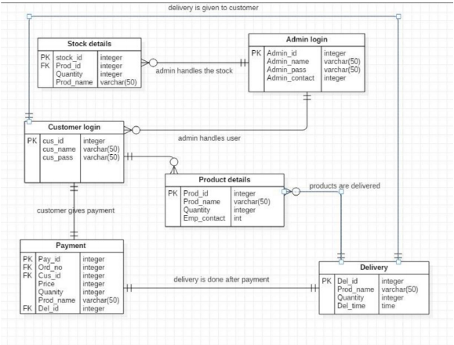

Figure :E-R diagram

**3.5 Data Flow Diagram**

A data flow diagram (DFD) illustrates how data is processed by a system in terms of inputs and outputs. As its name indicates its focus is on the flow of information, where data comes from, where it goes and how it gets stored

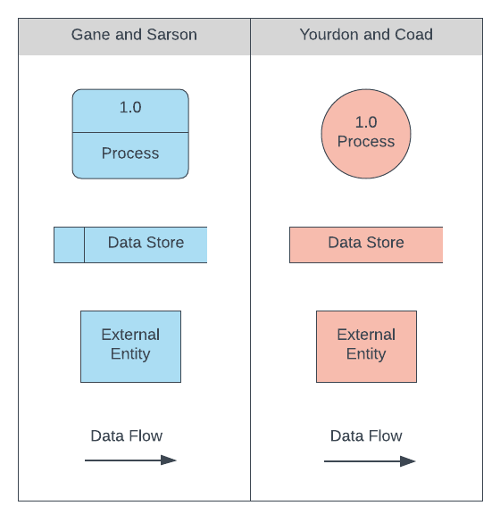**External Entity** – An external entity is a source or destination of a data flow which is outside the area of study. Only those entities which originate or receive data are represented on a business process diagram. The symbol used is an oval containing a meaningful and unique identifier..

**Process** – An activity that changes or transforms data flows. Since they transform incoming data to outgoing data, all processes must have inputs and outputs on a DFD.

.Processes are typically oriented from top to bottom and left to right on a data flow diagram.

**Data Store** – A data store does not generate any operations but simply holds data for later access.

Figure :DFD Components

Input flows to a data store include information or operations that change the stored data. Output flows would be data retrieved from the store.

**Data Flow** – Movement of data between external entities, processes and data stores is represented with an arrow symbol, which indicates the direction of flow.

This data could be electronic, written or verbal.Input and output data flows are labeled based on the type of data or its associated process or data store, and this name is written alongside the arrow

**Context Level:**

A context diagram gives an overview and it is the highest level in a data flow diagram, containing only one process representing the entire system. It should be split into major processes which give greater detail and each major process may further split to give more detail.

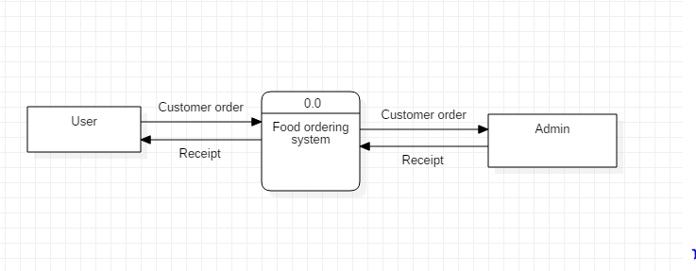

Figure : Context level Data Flow Diagram

**Level 1**

Processes in diagram 0 (with a whole number) can be exploded further to represent details of the processing activities. Example below shows the next level ((Diagram 1) of process explosion

**Admin**

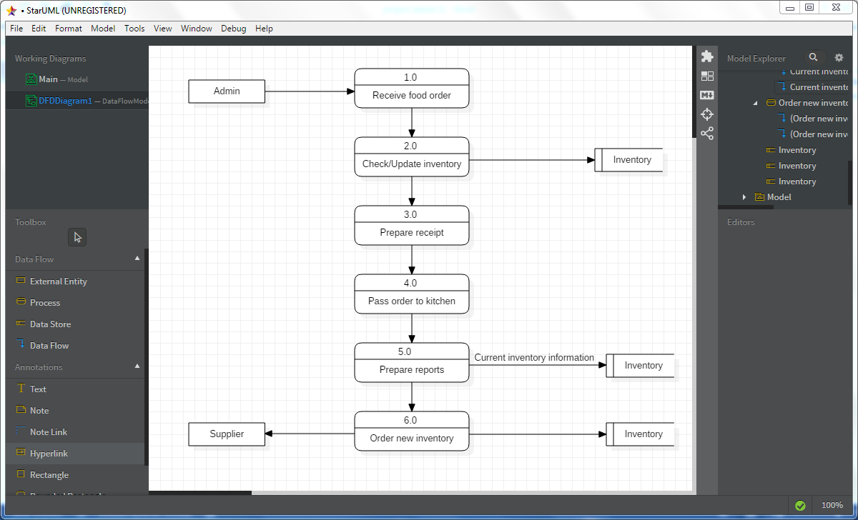

Figure : Level 1 Data Flow Diagram (admin)

**User**

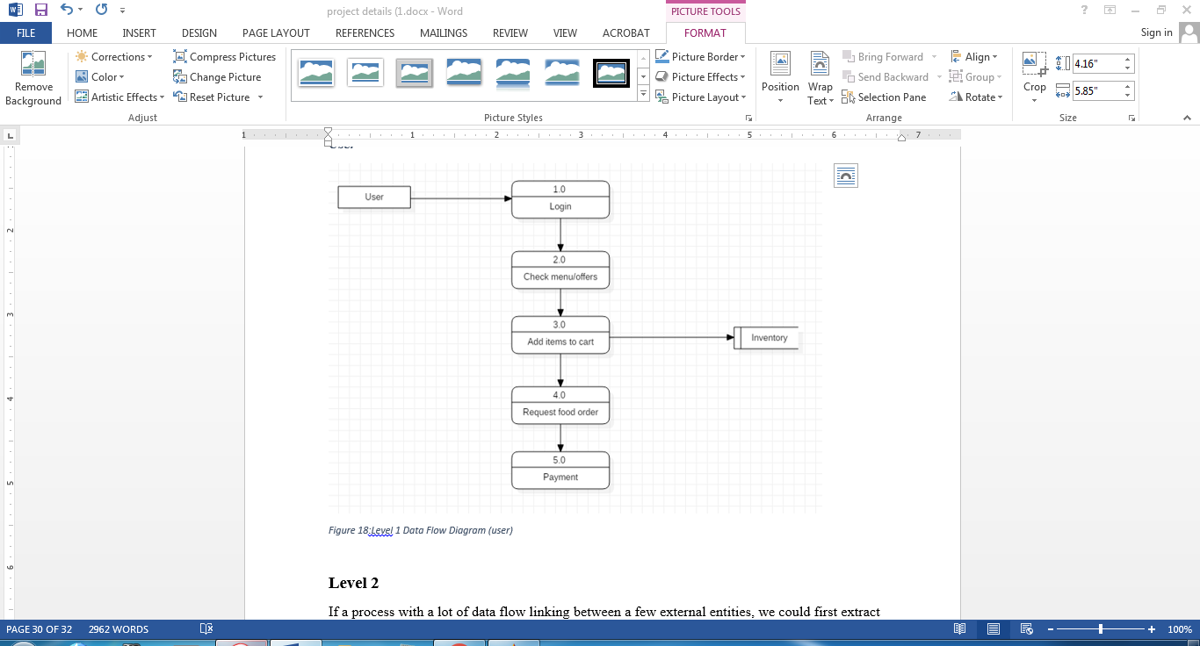

Figure :Level 1 Data Flow Diagram (user)

**Level 2**

If a process with a lot of data flow linking between a few external entities, we could first extract that particular process and the associated external entities into a separate diagram similar to a context diagram, before you refine the process into a separate level of DFD; and by this way you can ensure the consistency between them much easier.

**Admin:**

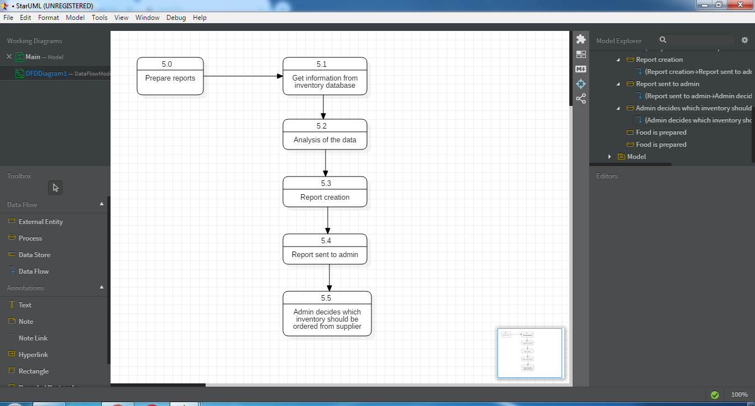

Figure :Level 2 Data Flow Diagram (admin)

**User:**

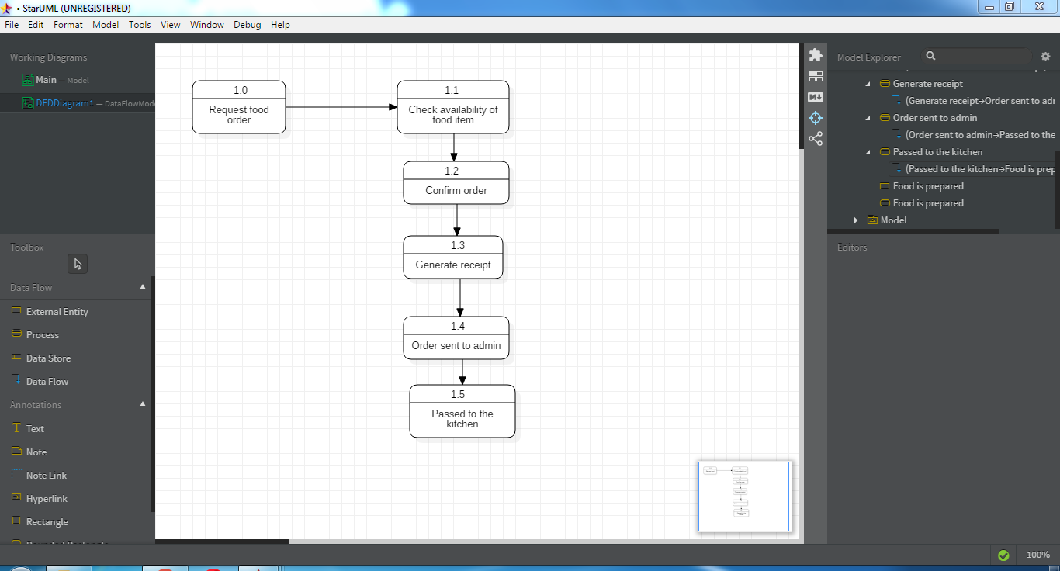

Figure :Level 2 Data Flow Diagram (user)

**3.6 UML Diagrams:**

UML is a standard language for specifying, visualizing, constructing, and documenting the artifacts of software systems.

* UML stands for Unified Modeling Language.
* UML is different from the other common programming languages such as C++, Java, COBOL, etc.
* UML is a pictorial language used to make software blueprints.
* UML can be described as a general purpose visual modeling language to visualize, specify, construct, and document software system.
* Although UML is generally used to model software systems, it is not limited within this boundary. It is also used to model non-software systems as well. For example, the process flow in a manufacturing unit, etc.

UML is not a programming language but tools can be used to generate code in various languages using UML diagrams. UML has a direct relation with object oriented analysis and design. After some standardization, UML has become an OMG standard.

The elements are like components which can be associated in different ways to make a complete UML picture, which is known as diagram. Thus, it is very important to understand the different diagrams to implement the knowledge in real-life systems.

We prepare UML diagrams to understand the system in a better and simple way. A single diagram is not enough to cover all the aspects of the system. UML defines various kinds of diagrams to cover most of the aspects of a system.

You can also create your own set of diagrams to meet your requirements. Diagrams are generally made in an incremental and iterative way.

There are two broad categories of diagrams and they are again divided into subcategories −

* Structural Diagrams
* Behavioral Diagrams

**3.6.1 Use Case Diagram**

In the Unified Modeling Language (UML), a use case diagram can summarize the details of your system's users (also known as actors) and their interactions with the system. To build one, you'll use a set of specialized symbols and connectors. An effective use case diagram can help your team discuss and represent:

* Scenarios in which your system or application interacts with people, organizations, or external systems
* Goals that your system or application helps those entities (known as actors) achieve
* The scope of your system

UML use case diagrams are ideal for:

* Representing the goals of system-user interactions
* Defining and organizing functional requirements in a system
* Specifying the context and requirements of a system
* Modeling the basic flow of events in a use case**Use Case Diagram objects**

Use case diagrams consist of 4 objects:

* Actor
* Use case
* System
* Package

##### **Actor**

Actor in ause case diagram is **any entity that performs a role** in one given system. This could be a person, organization or an external system and usually drawn like skeleton shown below.



##### **Use Case**

A use case**represents a function or an action within the system**. It’s drawn as an oval and named with the function.

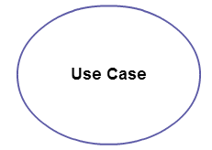

##### **System**

The system is used to **define the scope of the use case** and drawn as a rectangle. This an optional element but useful when you’re visualizing large systems. For example, you can create all the use cases and then use the system object to define the scope covered by your project. Or you can even use it to show the different areas covered in different releases.

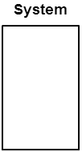

##### Package

The package is another optional element that is extremely useful in complex diagrams. Similar to [class diagrams](https://creately.com/diagram-type/class-diagram), packages are **used to group together use cases**. They are drawn like the image shown below.

[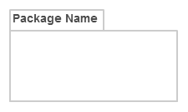](https://d3n817fwly711g.cloudfront.net/blog/wp-content/uploads/2014/03/Package1.png)

There can be 5 relationship types in a use case diagram:

* Association between actor and use case
* Generalization of an actor
* Extend between two use cases
* Include between two use cases
* Generalization of a use case

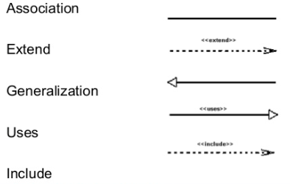

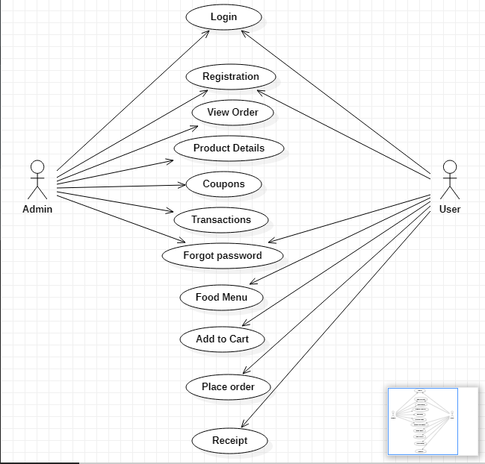

Figure :Use case diagram

**3.6.2 Sequence Diagram**

* UML Sequence diagrams are interaction diagrams that detail how operations are carried out. As sequence diagrams can be used to capture the interaction between objects in the context of a collaboration, one of the primary uses of sequence diagrams is in the transition from requirements expressed as use cases to the next and more formal level of refinement. Use cases are often refined into one or more sequence diagrams.
* Sequence diagrams are time focus and they show the order of the interaction visually by using the vertical axis of the diagram to represent time what messages are sent and when.

## Sequence Diagram Notations

### **Lifeline**

A lifeline represents an individual participant in the Interaction.

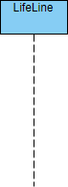

### **Actor**

An Actor a type of role played by an entity that interacts with the subject (e.g., by exchanging signals and data). An actor can also be an external to the subject (i.e., in the sense that an instance of an actor is not a part of the instance of its corresponding subject). They typically represent roles played by human users, external hardware, or other subjects.



### **Messages**

**Synchronous Message**  
A synchronous message requires a response before the interaction can continue. It's usually drawn using a line with a solid arrowhead pointing from one object to another.



**Asynchronous Message**  
Asynchronous messages don't need a reply for interaction to continue. Like synchronous messages, they are drawn with an arrow connecting two lifelines; however, the arrowhead is usually open and there's no return message depicted.



**Reply or Return Message**  
A reply message is drawn with a dotted line and an open arrowhead pointing back to the original lifeline.



**Self Message**  
A message an object sends to itself, usually shown as a U shaped arrow pointing back to itself.

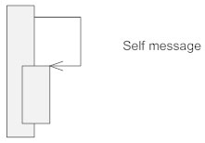

**Create Message**  
This is a message that creates a new object. Similar to a return message, it's depicted with a dashed line and an open arrowhead that points to the rectangle representing the object created.

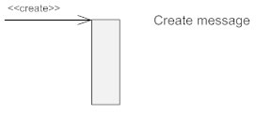

**Delete Message**  
This is a message that destroys an object. It can be shown by an arrow with an x at the end.

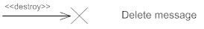

**Found Message**  
A message sent from an unknown recipient, shown by an arrow from an endpoint to a lifeline.

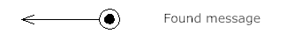

**Lost Message**  
A message sent to an unknown recipient. It's shown by an arrow going from a lifeline to an endpoint, a filled circle or an x.

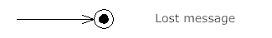

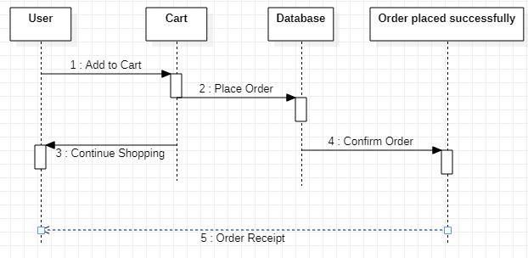

Figure :Sequence diagram

**3.6.3 Activity Diagram**

The Unified Modeling Language includes several subsets of diagrams, including structure diagrams, interaction diagrams, and behavior diagrams. **Activity diagrams**, along with use case and state machine diagrams, are considered behavior diagrams because they describe what must happen in the system being modeled.

Stakeholders have many issues to manage, so it's important to communicate with clarity and brevity. Activity diagrams help people on the business and development sides of an organization come together to understand the same process and behavior. You'll use a set of specialized symbols—including those used for starting, ending, merging, or receiving steps in the flow—to make an activity diagram, which we’ll cover in more depth within this activity diagram guide.

Basic components of an activity diagram

Before you begin making an activity diagram, you should first understand its makeup. Some of the most common components of an activity diagram include:

1. **Action**: A step in the activity wherein the users or software perform a given task.

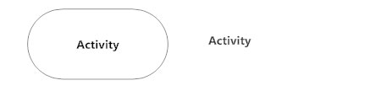

1. **Decision node**: A conditional branch in the flow that is represented by a diamond. When an activity requires a decision prior to moving on to the next activity, add a diamond between the two activities.



1. **Action flows**: Another name for the connectors that show the flow between steps in the diagram. Action flows, also called edges and paths, illustrate the transitions from one action state to another.

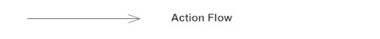

1. **Start point**: Symbolizes the beginning of the activity. The start point is represented by a black circle. For activity diagram using swim lanes, make sure the start point is placed in the top left corner of the first column.



1. **End point**: Represents the final step in the activity. The end point is represented by an outlined black circle. An arrow pointing to a filled circle nested inside another circle represents the final action state.

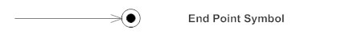

1. **Object Flow:** Object flow refers to the creation and modification of objects by activities. An object flow arrow from an action to an object means that the action creates or influences the object. An object flow arrow from an object to an action indicates that the action state uses the object.

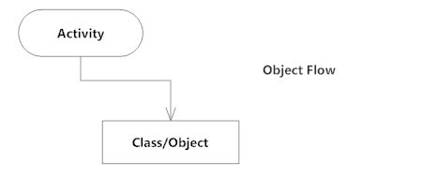

Admin side:

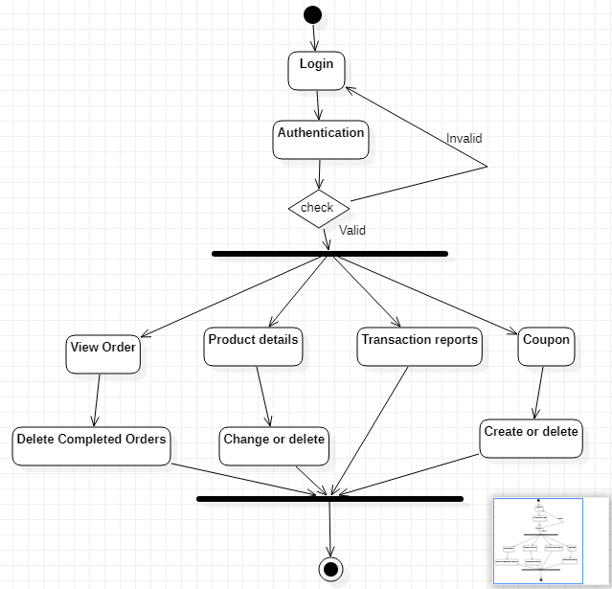

Figure :Activity diagram (admin)

User side:

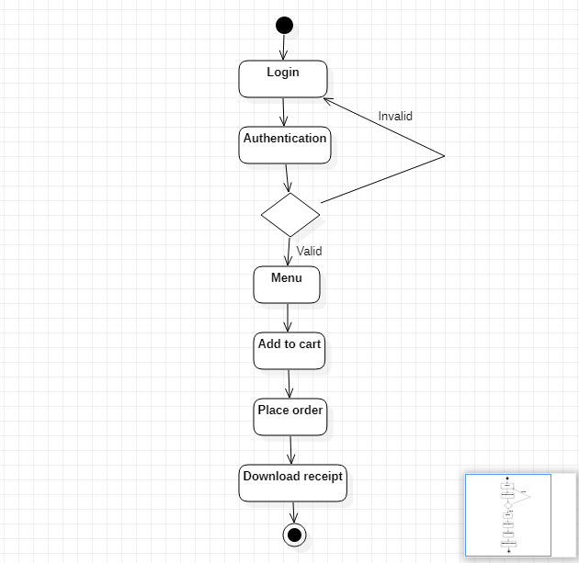

Figure :Activity diagram (user)

**3.6.4 Statechart Diagram**

* **State diagram** are used to capture the behaviour of a software system. UML State machine diagrams can be used to model the behaviour of a class, a subsystem, a package, or even an entire system. It is also called a Statechart or State Transition diagram.
* Statechart diagrams provide us an efficient way to model the interactions or communication that occur within the external entities and a system. These diagrams are used to model the event-based system. A state of an object is controlled with the help of an event.
* Statechart diagrams are used to describe various states of an entity within the application system.

**Purpose of Statechart diagram**

* Statechart diagram is used to capture the dynamic aspect of a system. State machine diagrams are used to represent the behavior of an application. An object goes through various states during its lifespan. The lifespan of an object remains until the program is terminated. The object goes from multiple states depending upon the event that occurs within the object. Each state represents some unique information about the object.
* Statechart diagrams are used to design interactive systems that respond to either internal or external event. Statechart diagram visualizes the flow of execution from one state to another state of an object.
* It represents the state of an object from the creation of an object until the object is destroyed or terminated.

## Notation and Symbol for State Machine

### **Initial state**

The initial state symbol is used to indicate the beginning of a state machine diagram.

### **Final state**

This symbol is used to indicate the end of a state machine diagram.

### **Decision box**

It contains a condition. Depending upon the result of an evaluated guard condition, a new path is taken for program execution.

### **Transition**

A transition is a change in one state into another state which is occurred because of some event. A transition causes a change in the state of an object.

### **State box**

It is a specific moment in the lifespan of an object. It is defined using some condition or a statement within the classifier body. It is used to represent any static as well as dynamic situations.

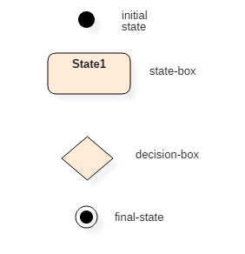

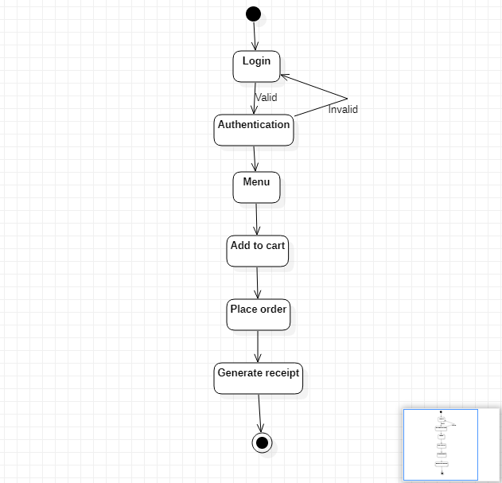

Figure :Statechart diagram

**3.7** **SDLC MODEL : Iterative Model**

Software Development Life Cycle is extremely vast and full of various development and testing activities, methodologies, techniques, tools, and more. It engages strong planning as well as management, computation, plan, and preparation. After completing all the cycles and iterations as per requirements, the application gets developed successfully.

An iterative life cycle model does not start with a full specification of requirements. In this model, the development begins by specifying and implementing just part of the software, which is then reviewed in order to identify further requirements. Moreover, in iterative model, the iterative process starts with a simple implementation of a small set of the software requirements, which iteratively enhances the evolving versions until the complete system is implemented and ready to be deployed. Each release of Iterative Model is developed in a specific and fixed time period, which is called iteration.

Furthermore, this iteration focuses on a certain set of requirements. Each cycle ends with a usable system i.e., a particular iteration results in an executable release. Iterative Model allows accessing previous phases, in which the changes are made accordingly. The final output of the product is revived at the end of the Software Development Life Cycle**.** Typically iterative development is used in conjunction with incremental development, in which a longer software development cycle is split into smaller segments that are built upon each other. Hence, iterative model is used in following scenarios:

## Process of Iterative Model:

The process of Iterative Model is cyclic, unlike the more traditional models that focus on a rigorous step-by-step process of development. In this process, once the initial planning is complete, a handful of phases are repeated again and again, with the completion of each cycle incrementally improving and iterating on the software. Other phases of the iterative model are described below:

1. Planning Phase**:** This is the first stage of the iterative model, where proper planning is done by the team, which helps them in mapping out the specifications documents, establish software or hardware requirements and generally prepare for the upcoming stages of the cycle.
2. Analysis and Design Phase**:** Once the planning is complete for the cycle, an analysis is performed to point out the appropriate business logic, database models and to know any other requirements of this particular stage. Moreover, the design stage also occurs in this phase of iterative model, where the technical requirements are established that will be utilized in order to meet the need of analysis stage.
3. Implementation Phase**:** This is the third and the most important phase of the iterative model. Here, the actual implementation and coding process is executed. All planning, specification, and design documents up to this point are coded and implemented into this initial iteration of the project.
4. Testing Phase**:** After the current build iteration is coded and implemented, testing is initiated in the cycle to identify and locate any potential bugs or issues that may have been in the software.
5. Evaluation Phase**:** The final phase of the Iterative life cycle is the evaluation phase, where the entire team along with the client, examine the status of the project and validate whether it is as per the suggested requirements.

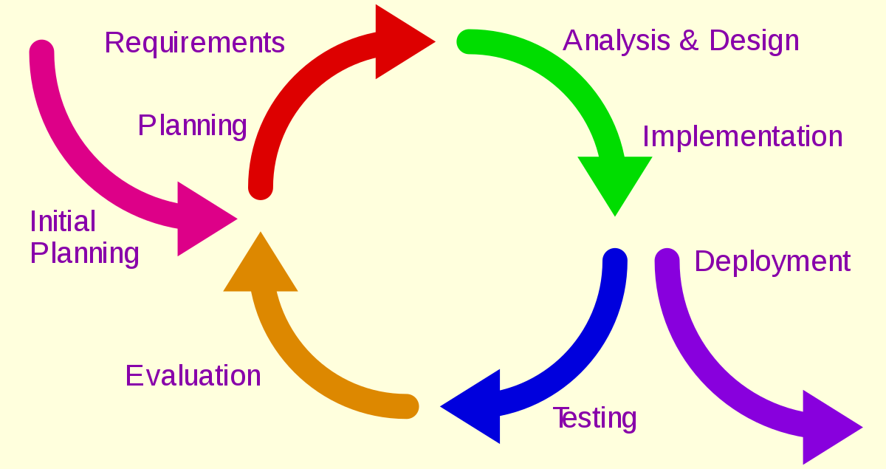

Figure :SDLC Model

|  |  |
| --- | --- |
| **Advantages** | **Disadvantages** |
| Some working functionality can be developed and early in the software development life cycle | More resources may be required. |
| It is easily adaptable to the ever changing needs of the project as well as the client. | More management attention is required. |
| It is more cost effective to change the scope or requirements in Iterative model. | Although cost of change is lesser, but it is not very suitable for changing requirements. |
| Parallel development can be planned. | Project progress is highly dependent upon the risk analysis phase. |

Table :Advantages/disadvantages of SDLC model

**3.8 Basic Modules**

A module is a software component or part of a program that contains one or more routines. One or more independently developed modules make up a program. A software application may contain several different modules, and each module serves unique and separate business operations.

**Module 1: Admin**

* Admin registration: This is a registration page for the admin. It contains various validations and captcha to prevent bots. The password entered will be encrypted before saving it to database.
* Admin login: This will be login for the admin who will receive the orders and maintain them. It will also contain a forgot password method where admin can send forgotten password to their email. The password will be decrypted here.
* View orders: this will display the orders made by the users. The admin can then delete the orders after they are completed.
* Product details: Admins can view the products and change their price or delete the product. They can also include new products.
* Coupons: Admins can create or delete coupons.
* Reports: Admins can view the monthly payments or payments till date. They can also view the details of the registered users and staff.
* Feedback: Admins can view the feedback sent by the user and reply to them.

**Module 2: User**

* User registration: This is a registration page for new users. It contains various validations and captcha to prevent bots. The password entered will be encrypted before saving it to database.
* User login: This will be login for the users. The password will be decrypted here. This is further divided into 2 parts:
  + - * Student login: Login designed for students.
      * Staff login: Login designed for staff.
* Forgot password: this will help the user access their forgotten passwords.
* Menu: This will display the menu.
* Order: Users can add one or multiple items of their choice to the cart. They can view products in order of price or recommendations. They can also search for the food they want and related results will be shown.
* Place order: Users can then place their order and checkout. The time at which they will collect their item is entered.
* Coupons: Users can use coupons to avail discounts.
* Receipt: Users can then download the receipt and show it when they collect their order.
* Feedback: Users can send their feedback or complaints to the admin. They can also view the reply sent by the admin.

**3.9 Data Design**

**3.9.1 Integrity Constraints**

* ID is the primary key (only one primary key) in the student module.
* Fullname is the primary key in admin and staff module.
* Foreign key i.e. ID provides a link between data in two tables.
* Unique Column Values is a unique value rule defined on a column (or set of columns)

allows to insert or update a row only if it contains a unique value in that column (or

set of columns).

**3.9.2 Algorithm:**

User side:

1. This system allows the students to order food online.
2. The users can view the menu and prepare their order.
3. The users can choose one or multiple items and place it in their cart.
4. The users can then place their order by specifying the time they will pick up the order.
5. If they have a coupon code, they can use it to get discounts.
6. After placing the order, the user will download the receipt generated and collect their order according to their order number.
7. They can give their feedback and also check for the reply.

Admin side:

1. This system will allow the admin to view all the orders or a particular order.
2. The admin can then prepare the orders according to the timings given.
3. After the order is delivered, the admin can delete the order.
4. The admin can then check the details of the products available and change their price or delete the items.
5. The admins can check the transactions placed till date and get reports. They can also view the details of the registered users.
6. The admin can create or delete coupons.
7. They can check the feedback sent by the users and give their reply.

**3.10 Business Rules:**

1. Registration:

* Only the current students studying in St. Andrews College of Arts, Science and Commerce and staff can create an account.
* Students from FYJC, SYJC and all degree courses can create their accounts.
* They must submit their roll number while registration.
* Captcha will be present to prevent illegal entries or bot entries.

2. Order:

* Orders should be made atleast an hour before collecting them.
* Users must download the receipt generated after placing the order.
* Users must show the order id in the receipt to the canteen staff to obtain their order.
* Items should be collected within the time mentioned by the user.
* Orders once placed cannot be deleted.
* Coupons will be be applicable only till their validity date.

3. Forgot Password

* User must enter the same mobile number or email address entered during registration.
* Only then will the password be sent to the user.

4. Feedback

* To view the feedback reply given by the admin, users must enter the feedback id given at the time of feedback.

**3.11 Test cases:**

The list of items that need to be tested are:

* Admin/User login
* Admin/User registration
* Forgot Password
* Coupon code
* Search box
* Feedback reply

|  |  |
| --- | --- |
| **Module** | Admin/User login |
| **Purpose** | To check if the admin or user is registered. |
| **Incorrect input** | Incorrect combination of username or password |
| **Result** | A notification appears on the screen that indicates the invalid username or password. |
| **Correct input** | Valid username and the matching password |
| **Result** | The user is directed to the main page. |

Table :Test case 1

|  |  |
| --- | --- |
| **Module** | Admin/User registration |
| **Purpose** | To create an account for a new user or admin. |
| **Incorrect input** | Incorrect format entered in the input fields for the  registration page. |
| **Result** | A notification appears on the screen that indicates incorrect input format in the fields. |
| **Correct input** | The correct format entered by the user into the  input fields of the registration page. |
| **Result** | Successful registration of the user or admin |

Table :Test case 2

|  |  |
| --- | --- |
| **Module** | Forgot Password |
| **Purpose** | To send forgotten password to user email address or phone number mentioned during registration. |
| **Incorrect input** | Different email address or phone number from the one registered is entered. |
| **Result** | A notification appears on the screen that indicates invalid email address or phone number is entered. |
| **Correct input** | Email address or phone number entered matches the email address or phone number entered during registration. |
| **Result** | The password is sent to email address or phone number entered. |

Table :Test case 3

|  |  |
| --- | --- |
| **Module** | Coupon code |
| **Purpose** | To avail discount using a coupon. |
| **Incorrect input** | Incorrect coupon code is entered. |
| **Result** | A notification appears on the screen that indicate that the coupon code entered is invalid. |
| **Correct input** | Correct coupon code is entered. |
| **Result** | Discount on the original price is availed. |

Table :Test case 4

|  |  |
| --- | --- |
| **Module** | Search box |
| **Purpose** | To find particular food items. |
| **Incorrect input** | Invalid keyword entered. |
| **Result** | No food item is returned |
| **Correct input** | Valid keyword entered. |
| **Result** | Appropriate food items are displayed. |

Table :Test case 5

|  |  |
| --- | --- |
| **Module** | Feedback reply. |
| **Purpose** | To get the reply to the feedback sent by admin. |
| **Incorrect input** | Invalid feedback id entered. |
| **Result** | Feedback id not found message appears |
| **Correct input** | Valid feedback id entered. |
| **Result** | Status and reply of the feedback is shown. |

Table :Test case 6

**3.12 Security Issues**

* If a User ID is known by an unauthorized individual, he/she can easily attack the system.
* No limit on the number of unsuccessful login attempts.
* Users can view any other users account, if he/she knows the credentials of that

particular user.

**3.13 Software Quality**

Quality control is a set of methods used by organizations to achieve quality parameters or

quality goals and continually improve the organization's ability to ensure that a software

product will meet quality goals.

The total quality control process consists of:

* Plan - It is the stage where the Quality control processes are planned
* Do - Use a defined parameter to develop the quality
* Check - Stage to verify if the quality of the parameters are met
* Act - Take corrective action if needed and repeat the work

**Quality control from user point of view**:

1. Reliability: The product created should be reliable so that the user can fully trust

the product. It should work in various conditions and different types of browsers

effortlessly without causing problems for the user. This website works on

all browsers efficiently.

2. Security: The product must contain security that will help ensure that the data of

the user is secure from malicious attacks and hacking. The user’s data in the database

is completely safe and cannot be viewed by other users.

**Quality control from developer point of view:**

1. Usability: It is the job of the developer to ensure that the product created is easy

to understand and can be easily used by someone who is not well aware with

software. The interface should be very attractive and also the overall product should

be easy to use.

2. Maintainability: The product should be maintained by the developer and any

changes required should be provided with updates. The developers should ensure that

the product created is maintained every now and then.

**4. Implementation And Testing**

**4.1 Implementation Approach: Spiral Model**

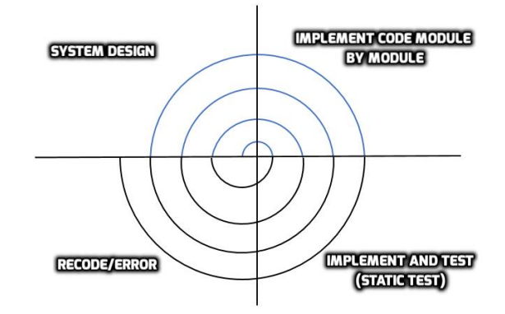

Figure :Spiral model

**System Design:**

The modules of this project were identified. The entire project was divided into basic modules and these modules were further divided into other modules. A rough design of how the website should look was made. The overall palette was decided.

**Implement Code module by module:**

First, coding for login and registration modules were done. This was followed by developing other modules and then integrating them together. The user interface was developed after all the coding was done. Pages like add to cart and place order contained more codes compared to other pages.

**Implement and test:**

After a module was developed , it was first tested if it module was working properly or not and then was integrated with other modules in the subsequent spiral and was integration testing was done. After

integration test, the whole system was tested. This phase also included testing the database connectivity with respect to the modules.

**Recode/Error:**

Many coding errors were found while testing. In the add to cart page, coding errors were found when coupon code was added. This was rectified by further modifying the code to obtain the grand total after applying the coupon code. There were issues with creating an order id which was later rectified. and there were some minute errors in the other pages that were reworked. Then the first step of the spiral model was started again and the errors were reduced and the quality of the website was improved.

**4.2 Code And Efficiency**

* The login was done without session variables. This was later rectified by introducing session variables to login.
* Registration page would take any values which would cause errors while entering these values in the database. This was rectified using validation controls.
* There were errors while trying to obtain the grand total price after applying a coupon code. This was rectified was modifying the code.
* To make each order id unique, a particular pattern was created of time and random numbers and letters for each order.
* There were issues when transferring variables from one page to the other. This was rectified by continuous monitoring of the variables sent from one page to the other.
* Insert, delete and update functions were used so that the admins could modify the product list. This change will be reflected all throughout the website.

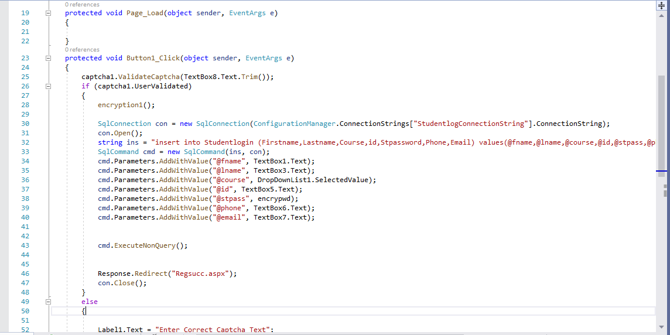

Figure :Student registration

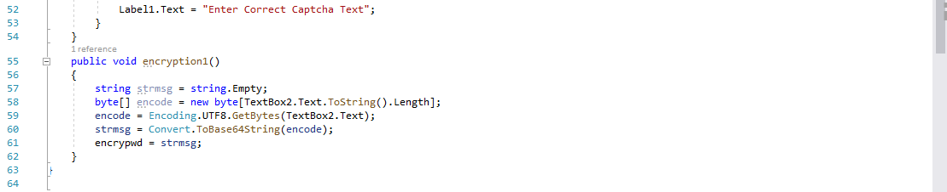

Figure :Encryption of password

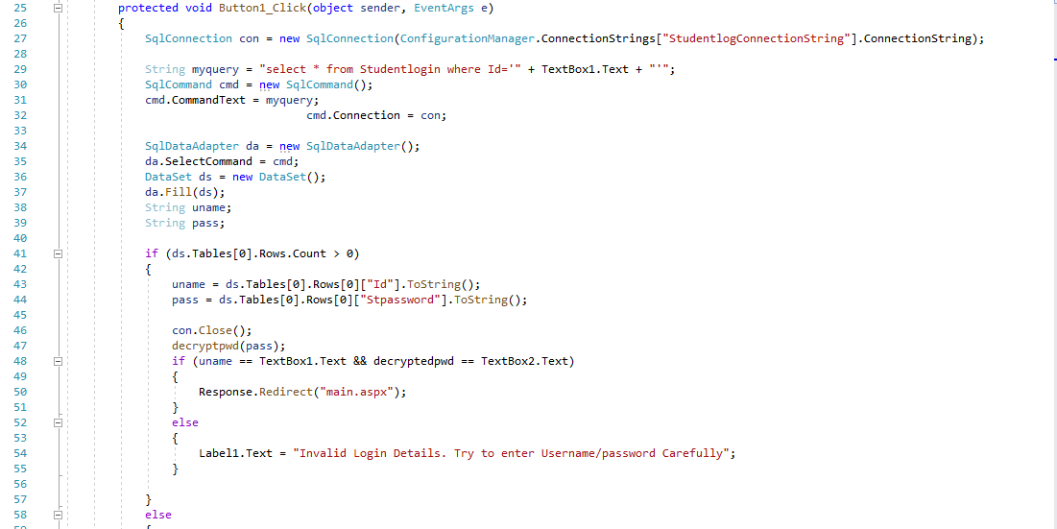

Figure :Student login

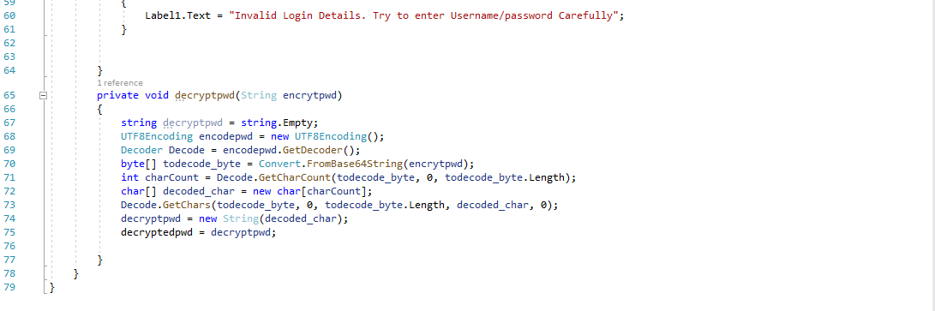

Figure :Password decryption

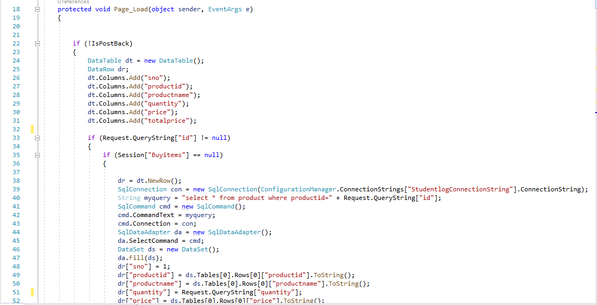

Figure :Add to cart(1)

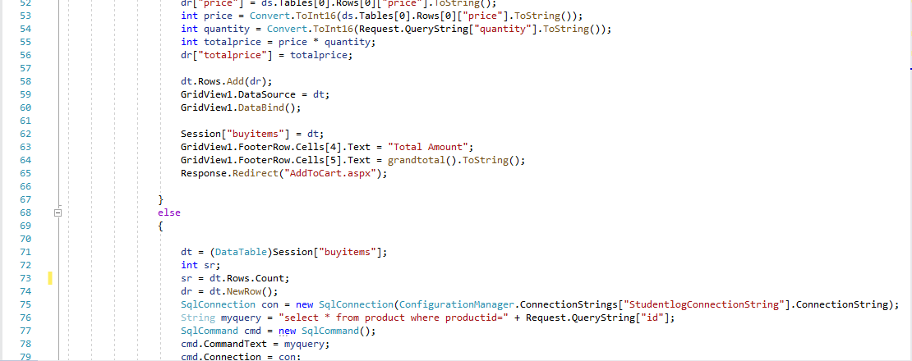

Figure :Add to cart(2)

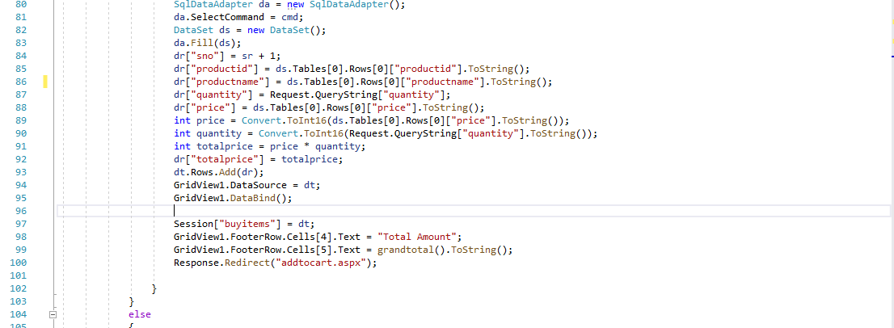

Figure :Add to cart(3)

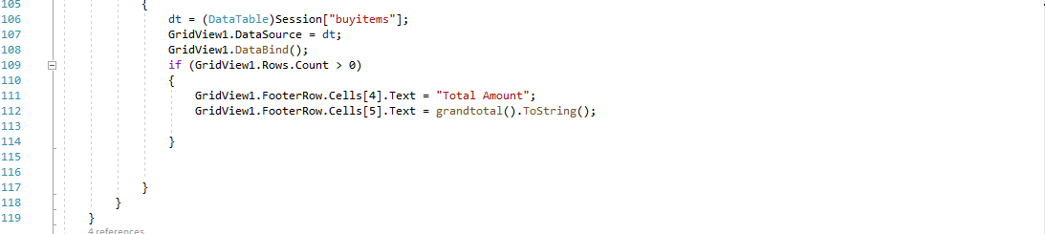

Figure :Add to cart(4)

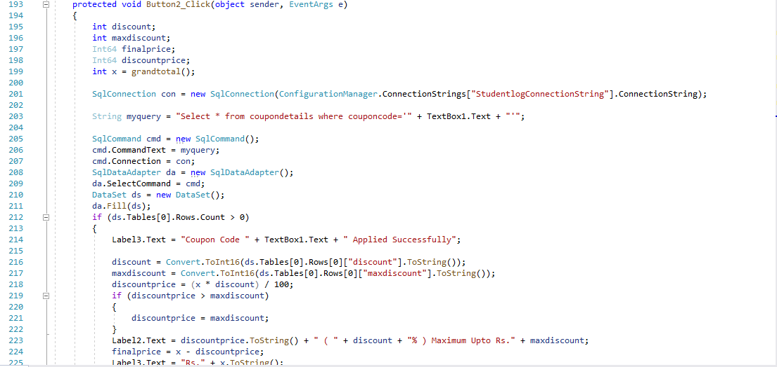

Figure :Application of coupon(1)

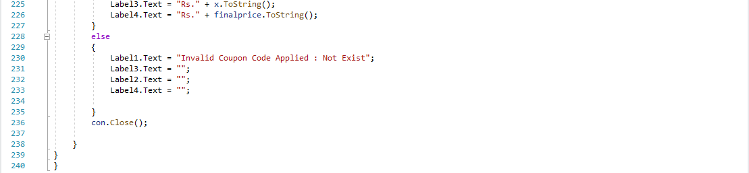

Figure :Application of coupon(2)

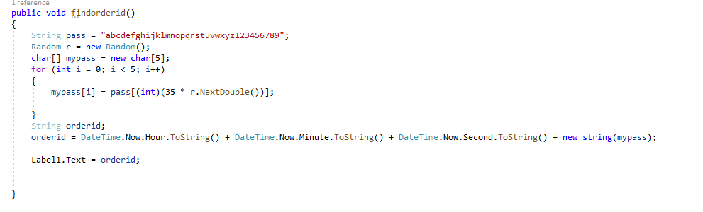

Figure :Get order id

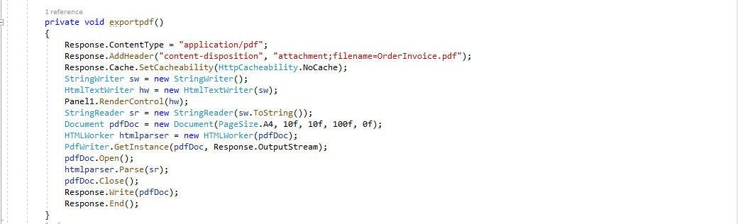

Figure :Create pdf of receipt

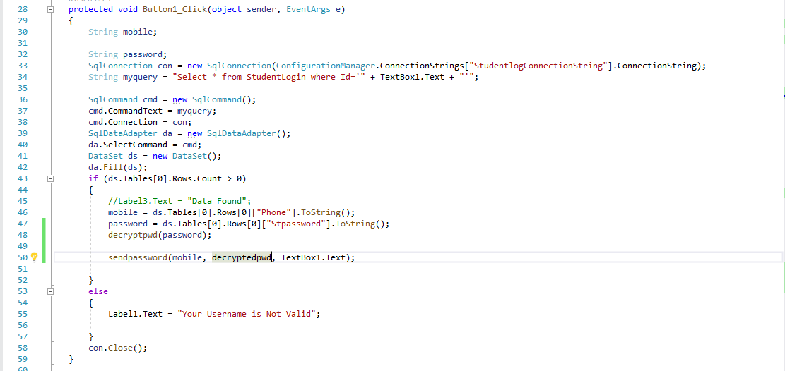

Figure :Send forgotten password to user's mobile number(1)

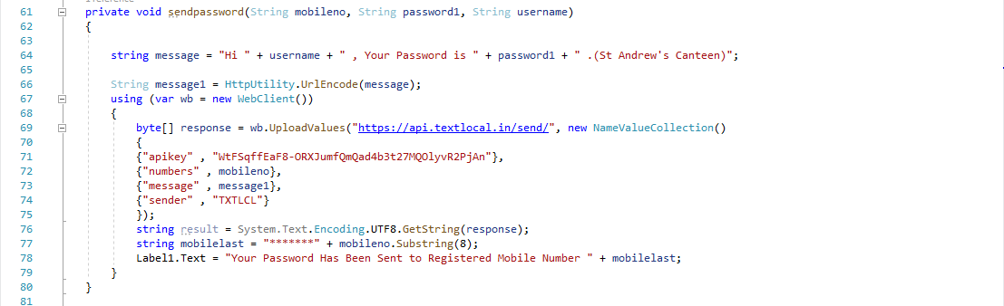

Figure :Send forgotten password to user's mobile number(2)

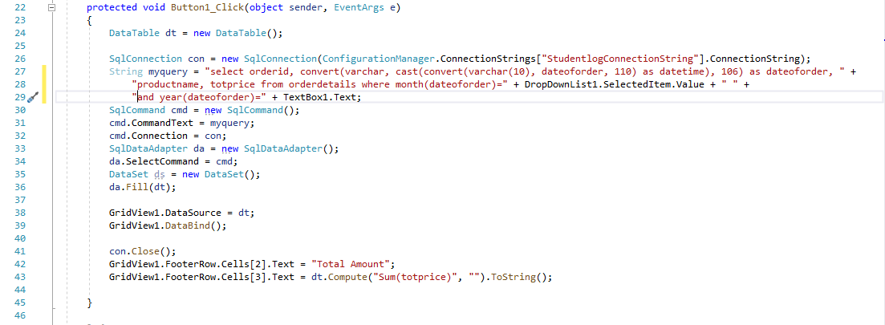

Figure :Get transaction details of a particular month

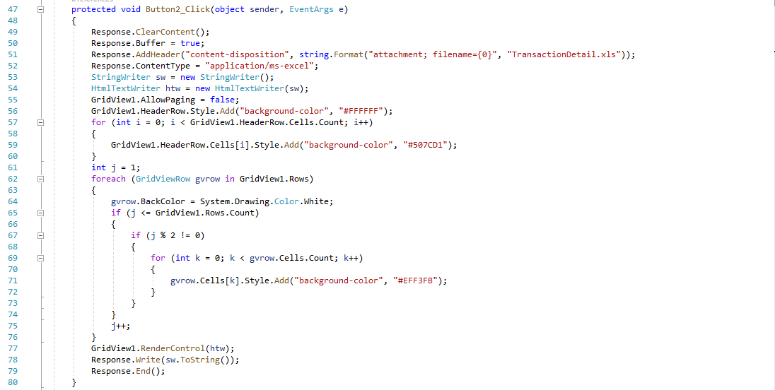

Figure :Convert transaction details to an excel file

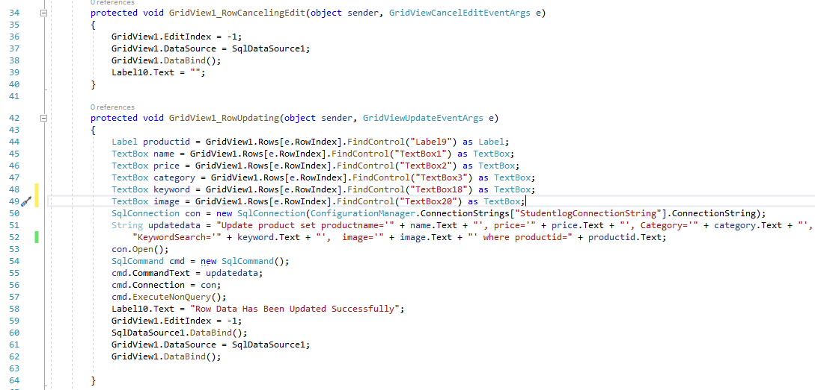

Figure :Update and delete stock details

**4.3 Testing Approach**

**4.3.1 Early testing**

Early testing involves making use of the data that has been gathered through

surveys and questionnaires which helps the developers to build the application according to

what the user specifies.

The requirement gathered through the questionnaire has been analyzed and the

various requirements which can be implemented is checked and which cannot be

implemented is also checked.

**4.3.2 Unit testing**

1. Admin module

* Pages like admin login, admin registration, order details, product details, transactions and reports were developed.
* Login page facilitates registered admin to login to their page and view their profile.
* Registration page facilitates an admin to register themselves.
* Admin can view the orders with the order details page.
* Admin can view, update or delete product details from product page.
* They can view the transactions and reports.

2. User module

* Pages like user login, user registration, menu, add to cart, place order, placed successfully etc were developed.
* Login page facilitates registered user to login to their page and view their profile.
* Registration page facilitates a user to register themselves.
* A user can add products to their cart using add to cart page.
* They can further place order and download the receipt from place order and placed successfully pages respectively.

**4.3.3 Integration testing**

Integrated all the above modules on the one home page.

**4.3.4 System testing**

* Operational Testing: Operational testing ensures system and component compliance in the application's standard operating environment. A key operational testing feature is error detection, which ensures correct functional implementation. Websites works in all types of browsers.
* Functional Testing: **Functional testing** is a type of software testing that validates the software system against the functional requirements/specifications. The purpose of Functional tests is to test each function of the software application, by providing appropriate input, verifying the output against the Functional requirements. It involves Testing the whole system and checking for any bugs and errors.
* Security Testing: Security tests involve checks to verify the proper performance of

system access and data access mechanisms.

* Usability Testing: **Usability testing** is a type of testing done from an end-user’s perspective to determine if the system is easily usable.. It is done to verify that the system is easy to use and that the user interface appearance is appealing. Test engineer needs to evaluate the application from the prospective of the end user.

**4.3.5 Acceptance testing**

**White Box testing**

**White Box Testing**is testing of a software solution's internal structure, design, and coding. In this type of testing, the code is visible to the tester. It focuses primarily on verifying the flow of inputs and outputs through the application, improving design and usability, strengthening security.

White box testing involves the testing of the software code for the following:

* Internal security holes
* Broken or poorly structured paths in the coding processes
* The flow of specific inputs through the code
* Expected output
* The functionality of conditional loops
* Testing of each statement, object, and function on an individual basis

The testing can be done at system, integration and unit levels of software development. One of the basic goals of whitebox testing is to verify a working flow for an application. It involves testing a series of predefined inputs against expected or desired outputs so that when a specific input does not result in the expected output, you have encountered a bug.

|  |  |
| --- | --- |
| **Advantages** | **Disadvantages** |
| * Code optimization by finding hidden errors. | * White box testing can be quite complex and expensive. |
| * White box tests cases can be easily automated. | * Developers who usually execute white box test cases detest it. The white box testing by developers is not detailed can lead to production errors. |
| * Testing is more thorough as all code paths are usually covered. | * White box testing requires professional resources, with a detailed understanding of programming and implementation. |

Table :Advantages/disadvantages of White Box Testing

**Black box testing**

**Black Box Testing** is defined as a testing technique in which functionality of the Application Under Test is tested without looking at the internal code structure, implementation details and knowledge of internal paths of the software. This type of testing is based entirely on software requirements and specifications. In BlackBox Testing we just focus on inputs and output of the software system without bothering about internal knowledge of the software

This method is named so because the software program, in the eyes of the tester, is like a black box; inside which one cannot see. This method attempts to find errors in the following categories:

* Incorrect or missing functions
* Interface errors
* Errors in data structures or external database access
* Behavior or performance errors
* Initialization and termination errors

|  |  |
| --- | --- |
| **Advantages** | **Disadvantages** |
| * Tests are done from a user’s point of view and will help in exposing discrepancies in the specifications. | * Only a small number of possible inputs can be tested and many program paths will be left untested. |
| * Tester need not know programming languages or how the software has been implemented. | * Without clear specifications, which is the situation in many projects, test cases will be difficult to design. |
| * Test cases can be designed as soon as the specifications are complete. | * Tests can be redundant if the software designer/developer has already run a test case. |

Table :Advantages/disadvantages of Black Box Testing

**4.4 User Interface**

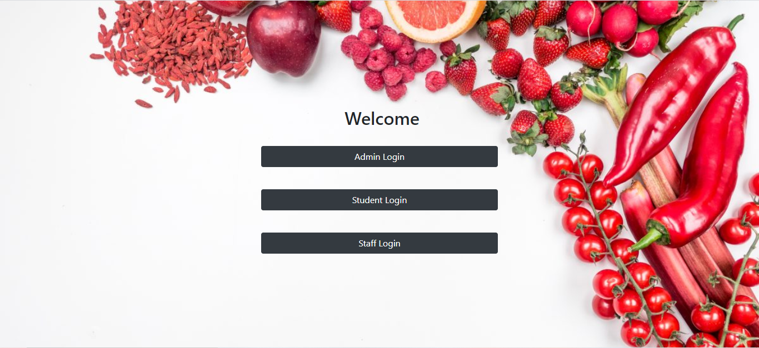

Figure :Welcome page

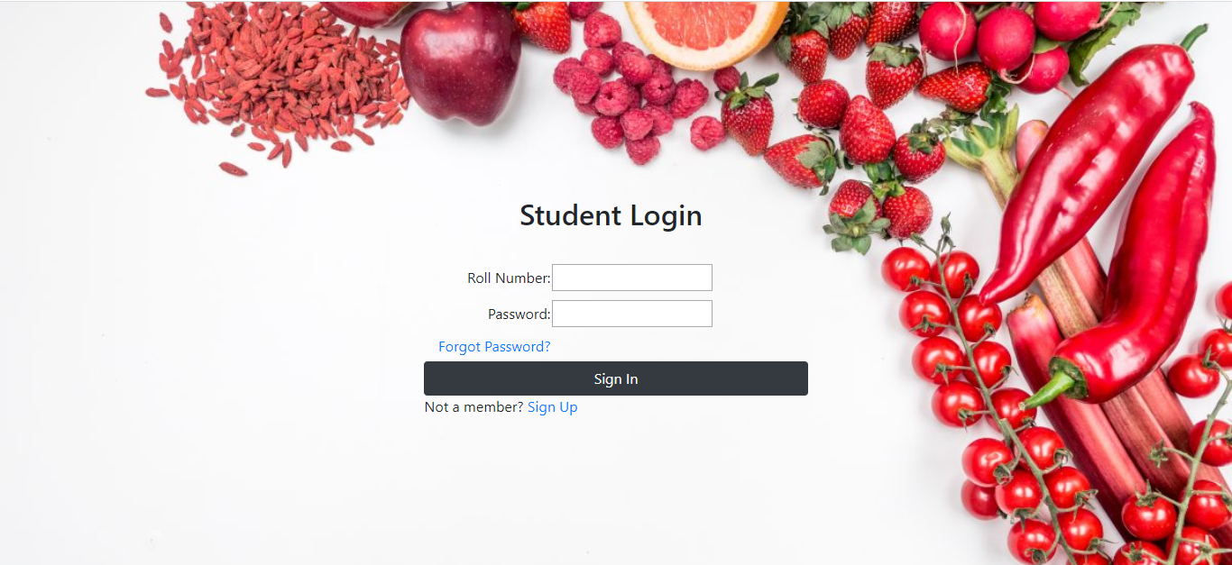

Figure :Student Login

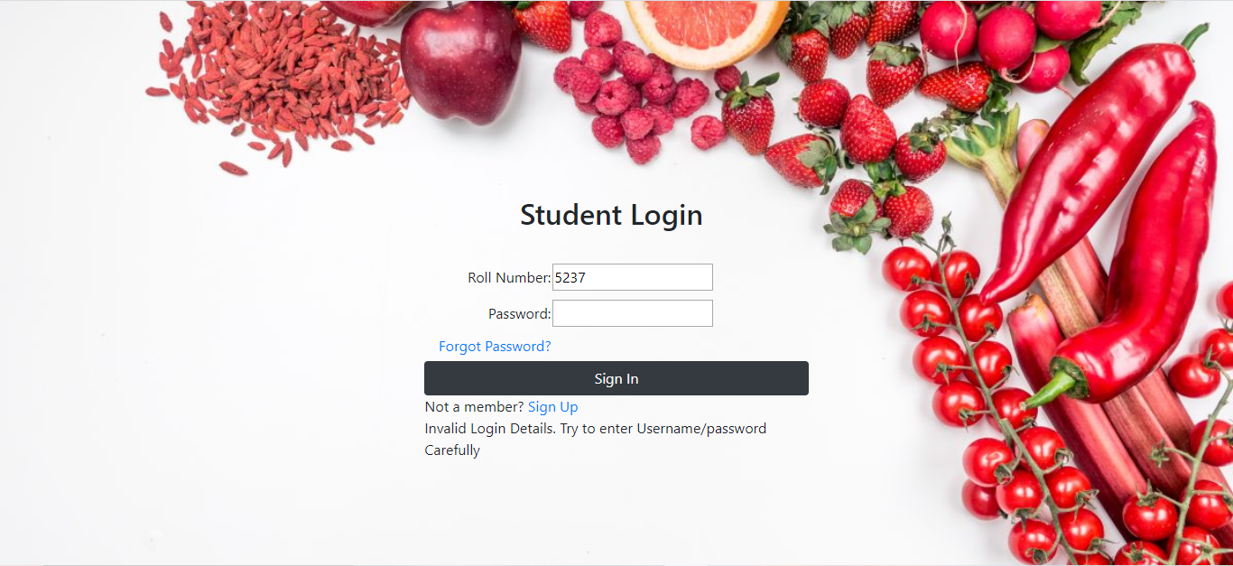

Figure :Invalid login details

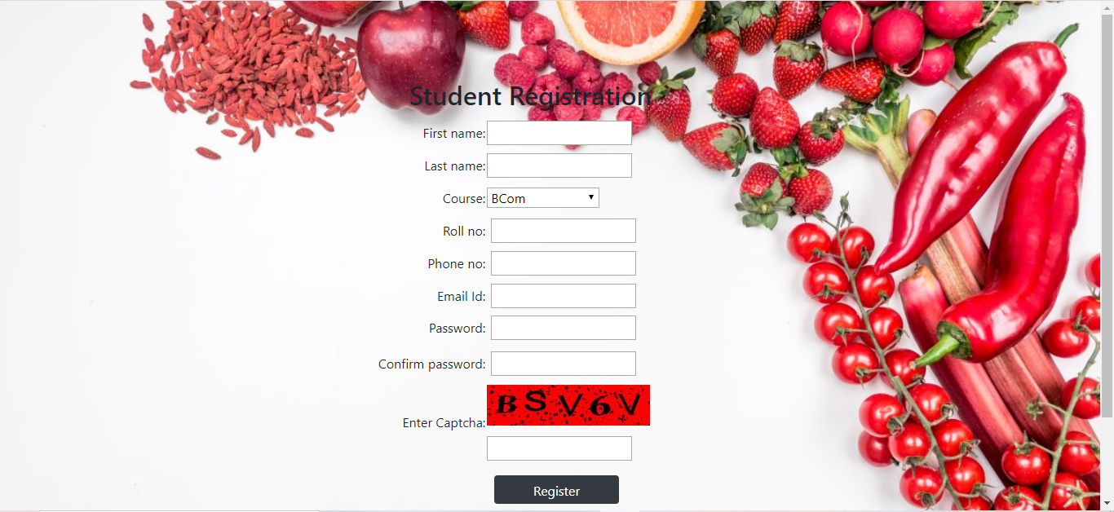

Figure :Student registration

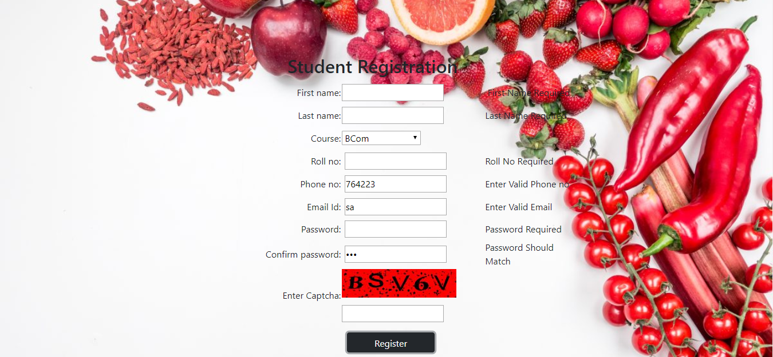

Figure :Student registration(Validation controls)

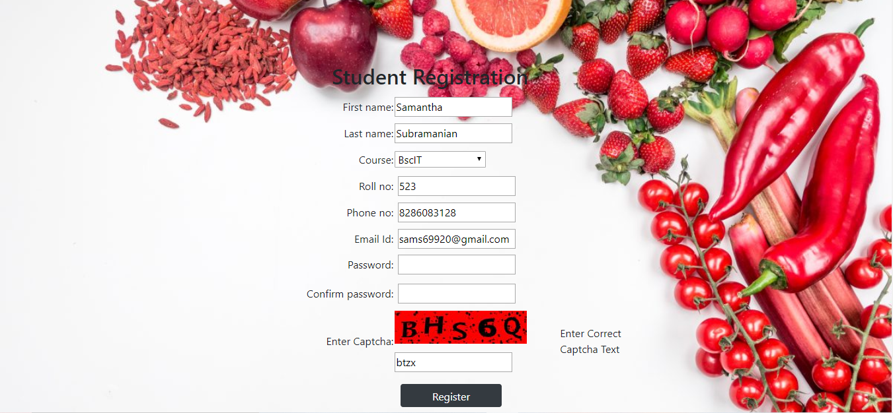

Figure :Student registration(Incorrect captcha)

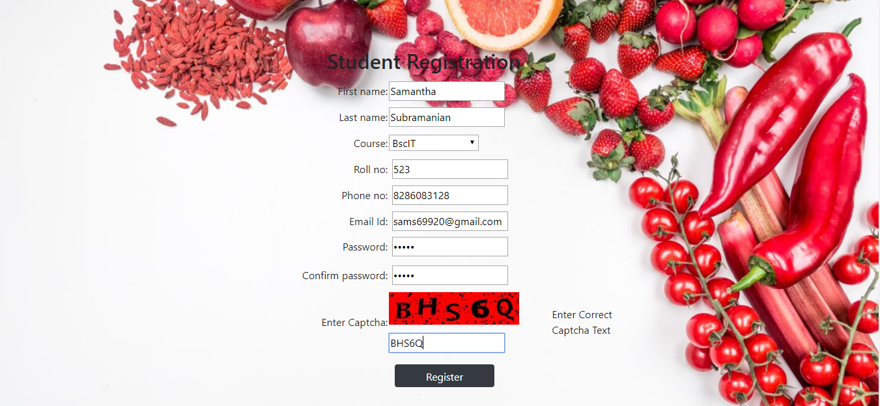

Figure :Student registration(correct captcha)

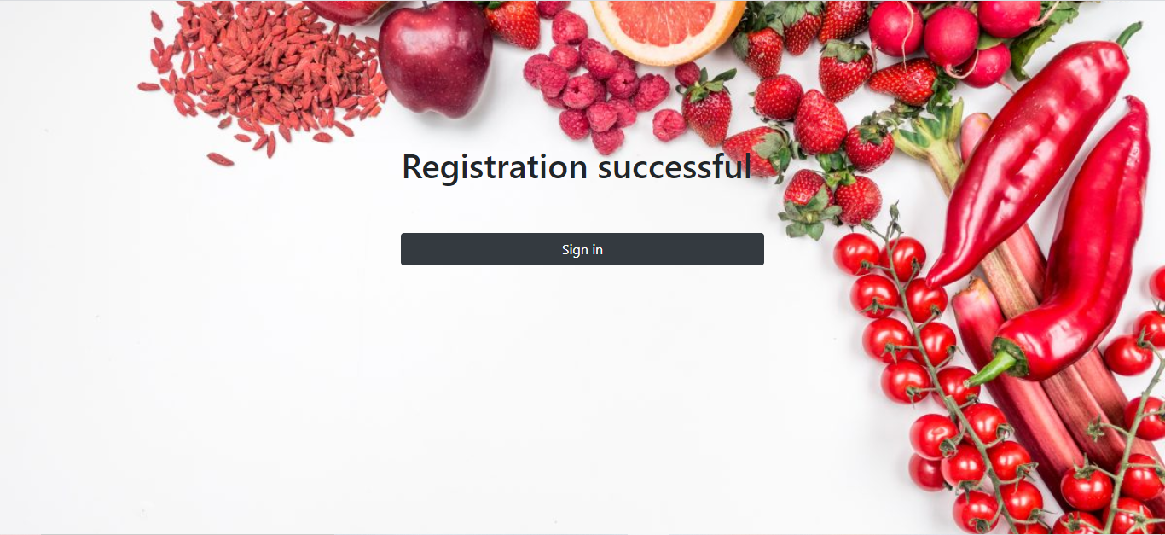

Figure :Registration successful

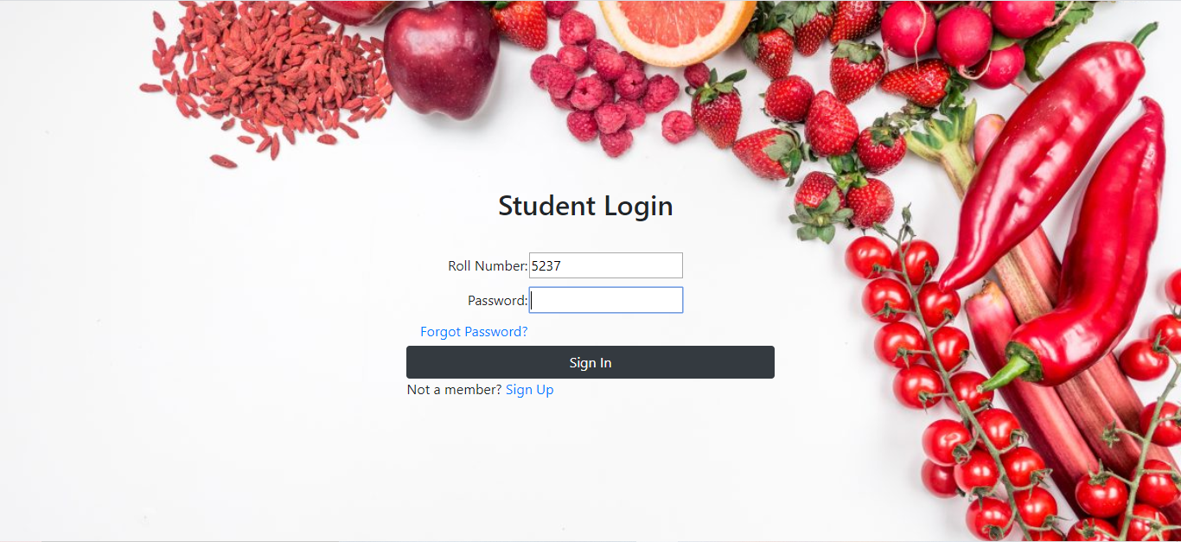

Figure :Student login

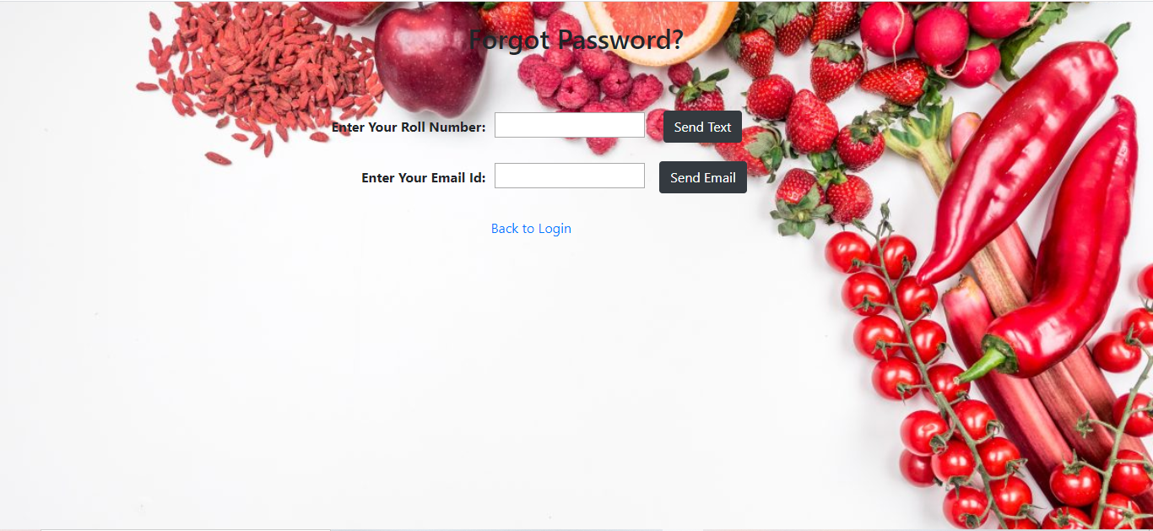

Figure :Forgot password

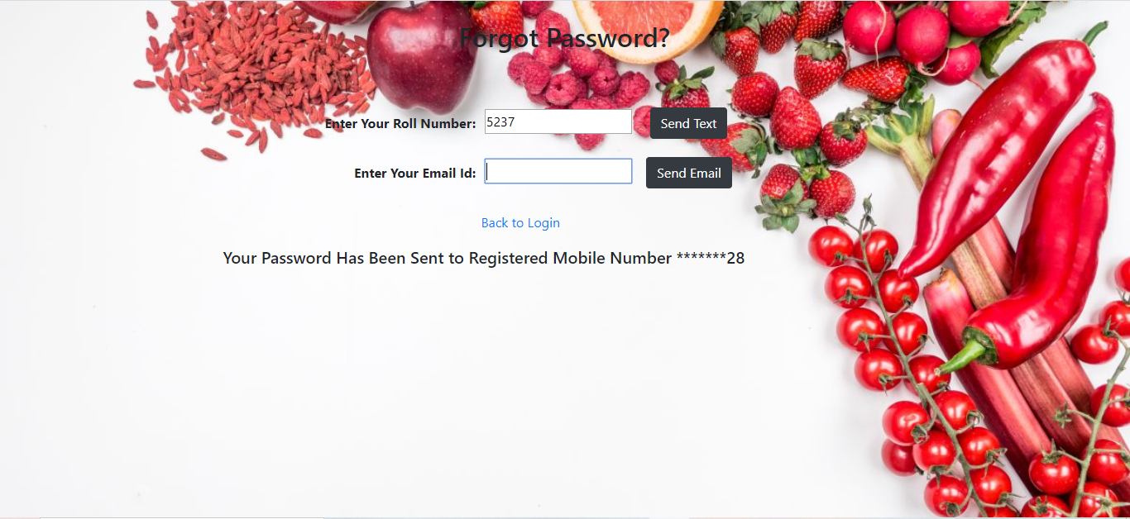

Figure :Send password to registered mobile number

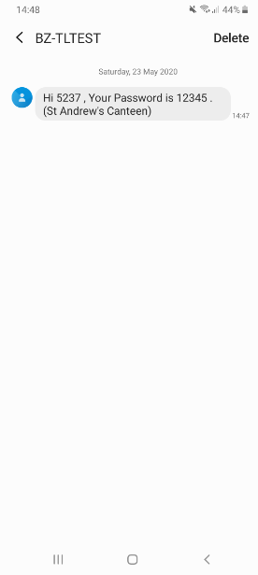

Figure :Message sent to registered mobile number

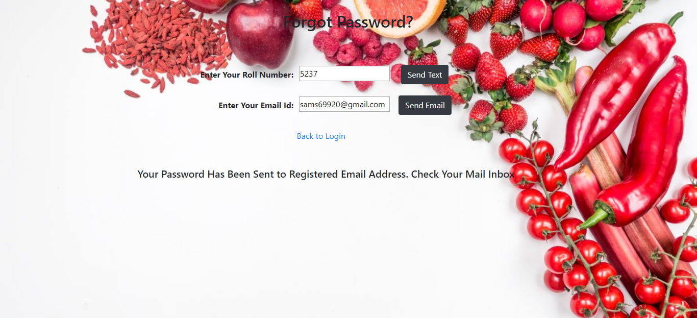

Figure :Send password to registered email address

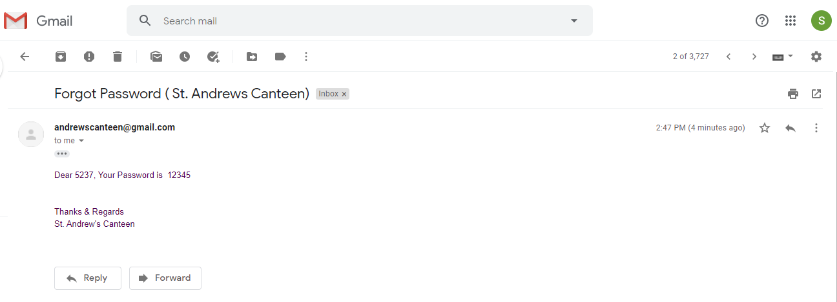

Figure :Email sent to registered email address

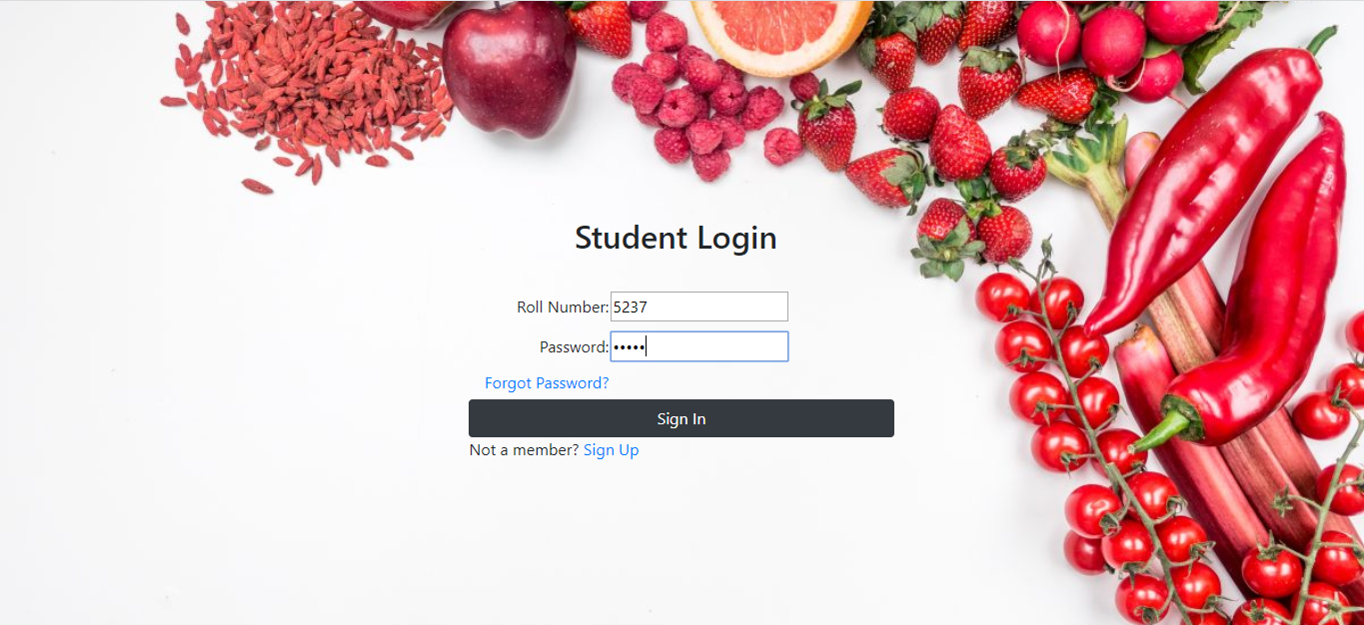

Figure :Student login

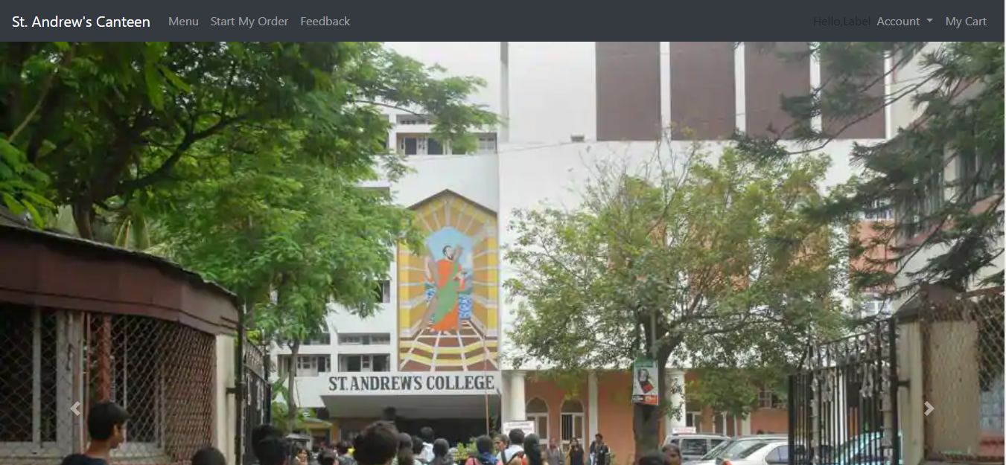

Figure :Student Home page

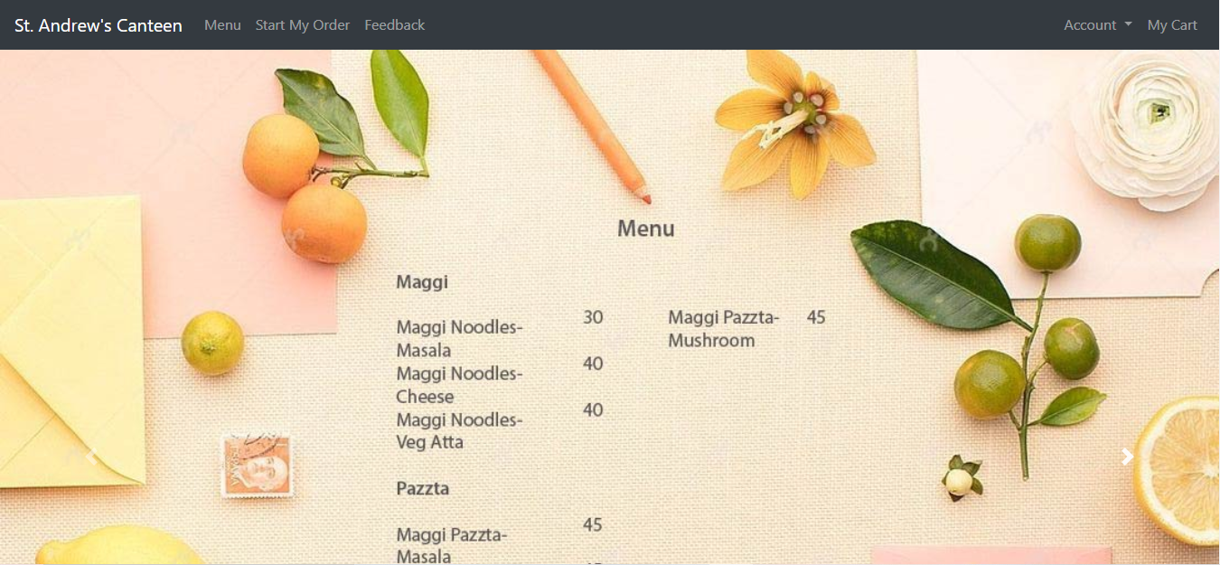

Figure :Menu(1)

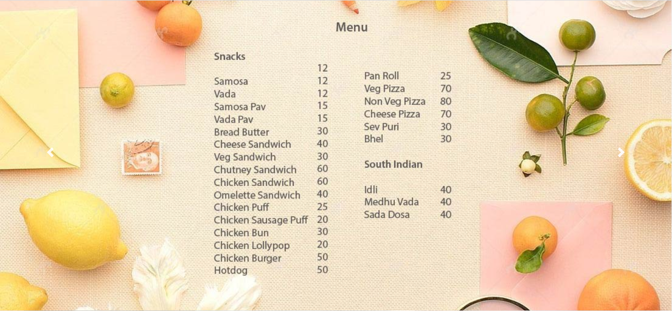

Figure :Menu(2)

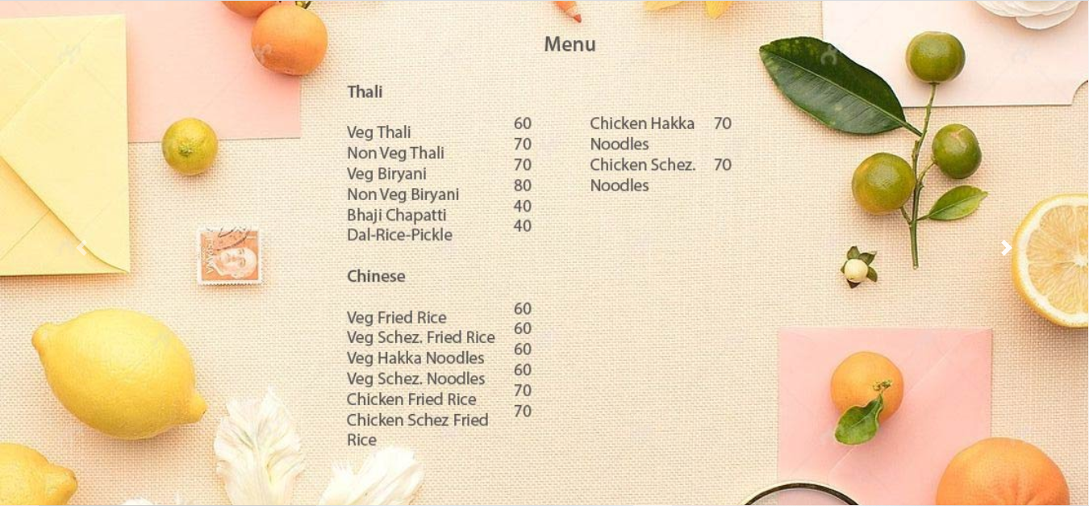

Figure :Menu(3)

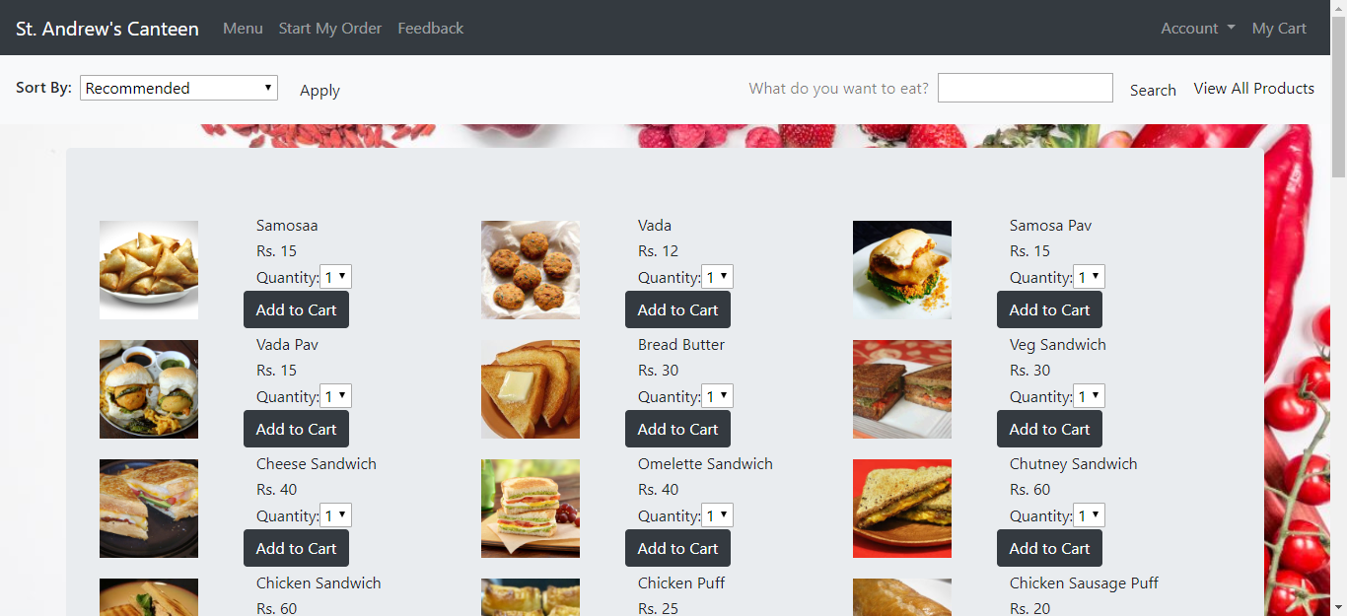

Figure :Start my order(1)

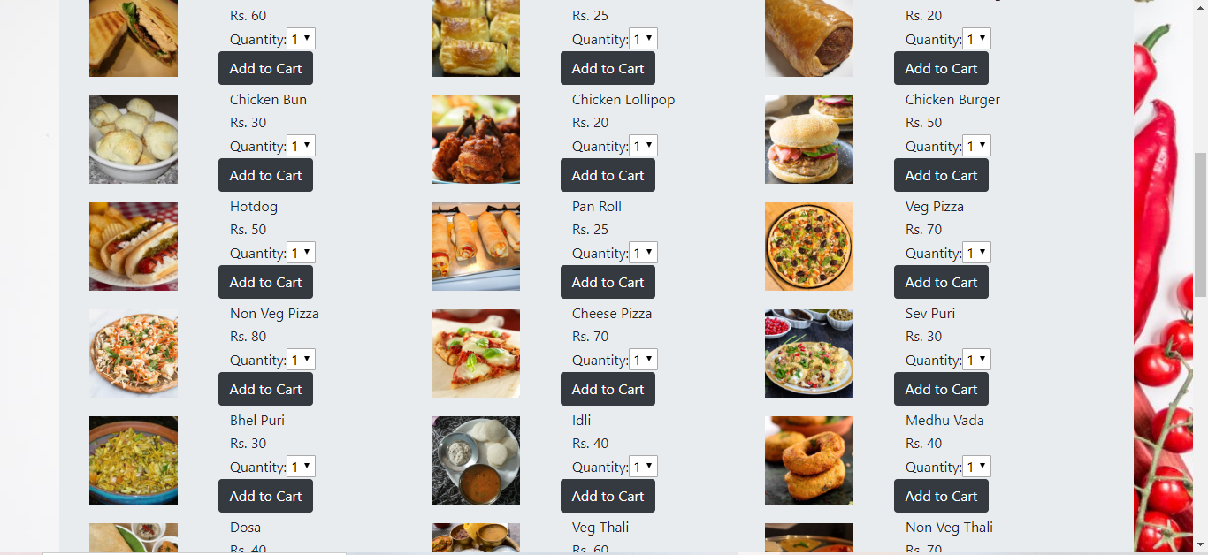

Figure :Start my order(2)

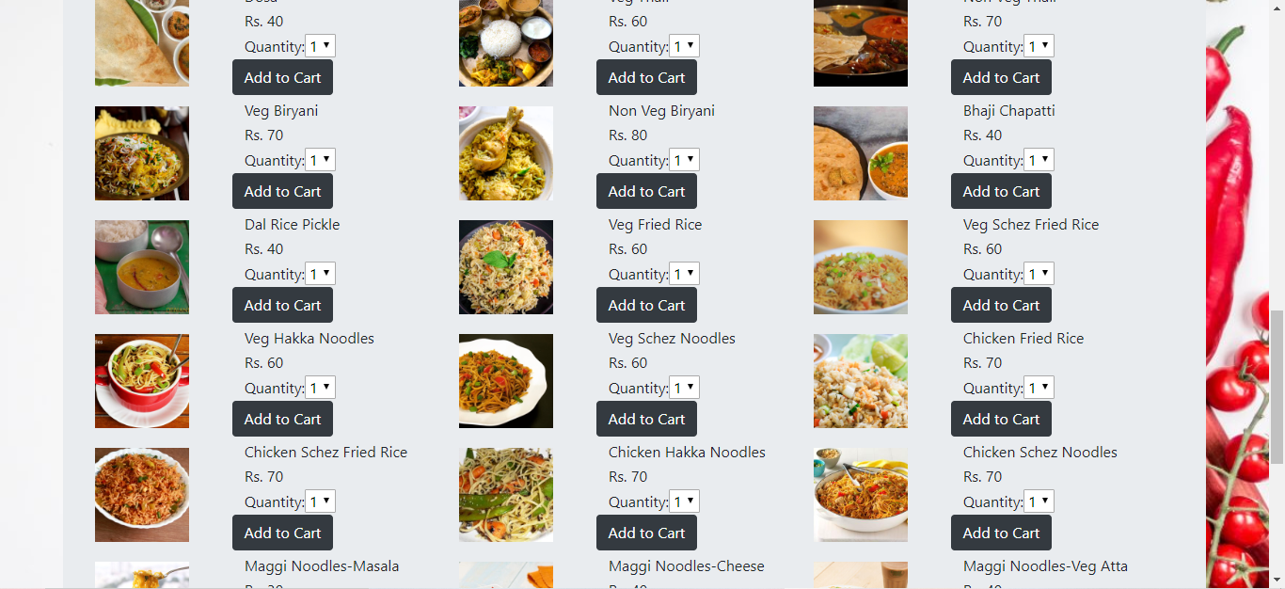

Figure :Start my order(3)

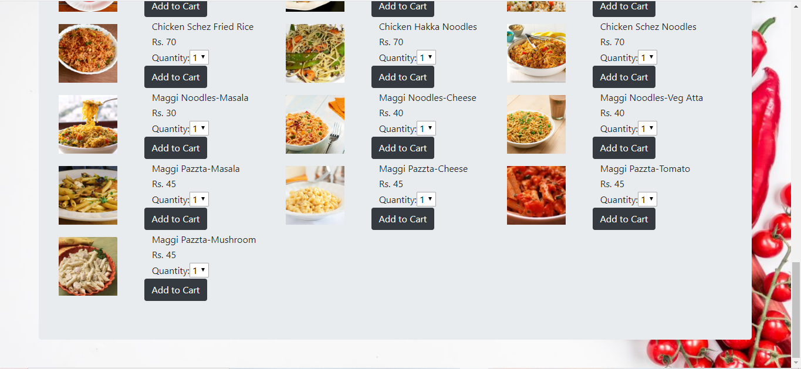

Figure :Start my order(4)

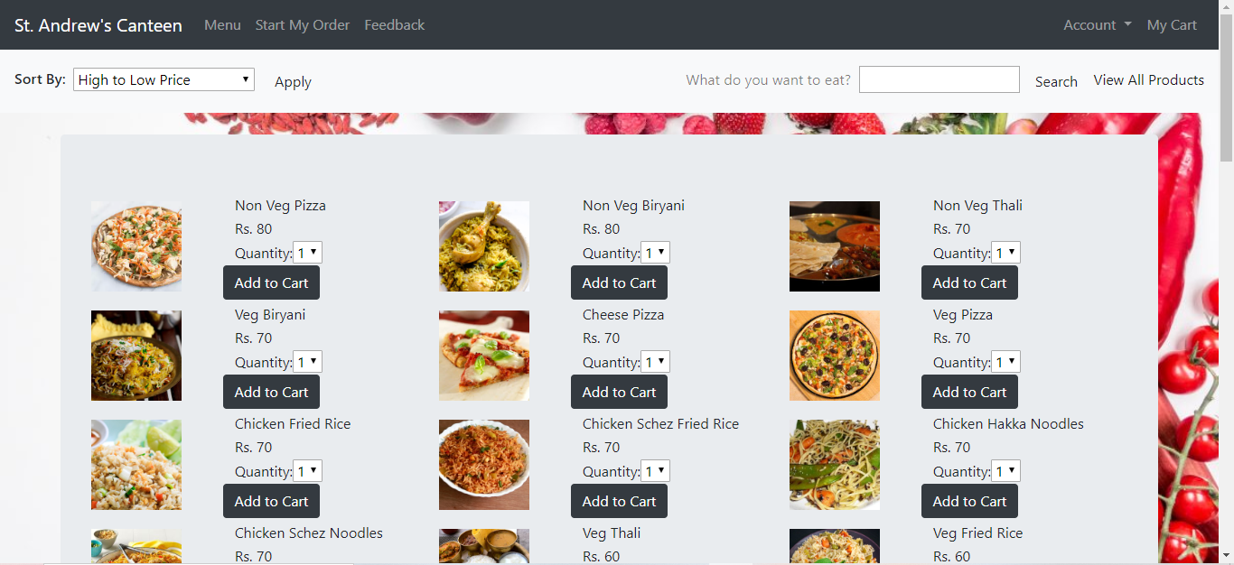

Figure :Sort products (High to low price)

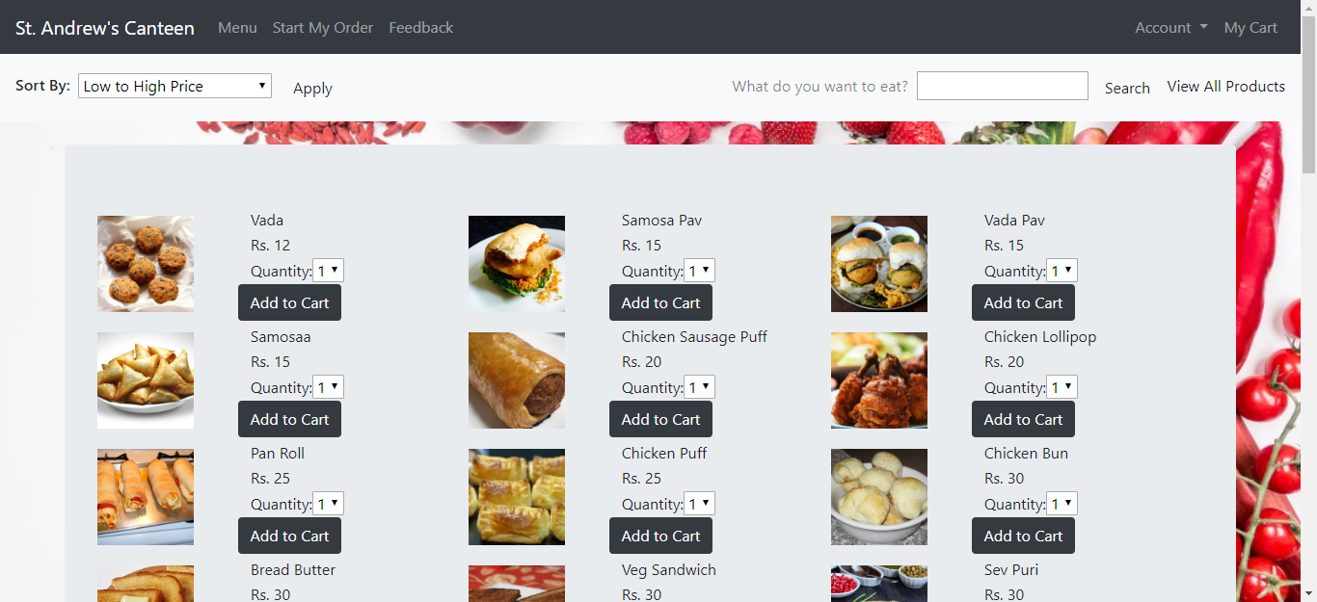

Figure :Sort products (Low to high price)

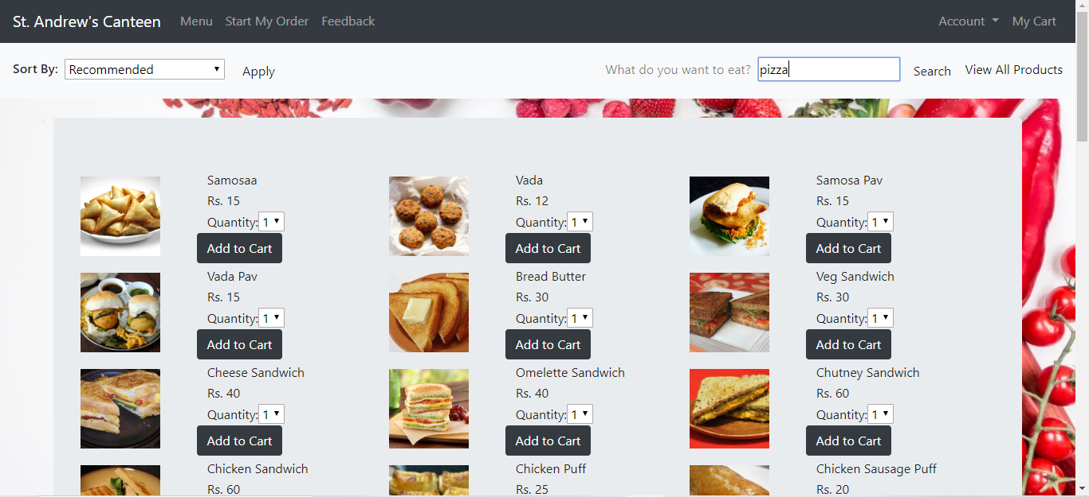

Figure :Using the search bar

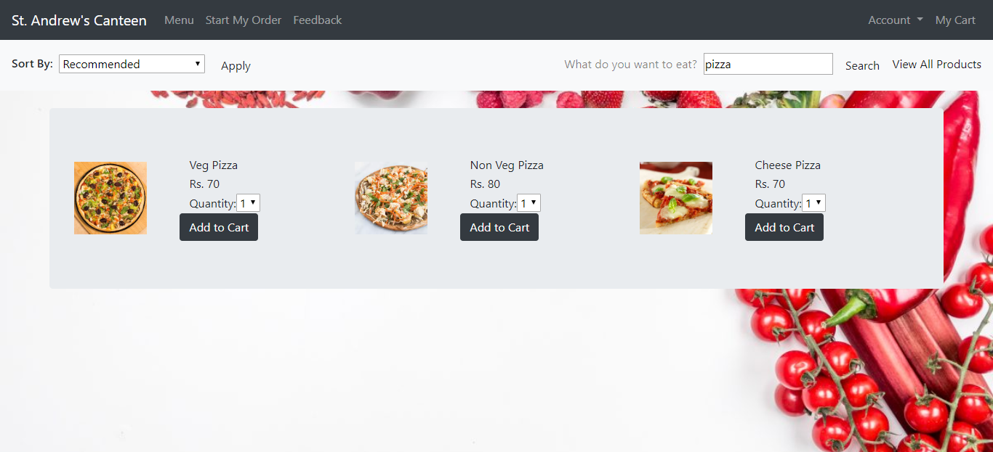

Figure :Results from the search bar

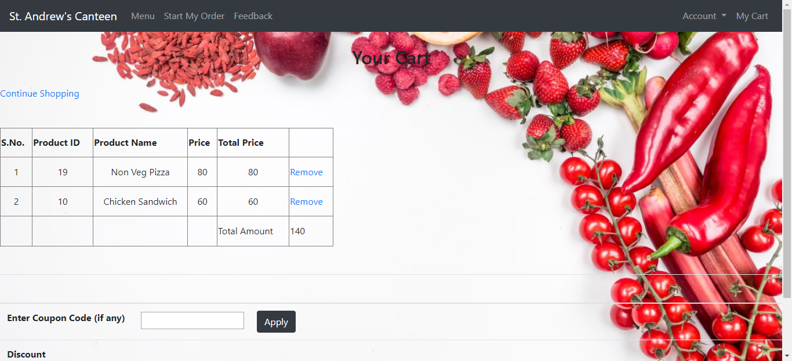

Figure :Cart

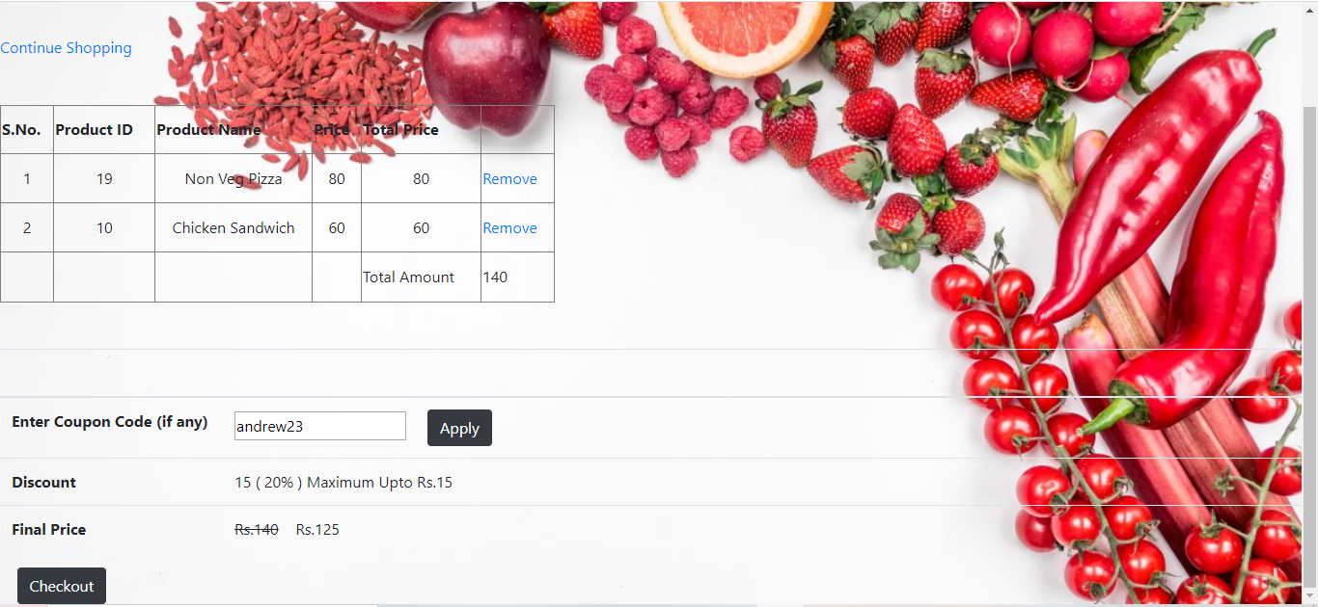

Figure :Coupon code added

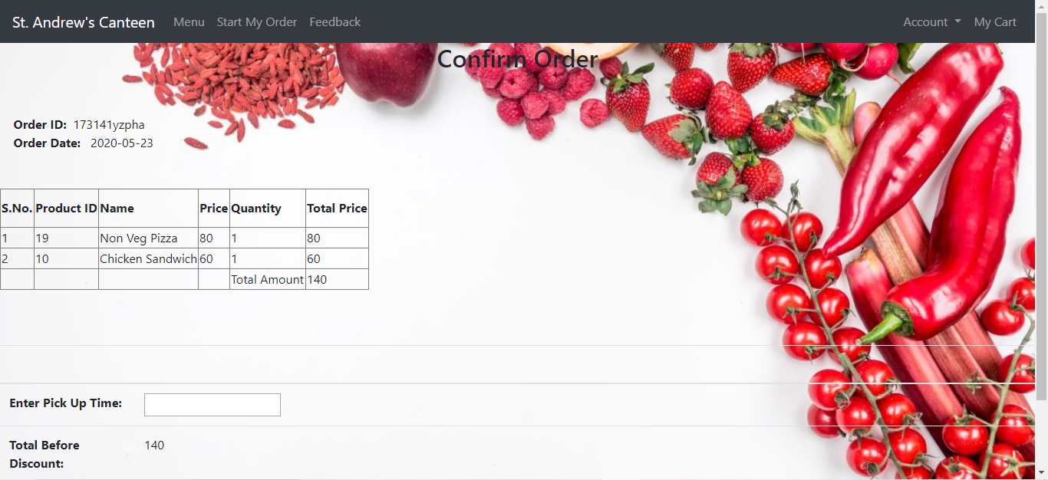

Figure :Order confirmation

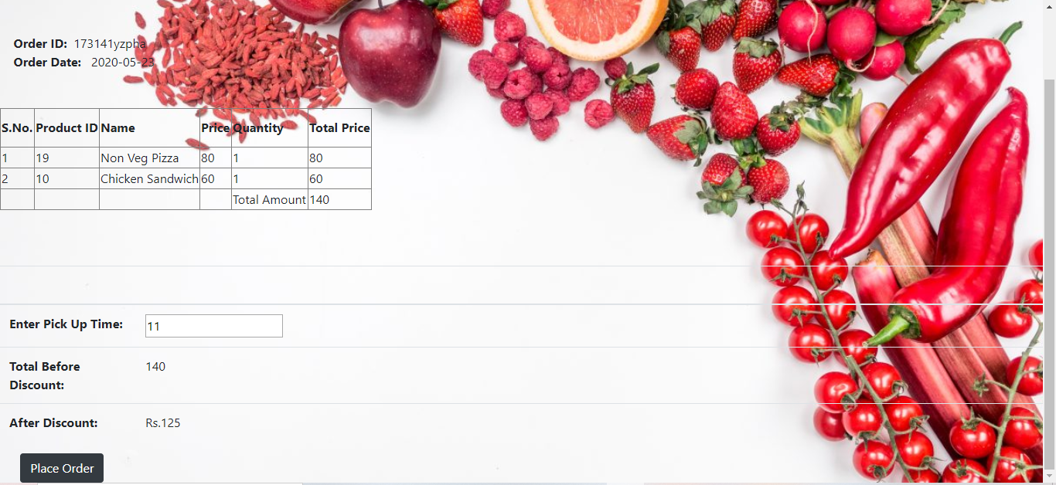

Figure :Order pick up time

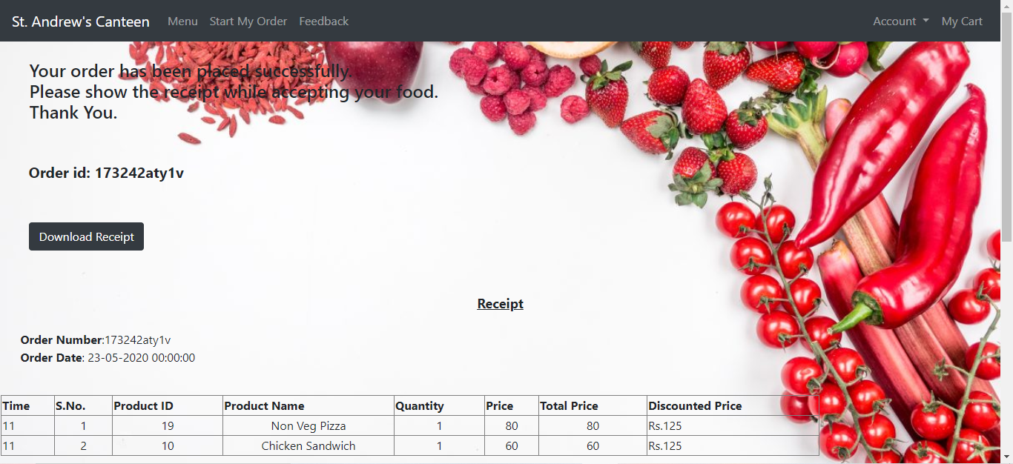

Figure :Order placed successfully

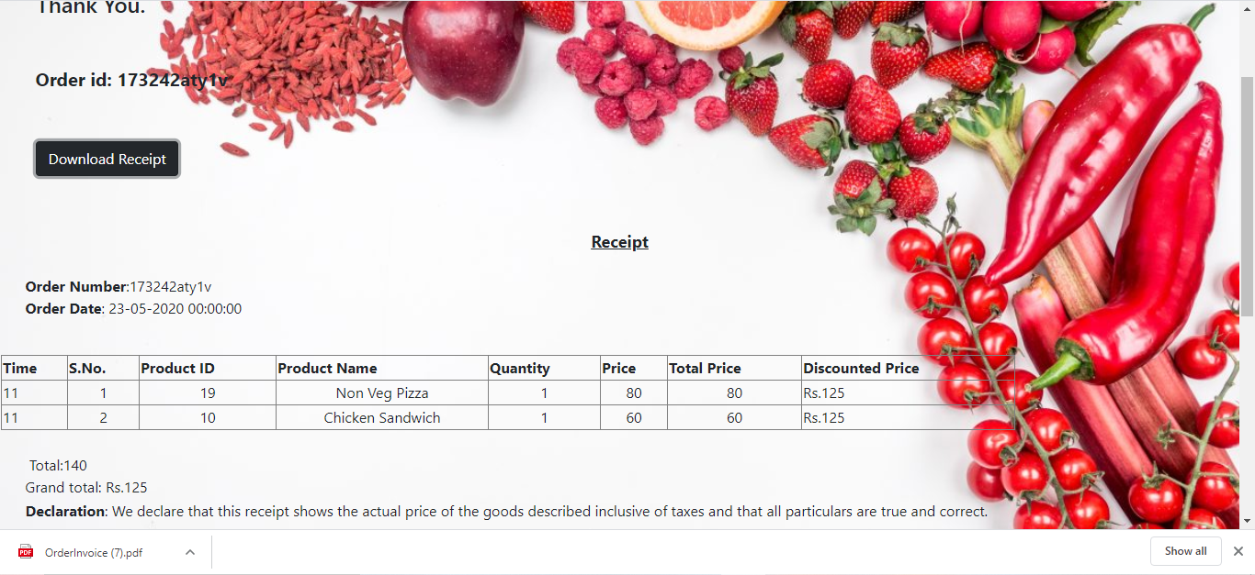

Figure :Download order receipt

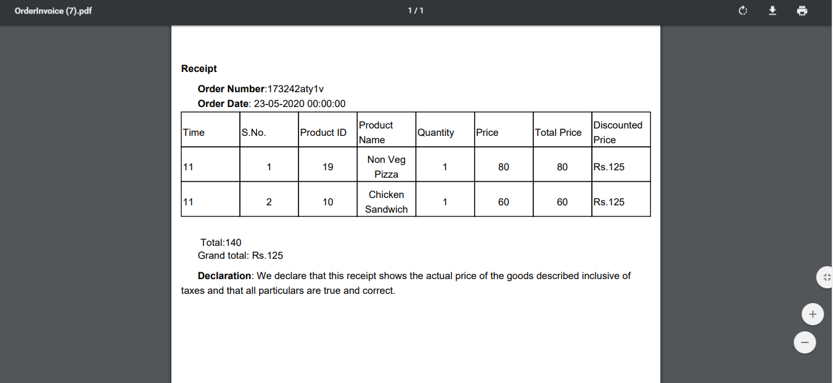

Figure :Order receipt

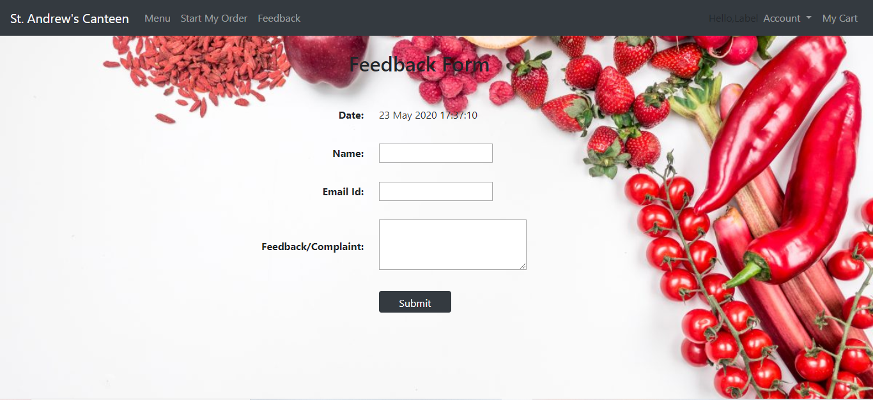

Figure :Feedback form

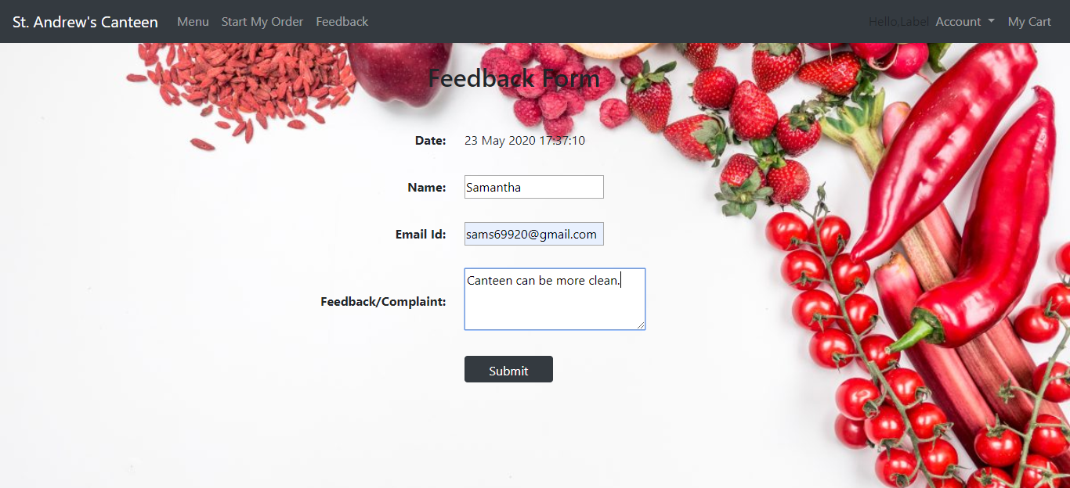

Figure :Feedback

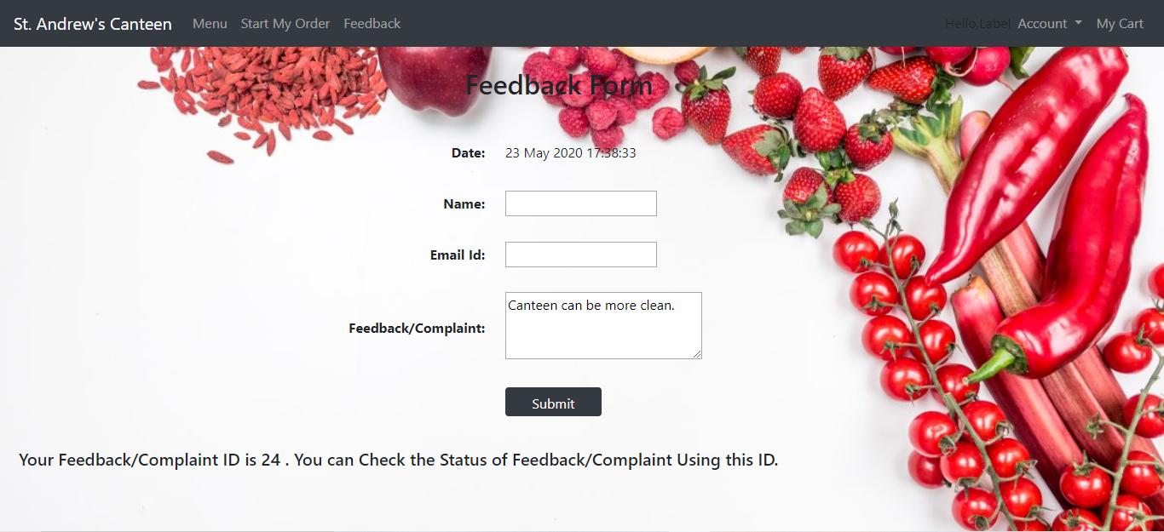

Figure :Feedback submitted successfully

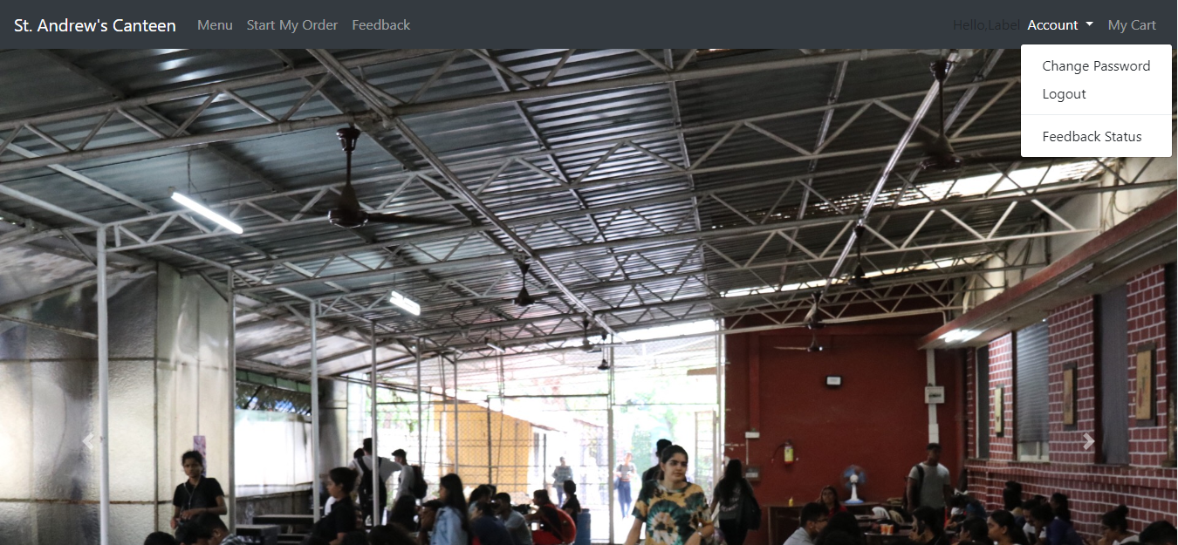

Figure :Homepage dropdown list

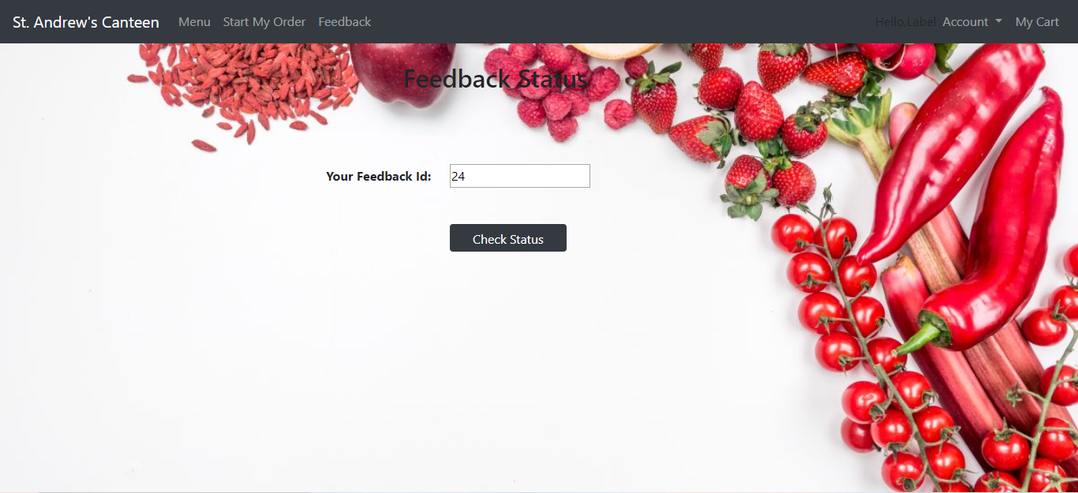

Figure :Check feedback status

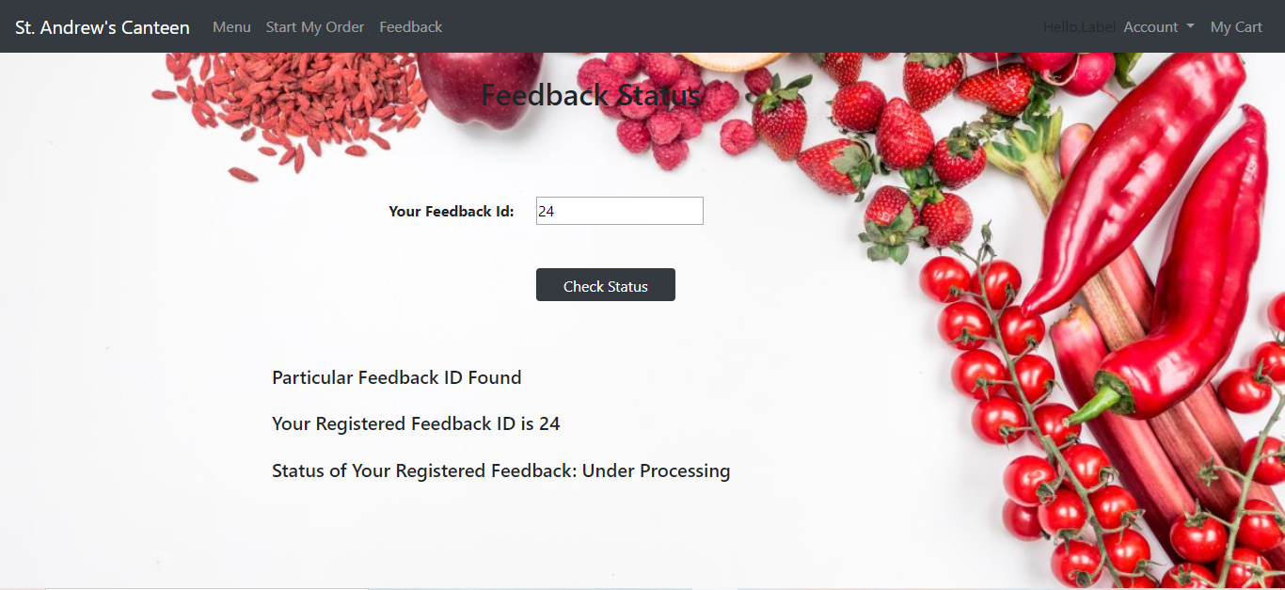

Figure :Feedback is being processed



Figure :Homepage dropdown list

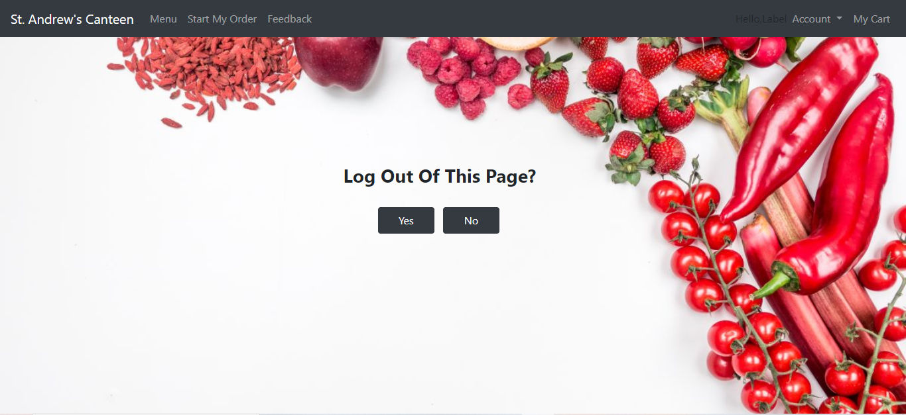

Figure :Log out

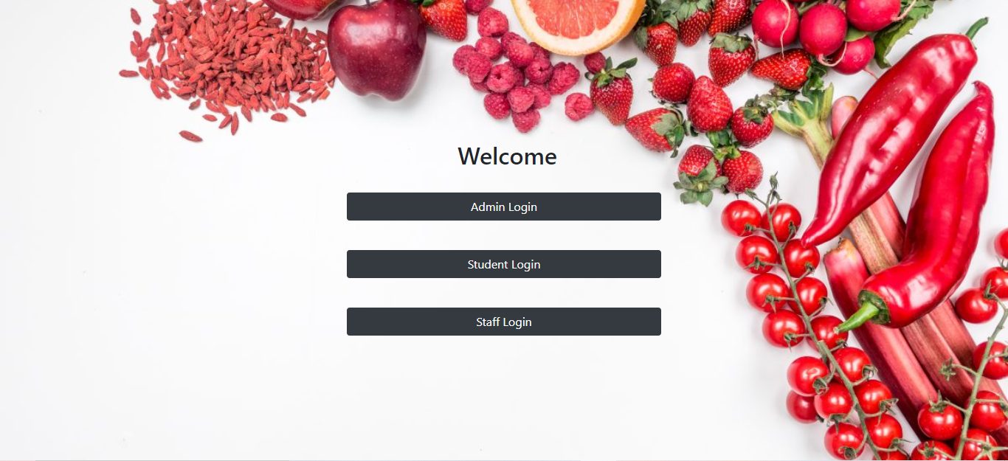

Figure :Welcome page

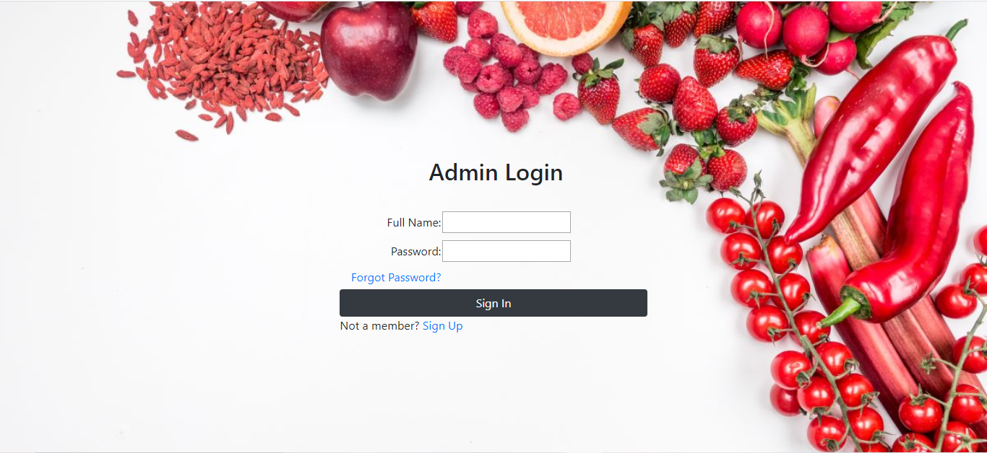

Figure :Admin login

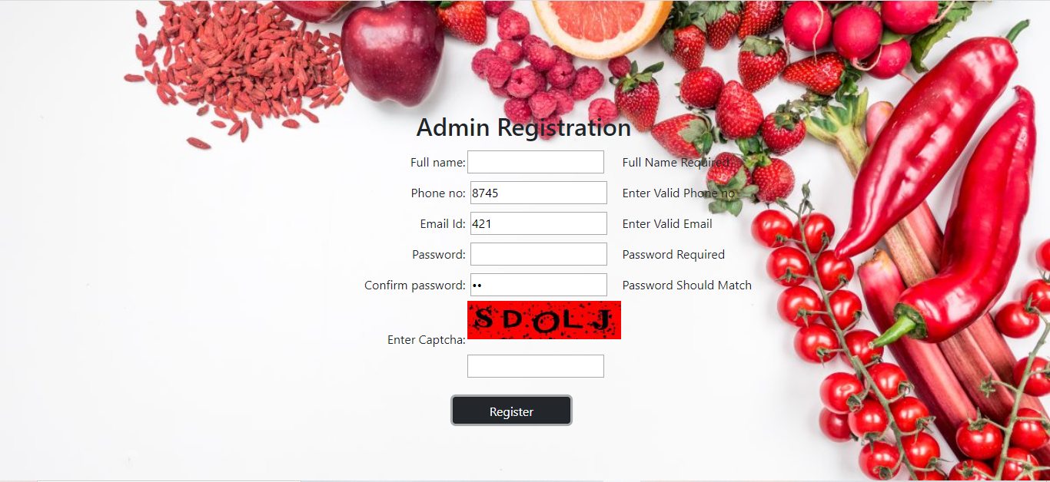

Figure :Admin registration(Validation controls)

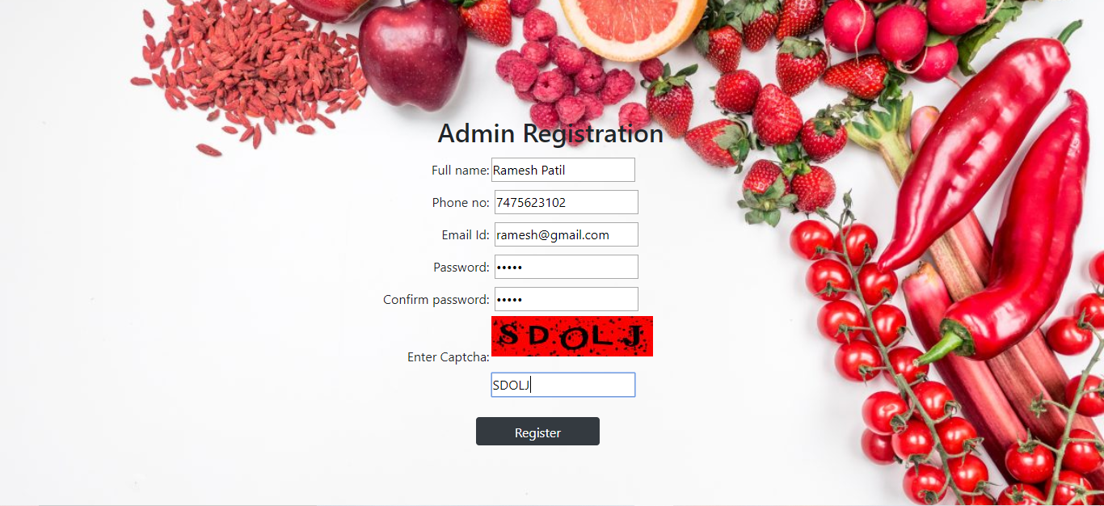

Figure :Admin registration with captcha

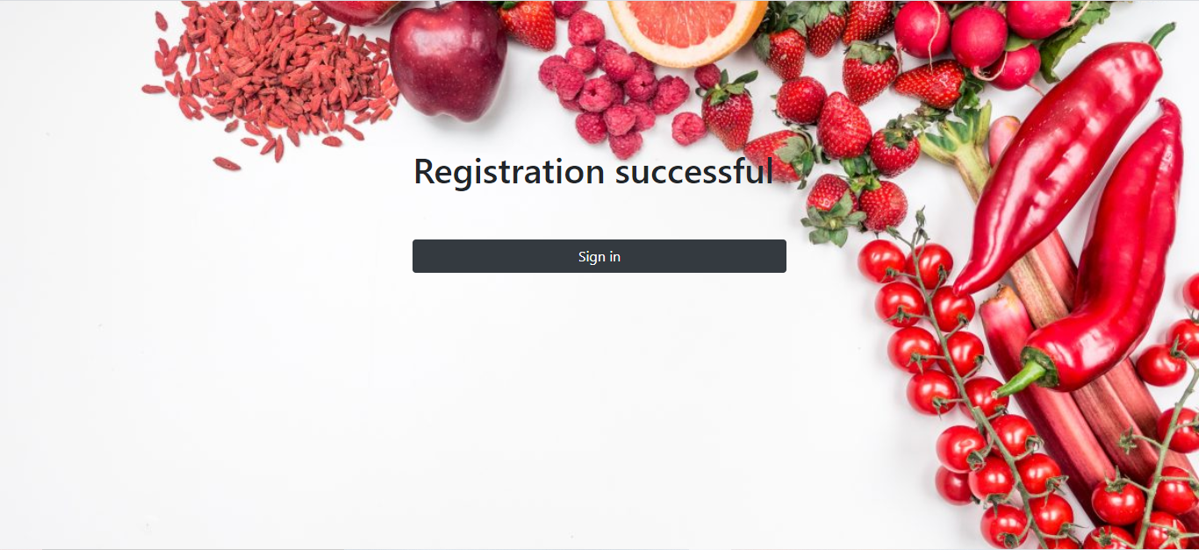

Figure :Registration successful

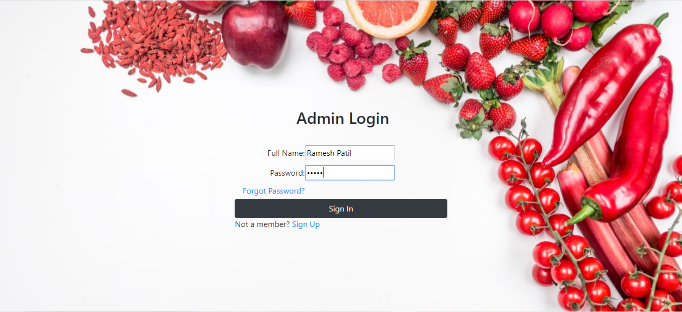

Figure :Admin login

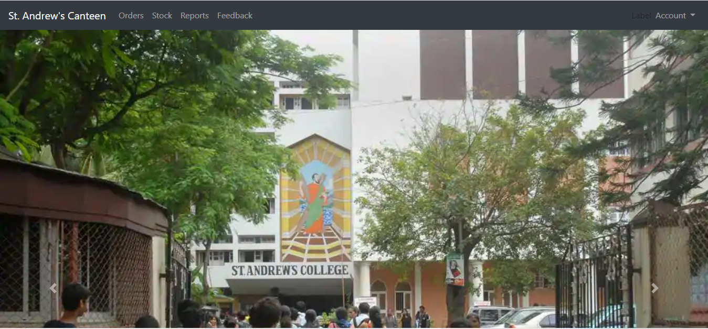

Figure :Admin homepage

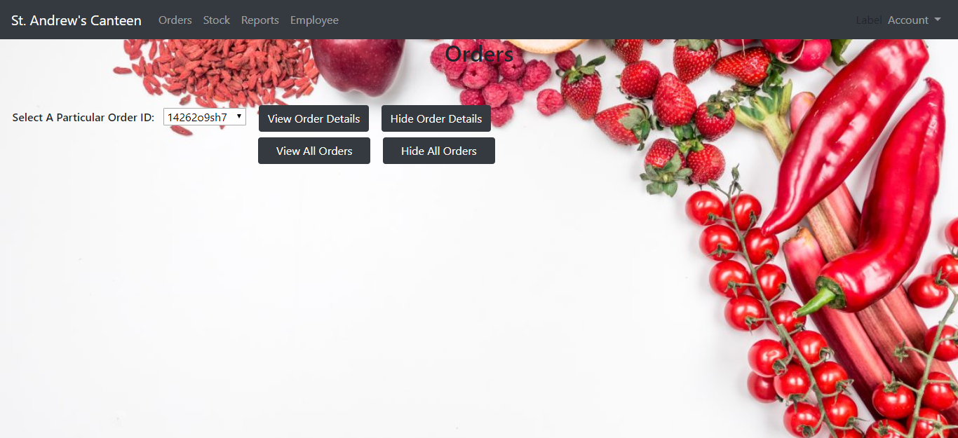

Figure :View orders

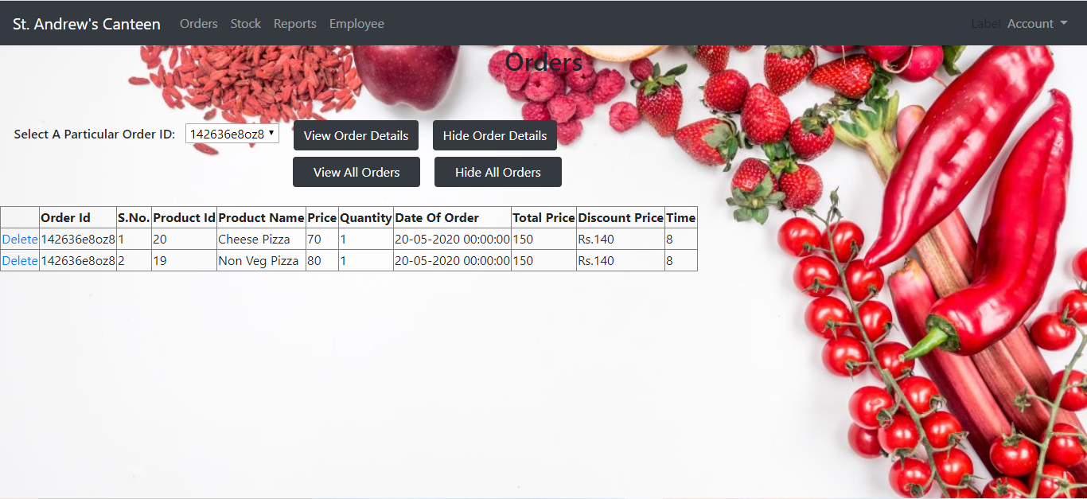

Figure :View a particular order

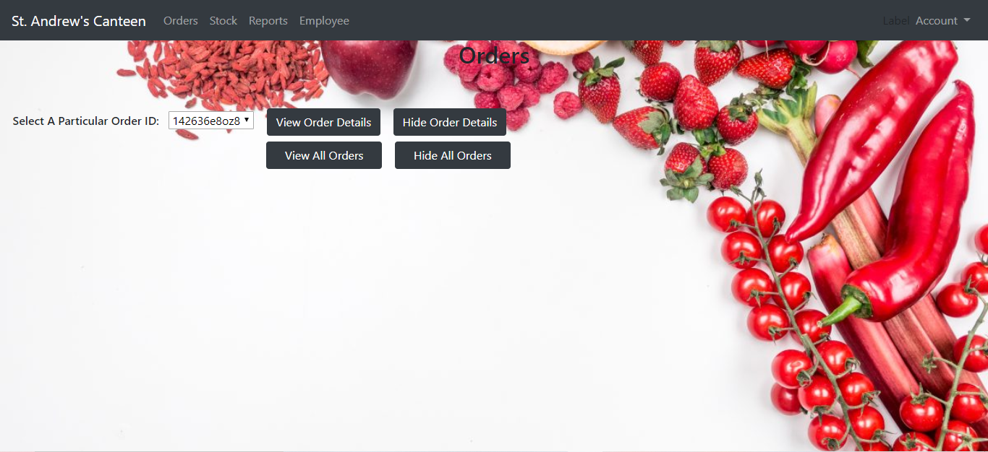

Figure :Hide order details

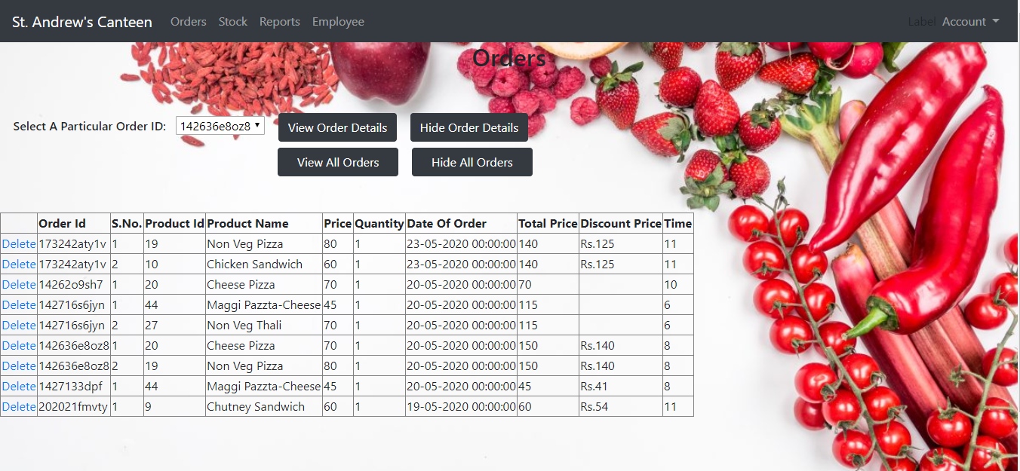

Figure :View all orders

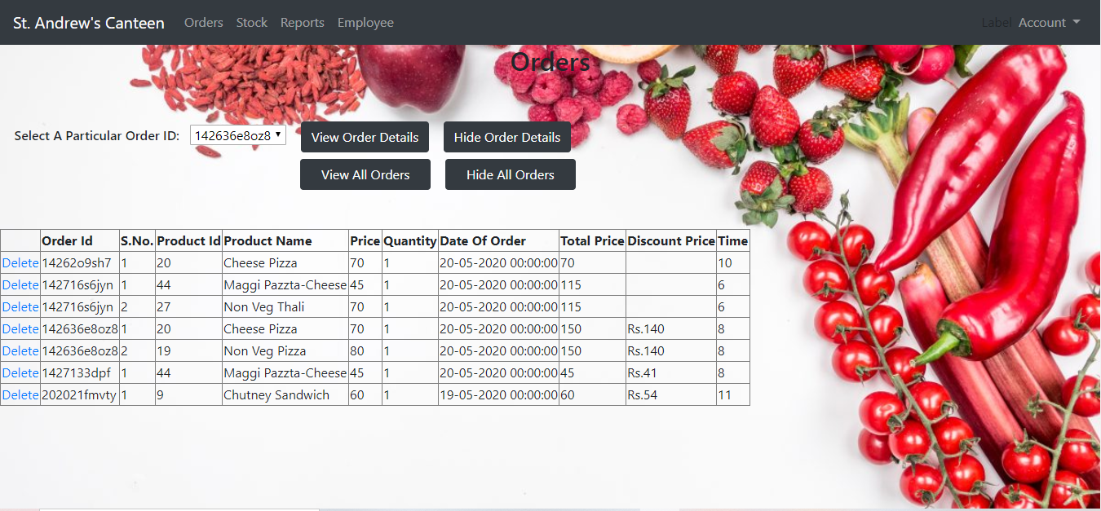

Figure :Delete order after completion

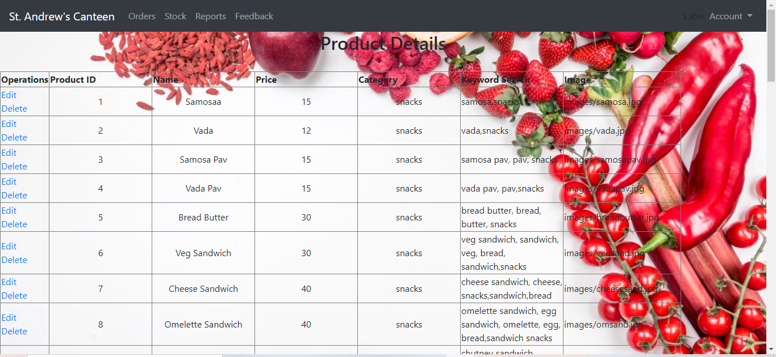

Figure :Product details(1)

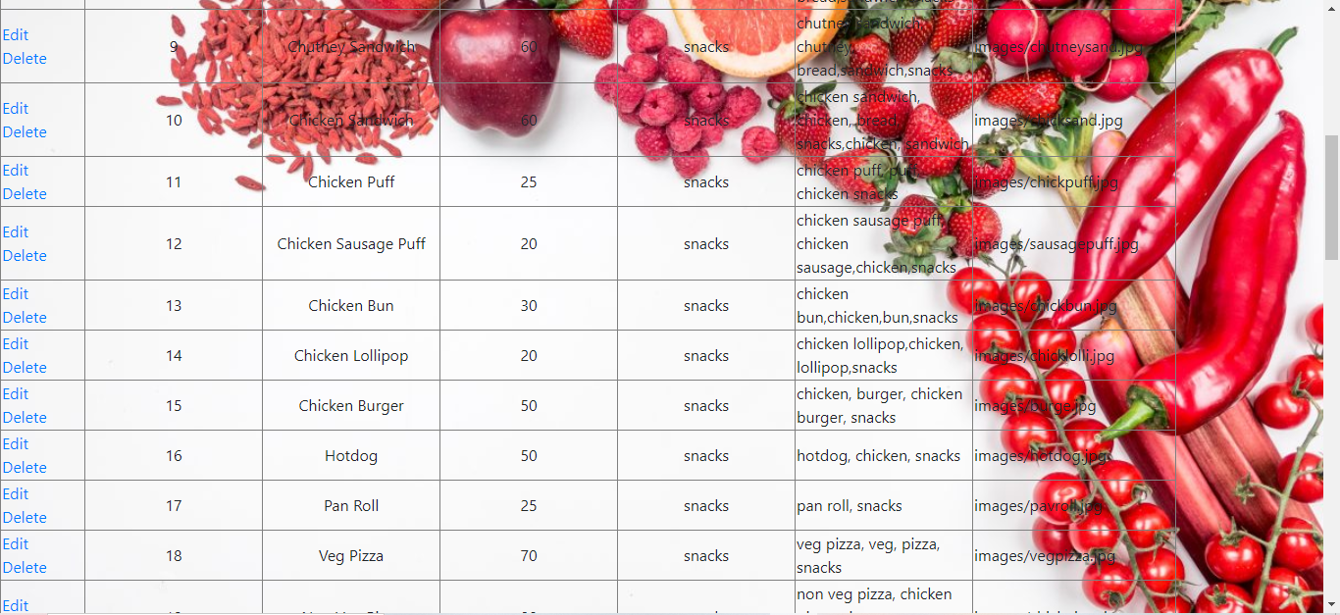

Figure :Product details(2)

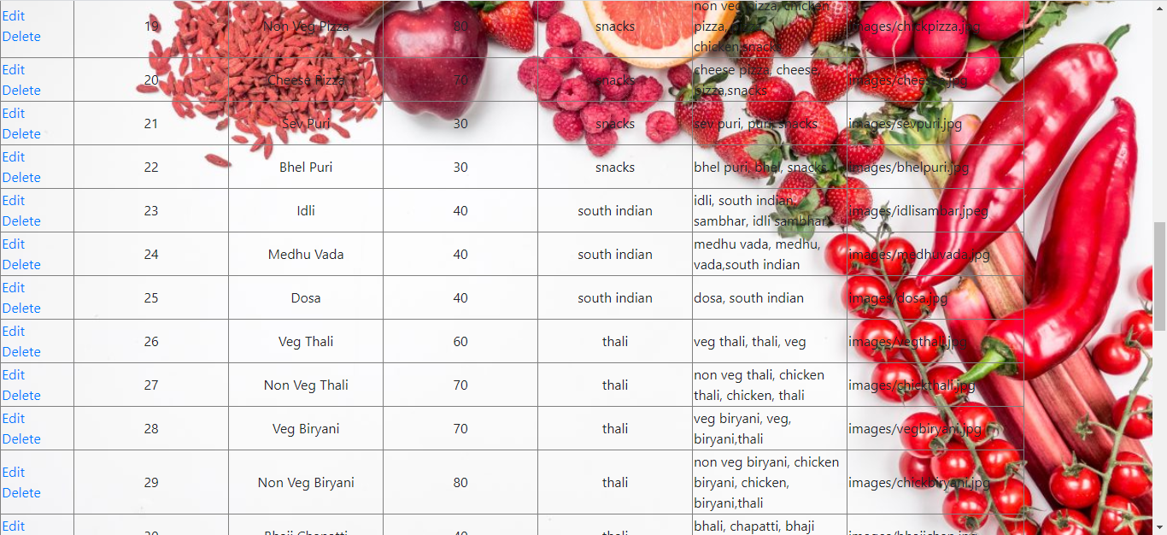

Figure :Product details(3)

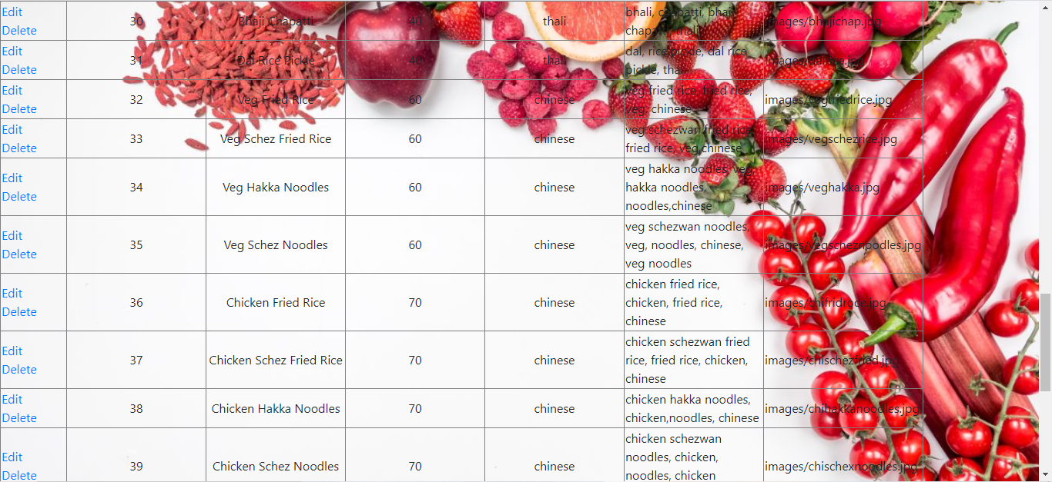

Figure :Product details(4)

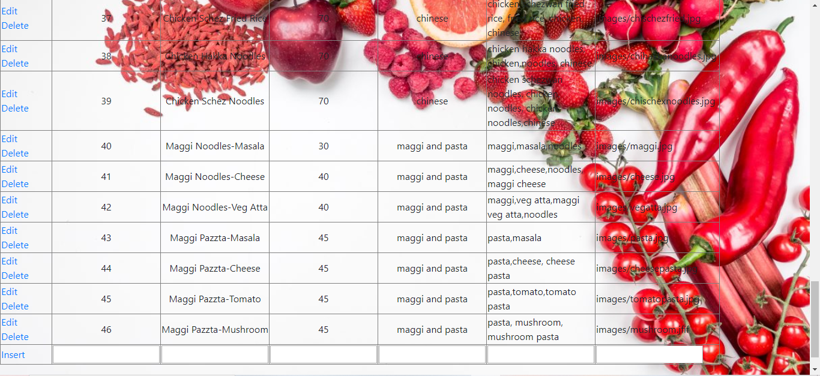

Figure :Product details(5)

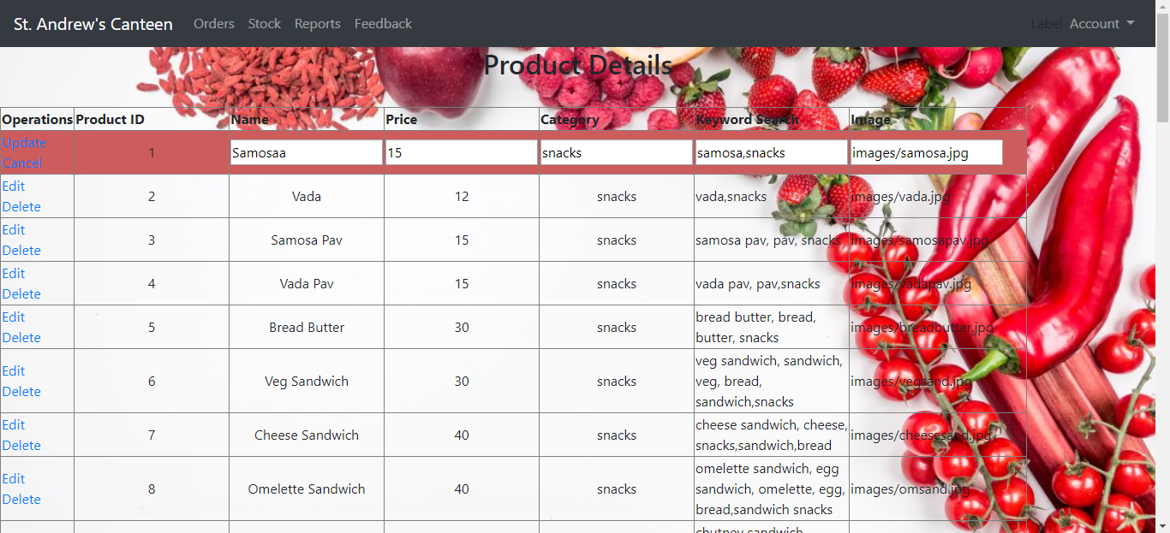

Figure :Edit product details

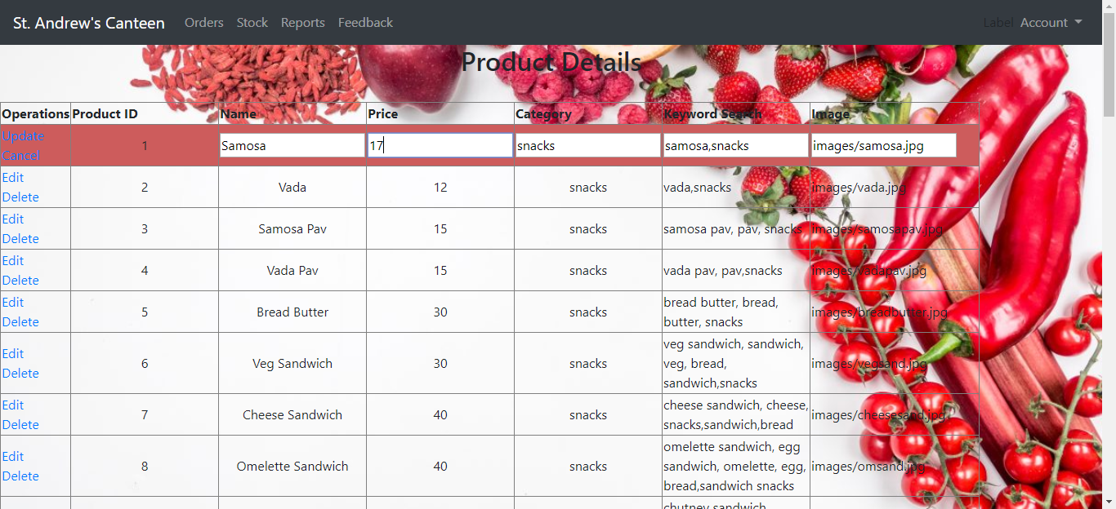

Figure :Edit product details

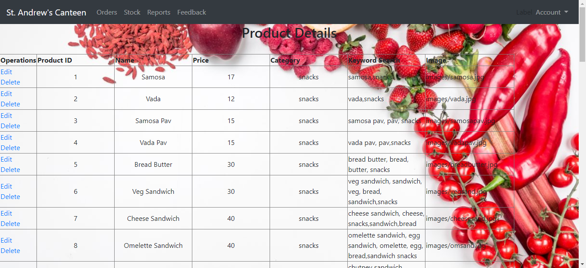

Figure :Update product details

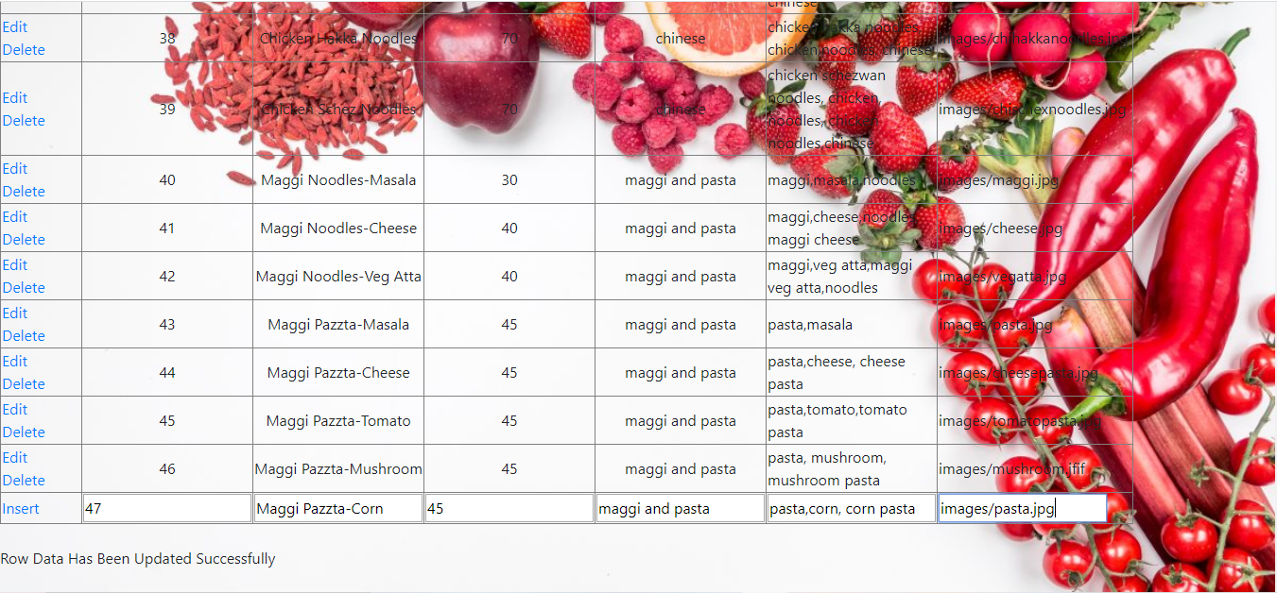

Figure :Insert a new product in product details

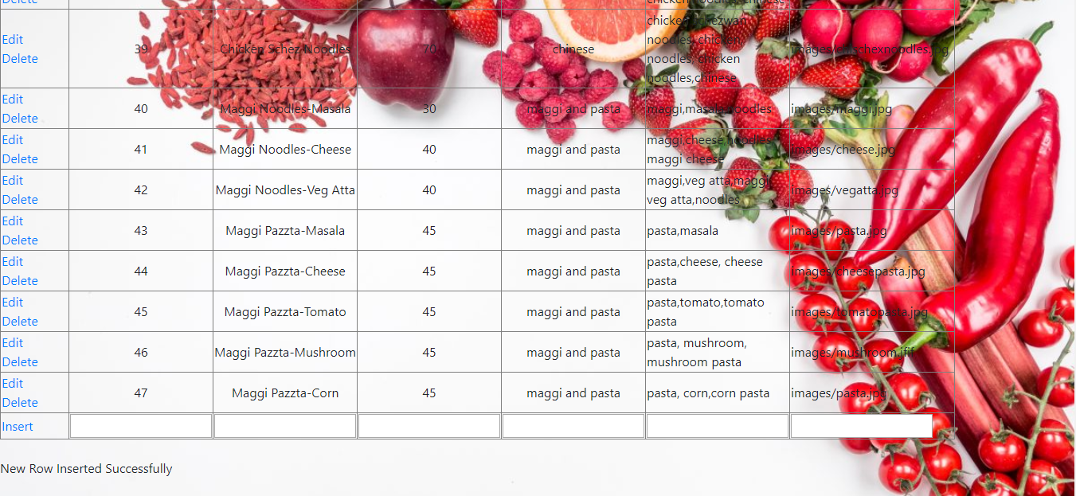

Figure :New product inserted

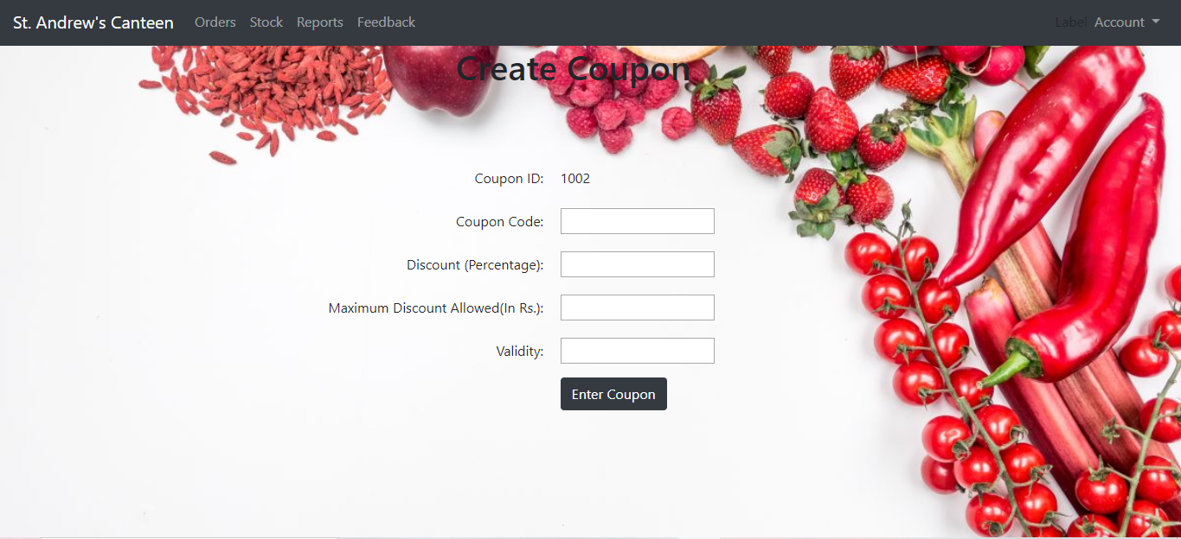

Figure :Create coupon

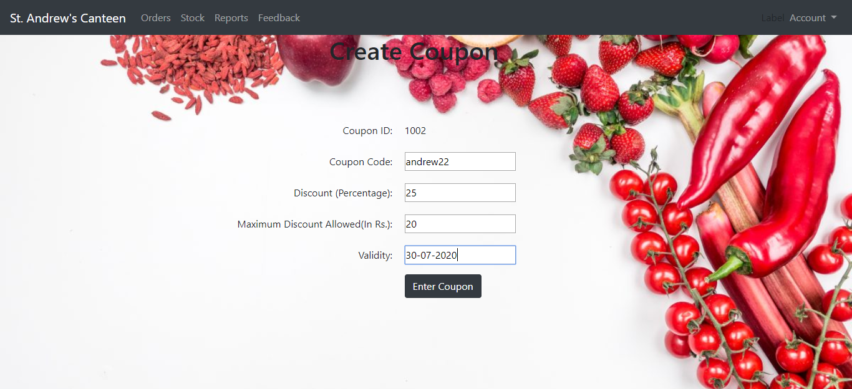

Figure :Coupon details

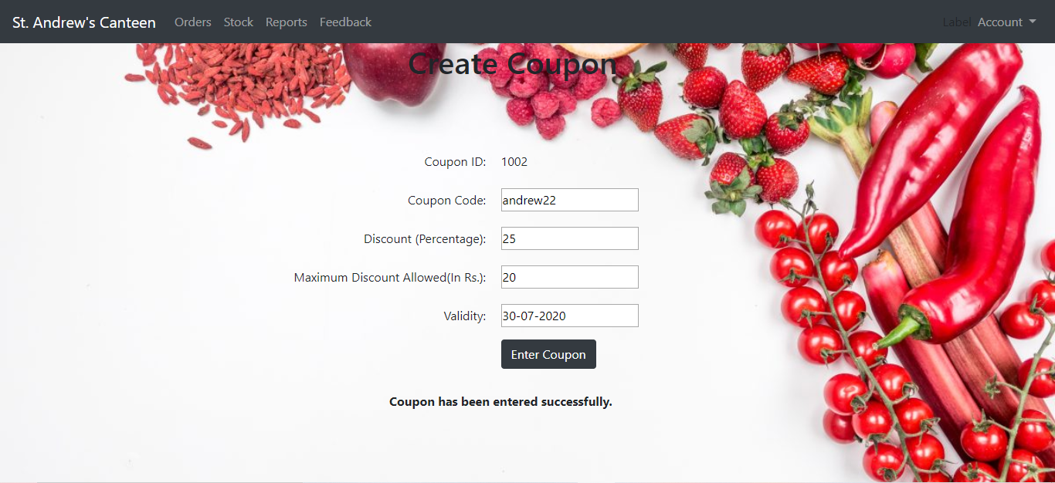

Figure :Coupon created successfully

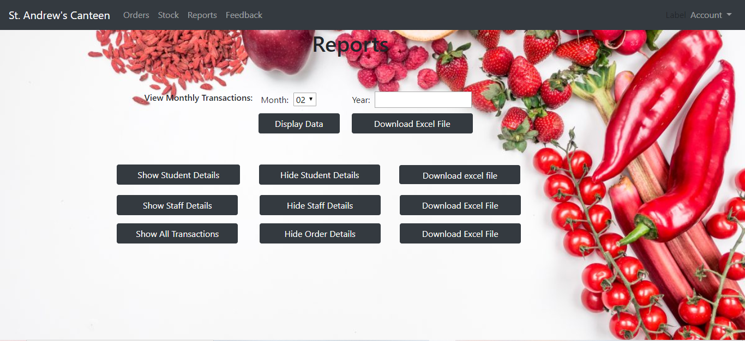

Figure :Reports

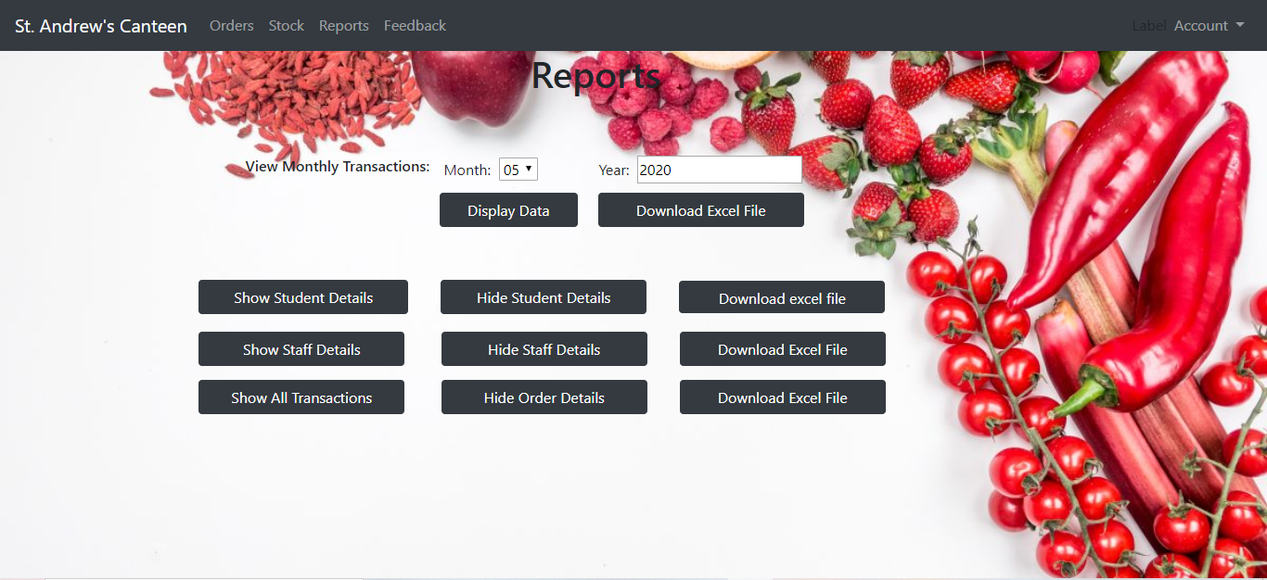

Figure :Find transactions of a particular month

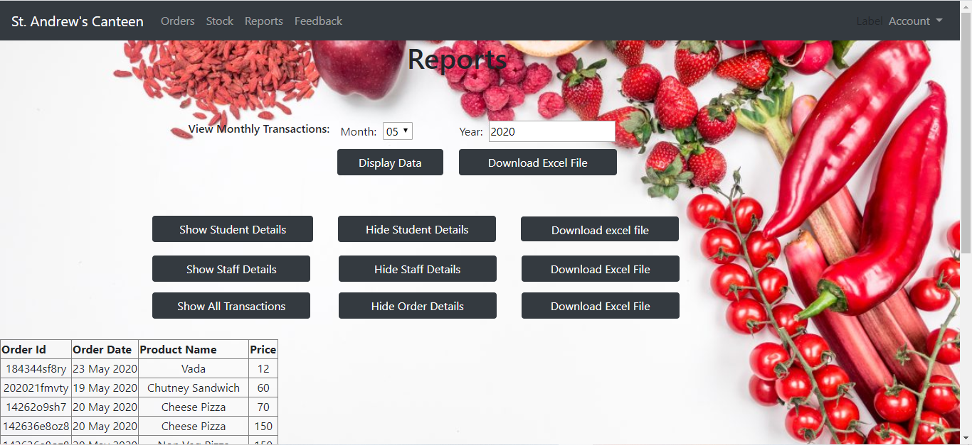

Figure :Transaction details of a particular month

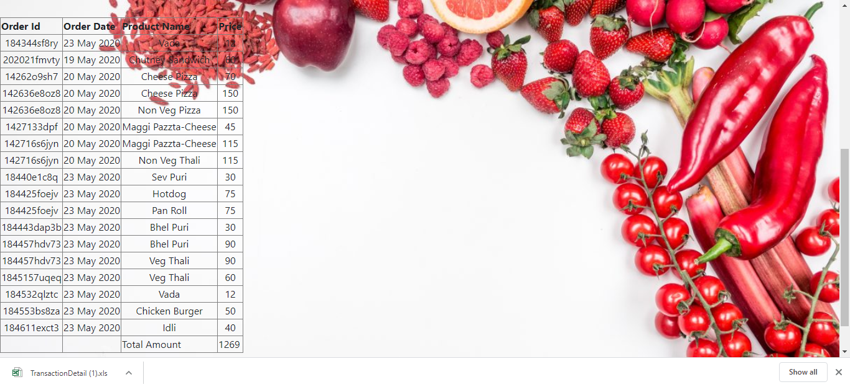

Figure :Download transaction excel file

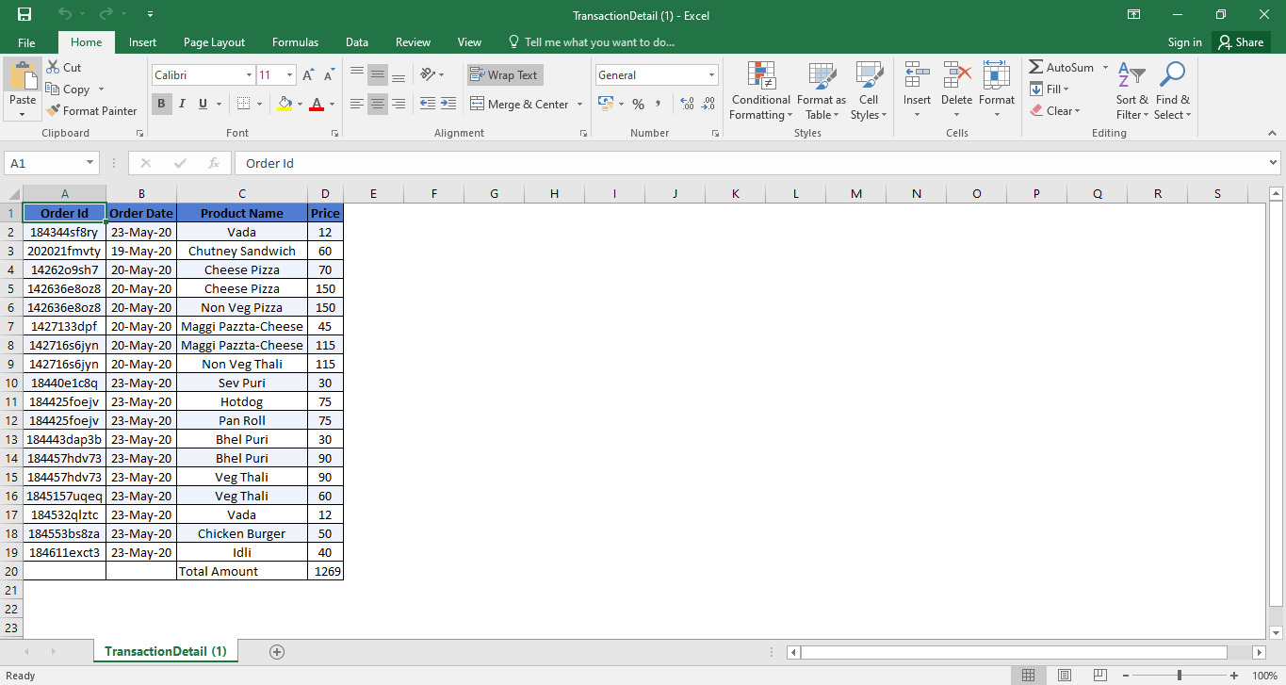

Figure :Transaction details excel file

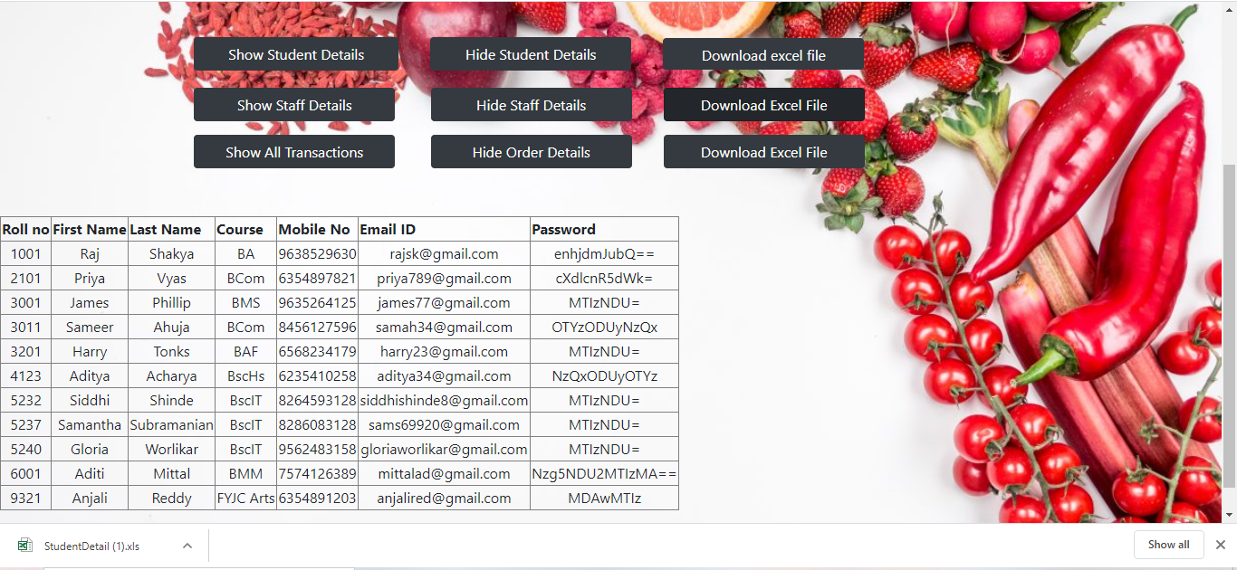

Figure :View and download all Student details

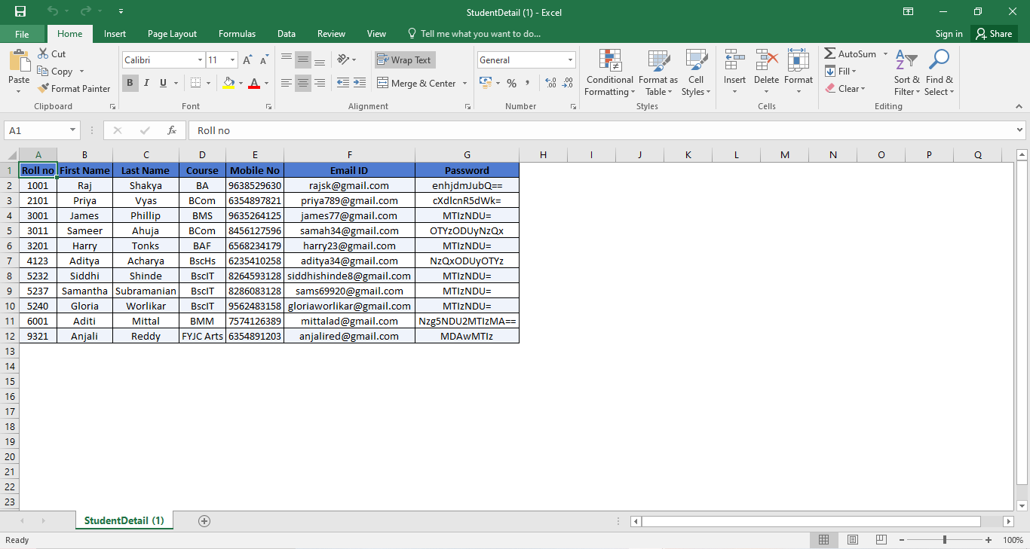

Figure :Student details excel file

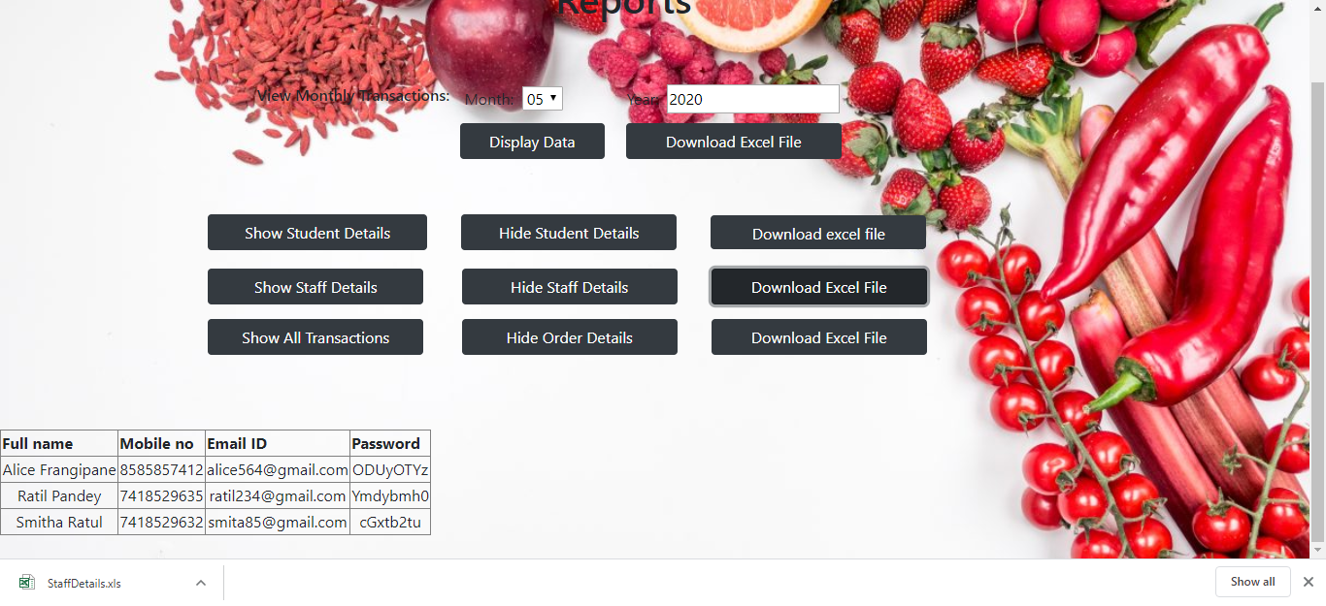

Figure :View and download all staff details

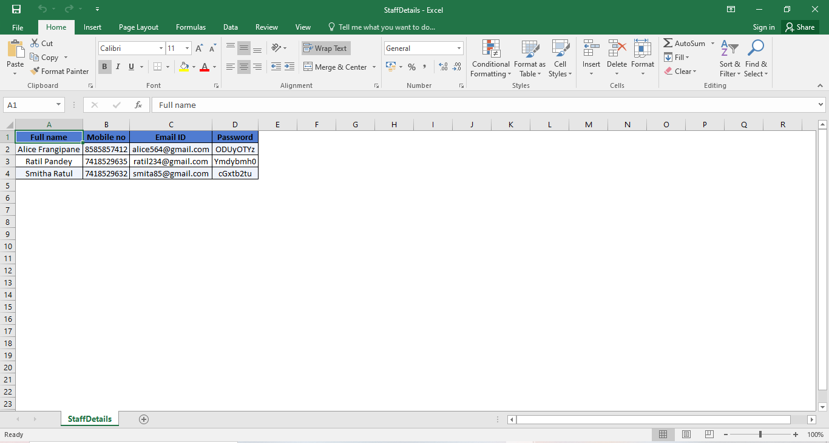

Figure :Staff details excel file

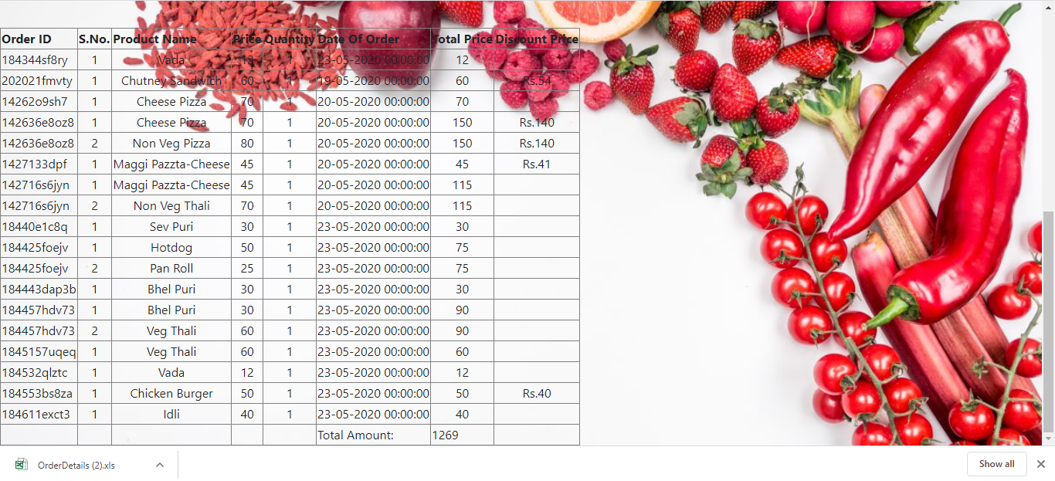

Figure :View and download order details

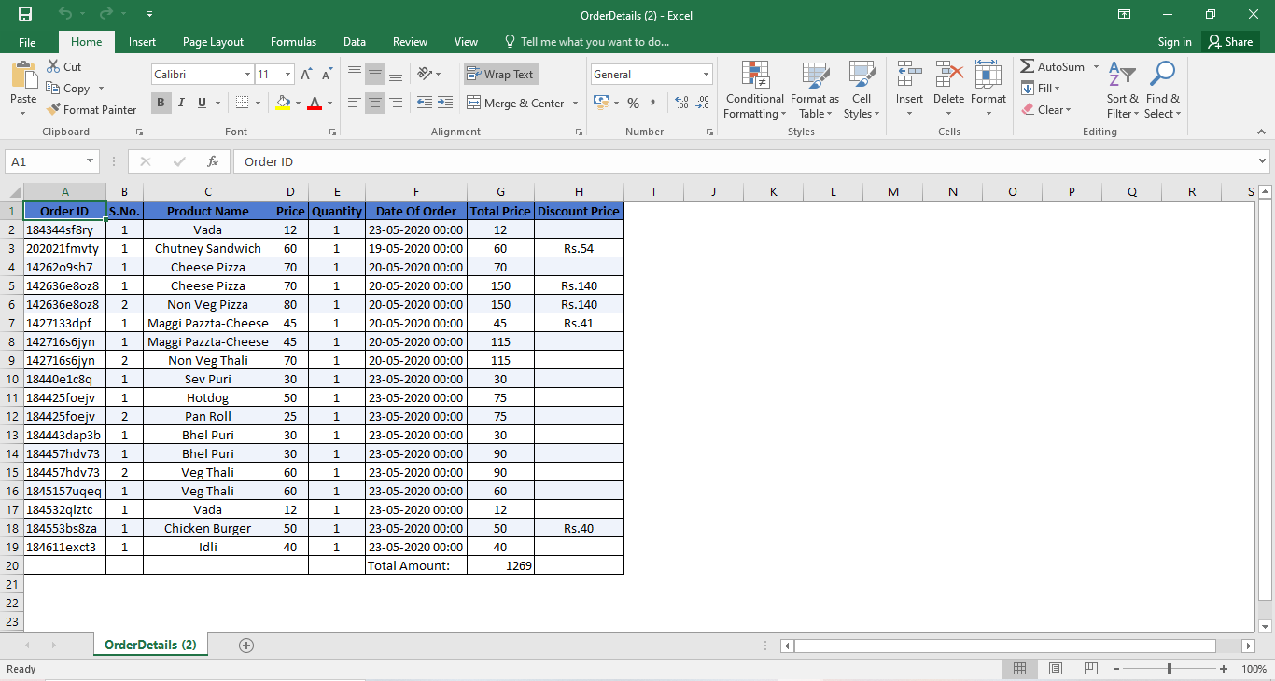

Figure :Order details excel file

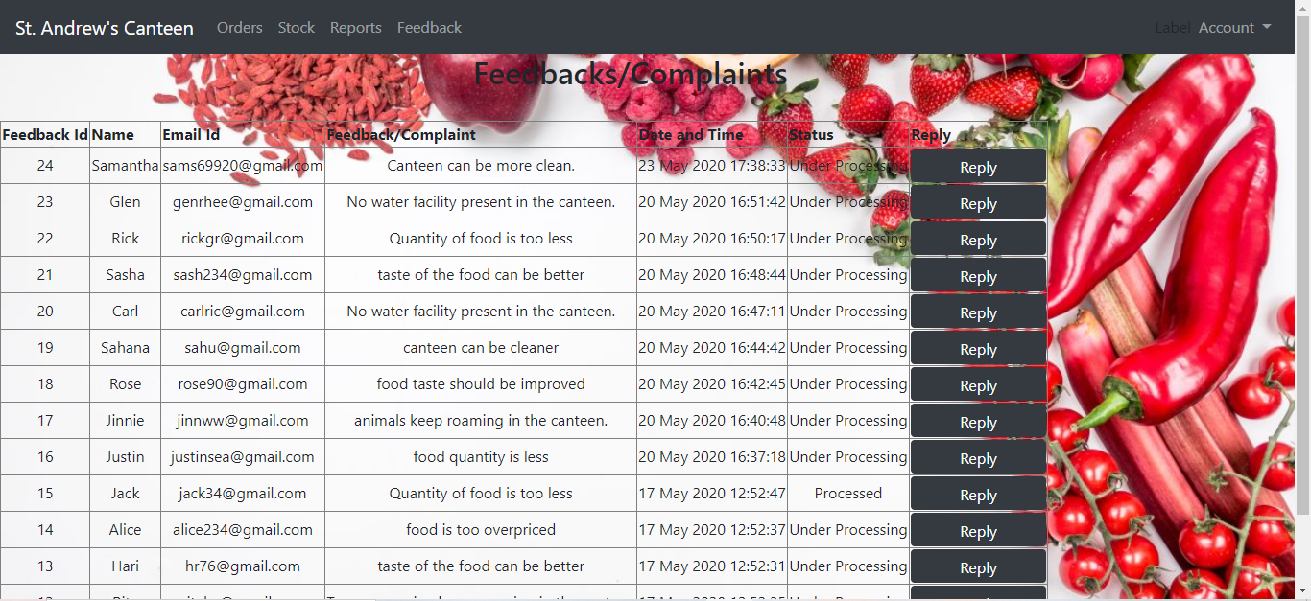

Figure :View all feedbacks

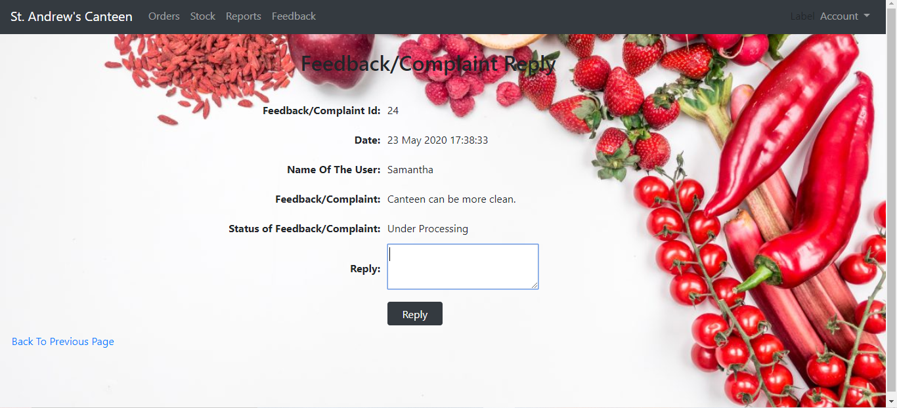

Figure :Reply a particular feedback

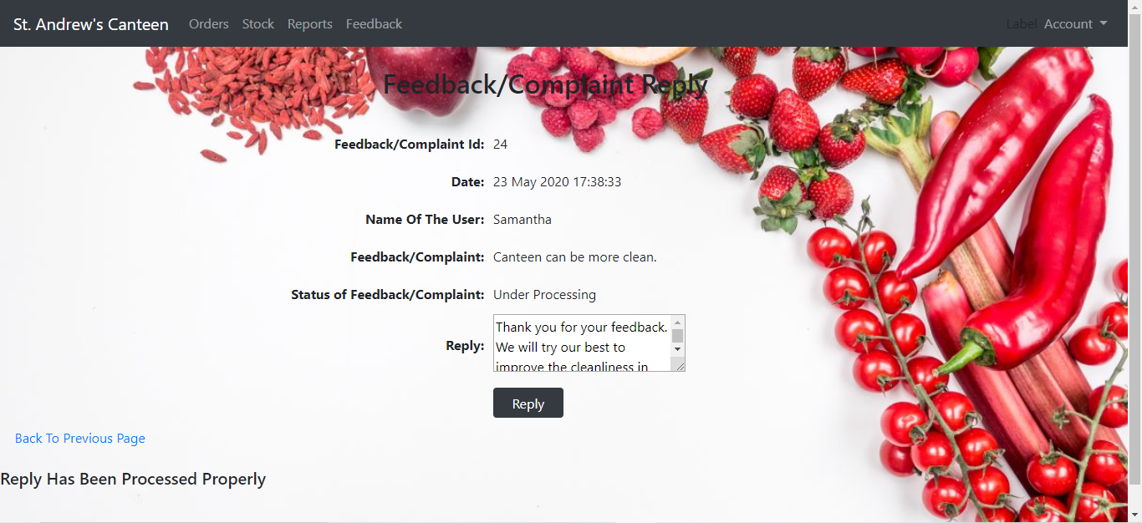

Figure :Reply inserted successfully

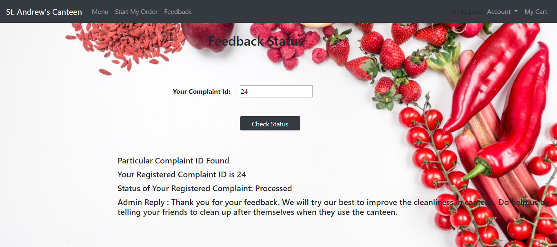

Figure :User views admin's reply

**5. Results And Discussion**

**5.1 Test Reports**

|  |  |  |
| --- | --- | --- |
| **Types of test** | **Description** | **Status** |
| 1. Unit testing | Each module was tested  individually. All the forms  created were tested. | The results generated were as  expected. So the overall status  of unit testing is PASS. |
| 2.Integration Testing | All the various modules and  the way they interact were  tested. | The results were as expected.  The interactions between the  modules took place  effectively. The overall status  of Integration Testing is  PASS. |
| 3. System Testing | This includes the Operation,  Functional and Security and  Portability Testing |  |
| 3.1 Operational Testing | It includes the performance,  security, reliability and  maintainability. | The system was tested based  on the criteria. The overall  status of Operational Testing  is PASS. |
| 3.2 Functional Testing | All the functions with respect  to the system were tested. The  Flights uploaded the Admin  could be seen by the users. | All the functions were tested.  The functions provided an  output which was as expected.  The overall status of  Functional Testing is PASS. |
| 3.3 Security and Portability | The system was checked in  terms of security and  portability to check security  and portability with different  web browsers. |  |
| 3.3.1 Security | All the passwords and user  data were secure. Every user  of the system was ensured  security of their accounts. | All checks were a success.  The overall output is PASS. |
| 3.3.2 Portability | Since it is a website, this  website could be opened on  different types of web  browsers effectively. | The overall output was as  expected. The final result is  PASS. |
| 4. Beta testing | The web application was  tested completely to make  sure it would work effectively  if deployed on users PC | All the functions were  properly carried out and  showed no errors. The final  result is PASS. |

Table :Test reports

**5.2 User Manual**

1. Users must first create an account with basic information to access various functions of the

web application.

1. Then the user is directed to the main page from where they can choose any page they desire.
2. User should check the menu to see all the food items that is present in one glance.
3. User should go the orders page to select the food item they want to buy.
4. This will store the item in the cart. If the user wants to buy multiple items, he/she can click on the ‘Continue Shopping’ to go back to orders page.
5. They can delete the items they don’t want from the cart and add coupon codes if they have any.
6. After this, they will be given an order id. They should enter the time they will pickup the food item and place the order.
7. The user can then download the receipt and show it at the time of receiving their item.
8. The user can give their feedback on the overall experience.

**6. Conclusion**

St. Andrew’s Online Canteen Management System solves many problems faced during rush canteen hours. The college canteen consists of few workers at the station and a few in the kitchen. Students rush to the canteens during break and order their respective items. The break lasts for 20 minutes. This is very less time for students to order, receive and finish their meals which discourages students from ordering from the canteen.This problem is solved using the online system.

It is a website where students can create their own accounts and order meals beforehand. They can order their meals and also pay for them online. The admin in the canteen will receive these orders and prepare food before the break. The student then has to only come and collect their food. This will improve the time management of the canteen system. Staff members can also have their accounts from which they can get food delivered to the staff rooms.

The main aim of this project is to provide smooth functioning to the canteen management system.

This system will take orders behorehand and prepare them. This saves the students time as the can order their food beforehand and later go and collect them.

It provides a smooth flow to the entire system.

The canteen workers can prepare the food as they receive the orders so this will not lead to overburdening them during rush hours. This leads to better time management

This app will introduce an online payment system. This will further simplify the process of getting the food faster

St. Andrews Canteen Management system will make canteen management simpler and more effective. This will help the admins to analyze the products and further keep the inventory stocked accordingly. This system will also maintain the order details and also the details of the employees.It will contain the details of the most frequent users and have special offers for them which will encourage them further to use this app. It will have an online payment system. This further makes the system more manageable.

**6.1 Significance of System**

* This project will provide smooth functioning to the canteen management system.
* This well help the students to order their food early and not deal with the rush during break.
* They can just go and collect their order during break.
* The workers get the order beforehand and can prepare them and keep them ready at the pickup time.
* This will reduce the crowds during rush hours.
* It will also allow the students to get enough time to finish their meal as it cuts down the waiting time.
* There will be no confusion of multiple orders.
* It introduces the concept of coupon codes which will further motivate students to use this website.
* Admins will be able to keep track of the transactions done in the month.
* They can also handle employee details using this website.
* Any changes made in the product details by the admin will be immediately shown to the user.

**6.2 Limitations of the project**

* It does not have an online payment system.
* Order id can be large and sometimes difficult to track.

**6.3 Future scope of the project**

* It will include an online payment system.
* A responsive app will be made.

**7. References**

* [www.canteentaco.com](http://www.canteentaco.com)
* www.mykidslunchbox.com.au
* [www.udemy.com](http://www.udemy.com)
* [www.w3schools.com](http://www.w3schools.com)
* [www.stackoverflow.com](http://www.stackoverflow.com)
* [www.teamtreehouse.com](http://www.teamtreehouse.com)
* [www.textlocal.in](http://www.textlocal.in)
* [www.codeproject.com](http://www.codeproject.com)
* [www.blackwasp.co.uk](http://www.blackwasp.co.uk)
* [www.forums.asp.net](http://www.forums.asp.net)
* [www.youtube.com](http://www.youtube.com)
* Bob Hughes, Mike Cotterell, Rajib Mall,Software project management
* Sweety Garg, Software engineering (Sheth publications)
* Matthew MacDonald, Beginning ASP.NET 4.5 in C#